Proof of Concepts

NAME of Project: (If applicable)

Date:

NAMES of Collaborators:
Collaborators may include people who need the document you are generating as input and people who have knowledge and resources you are using to generate this document.

Concept Name
How do you find a technical concept to document?
- Choose a concept to explore from your Engineering Needs and Requirements toward a specific target metric as you develop your Project Specifications.
- Choose one of your high level, functional system blocks from your brainstorming sessions through your Concept Generation.
- Concepts may be added as new issue arise from System Design, Detailed Design, and System Integration.
Continue to update the same document and iterate you submission for all Proof of Concepts.

Description
Include: Name of Building Block to which you are applying the concept, a brief discussion of how you are applying the concept to your circuit and what variables (target metric, requirements) you are analyzing, and a diagram, circuit schematic or equivalent with all important nodes, dimensions, components, etc. labelled or well commented.

Analysis
Include: The equations you are using to analyze (please show any derivations in the appendix to improve readability, and make sure that any variable or target metric you are referencing has been labelled in the schematic or diagram with the SAME NAME), a calculated value using the equation.

Simulation
Include: A labelled schematic of your simulation including the simulation commands (e.g., ‘.tran 1m’, the schematic can be the same one shown in Description), a plot or table of simulated values, a brief description of what the simulation is.

Measurement
Include: A description of what you are measuring and a plot or table of the measurement.
Do NOT Include: A picture of your physical circuit or physical components being tested

Discussion
Include: A table comparing calculated, simulated, and measured results (if it seems applicable), a comparison of calculated, simulated, and measured results, a description of how this analysis helped you design your circuit.
If there is any difference between calc, sim, and measurement provide a reason as to why (DO NOT say it is from ’human error’).

Related to Completion of Project Goals
1 | 2 | 3 | 4 | 5 | 6
Preliminary exploration (unsure) | Preliminary exploration may lead to knowledge needed for project | Knowledge gained from concept may be slightly unrelated to project (somewhat unsure of use) | Knowledge gained from concept may be slightly related to project (somewhat sure of use) | Concept is related to project but slight changes depend on final implementation choices | Final concept needed Finish Project

Explain your rating:

Optional Feedback from CE/PE:

Related to Curriculum and Knowledge from Courses
1 | 2 | 3 | 4 | 5 | 6
Definitely not related to anything I’ve learned in my discipline (heavy “Google” searching and online knowledge gained) | I am unsure if this relates to anything I’ve learned in my discipline | Slightly unrelated to something I have learned or am learning in my discipline | Slightly related to something I have learned or am learning in my discipline | Indirectly related to something I have learned or am learning in my discipline (foundation of concept is related) | Directly related to something I have learned or am learning in my discipline

Explain your rating (which topic and which course):

Optional Feedback from CE/PE:

Appendix
Place this at the very end of your Proof of Concepts. Any hand calculations or derivations you want to include in your report should be placed here. Provide a header name for the concept to which they correspond.

Concept Name
Include: Analysis corresponding to concept.

Updates
- You must submit a revised version of your prior Proof of Concepts. You must update your last graded Proof of Concepts to fix all sections for which points were deducted.

Other Things to Consider…
- Word has an equation editor you can access by pressing Alt+’=’. Google drive has an equation editor through Insert > Equation. These editors have lots of nice short cuts, like:
  - Special Characters: \alpha turns into $α$ (applicable to other Greek letters and special characters)
  - Subscript: A_0 turns into $A_{0}$
  - Superscript: A^0 turns into $A^{0}$
  - Fraction: A/(B+C) turns into $\frac{A}{B+C}$
  - And more…
- Make sure your simulation (i.e. LTSpice schematics) are neat and legible. You can draw shapes and lines in LTSpice by navigating to Edit > Draw. You can print a schematic to a pdf by printing the file to PDF.
- Use net labels or equivalent labeling to declutter your LTSpice schematics. Label dimensions clearly and with font that is easy to read. Label parts of a simulation with functional block names.
- Include your output plots (label input and output, dimensions, target metrics etc.)
- Please, keep the document short! More does not mean better. Use tables, equations, and plots to concisely explain your circuit. Don’t show derivations in the body of the report, and don’t do calculations in the text of a paragraph.

Example of Proof of Concepts
Voltage Divider
We used the Voltage Divider equation to analyze our Light Sensor circuit, shown below. The Light Sensor circuit consists of the Light Sensor, Rph, in series with a biasing resistor, RL. The Light Sensor is represented by a resistor in LTSpice. We used the equation to help us choose a biasing resistor RL that would maximize the change in output voltage, Vph, for a change in illumination corresponding to 1k<Rph<5k.
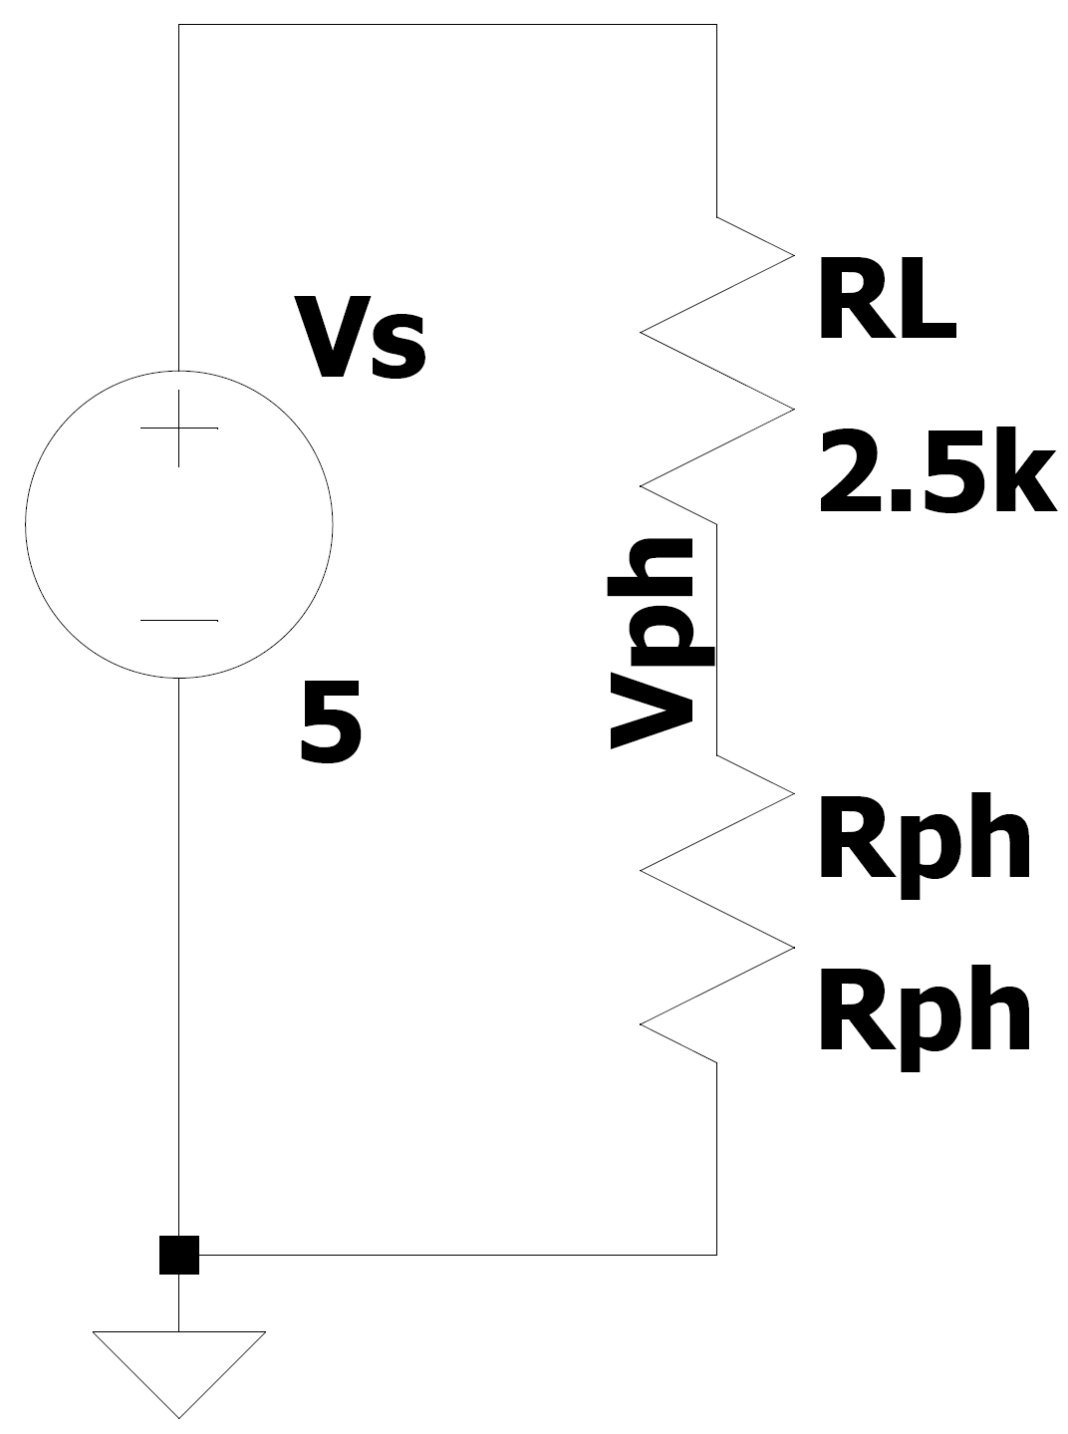
Clearly label all nodes you will reference
Analysis:
Describe clearly how you are applying the concept
We use the voltage divider equation to find the voltage output of the light sensor, Vph:
$$\begin{aligned}V_{ph}=\frac{R_{ph}}{R_{ph}+R_{L}}V_{s} \#\left(1\right)\end{aligned}$$
We want to find the change in Vph for a change in Rph, so we use Eqn. 1 to write:
$$\begin{aligned}ΔV_{ph}=\left(\frac{R_{ph1}}{R_{ph1}+R_{L}}-\frac{R_{ph2}}{R_{ph2}+R_{L}}\right)V_{s} \#\left(2\right)\end{aligned}$$
Where Rph1 and Rph2 are the resistances of the light sensor at two different illumination intensities, in our case they are 1kOhm and 5kOhm respectively. From Eqn. 2, we see that ΔVph is dependent on RL. We try a couple values to see its effect:
RL (Ohm) | ΔVph (V)
100 | 0.36
10k | 1.21

Simulation:
To help us quickly analyze several RL values and verify our calculations above, we simulate our circuit in LTSpice using RL=100, 2.5k, and 10k. This simulation below calculates Vph as Rph is swept from 1k to 5k.
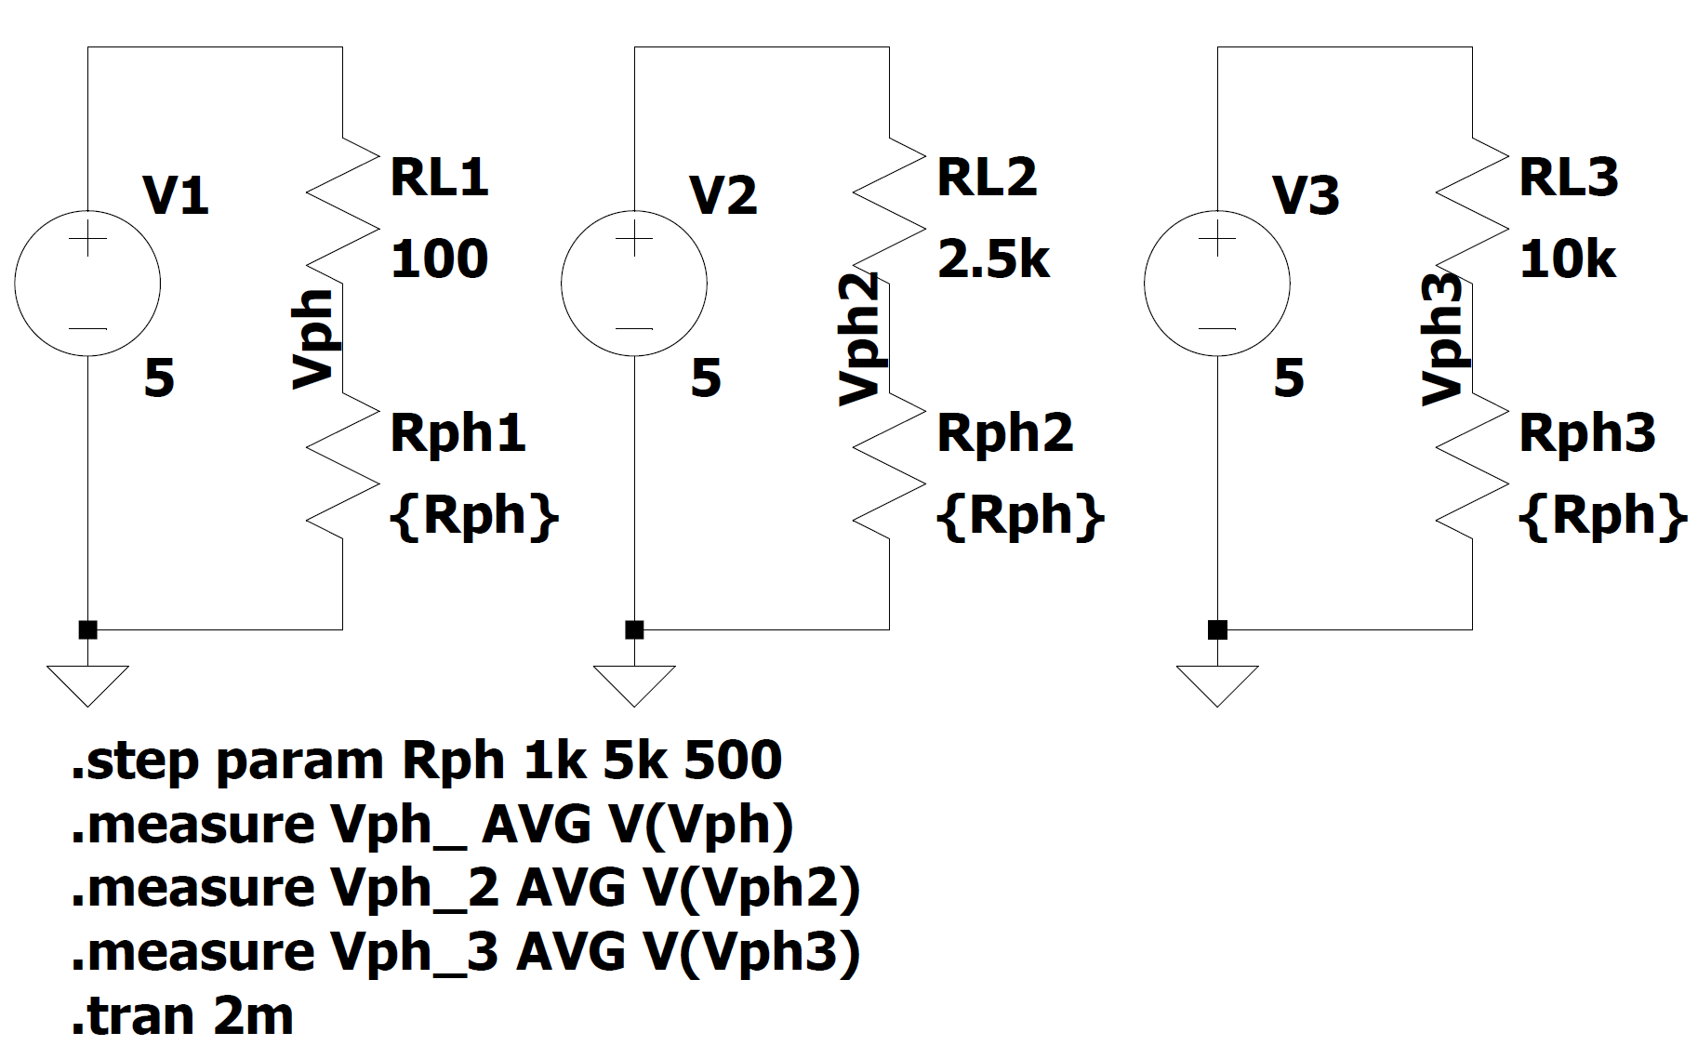
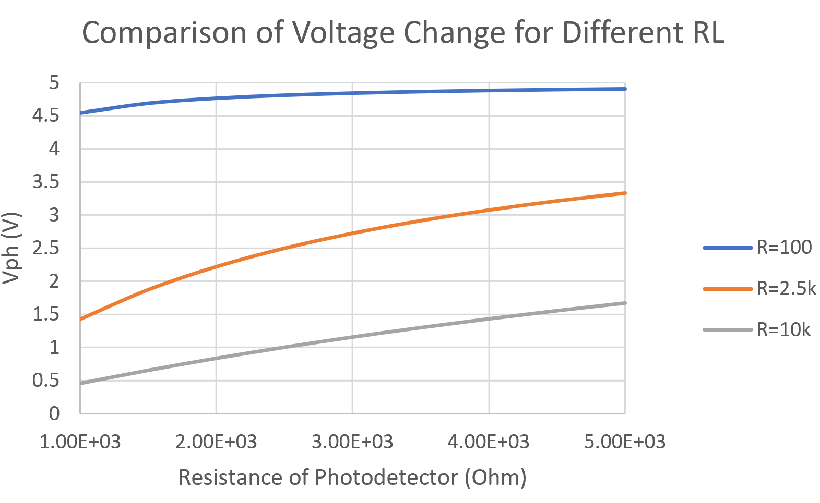
The results of the simulation are exported to Excel and plotted above. The results show that of the three biasing resistors, RL=2.5k results in the highest ΔVph. This is a sufficient output range for our project.
Measurement:
Remember to clearly show all axes in a measurement plot.
We constructed the light sensor circuit with RL=2.5kOhm. We measured the output of the light sensor circuit with approximately 100-150 lux incident which roughly corresponds to the 1k-5kOhm range. The measurement across the light sensor is shown below.
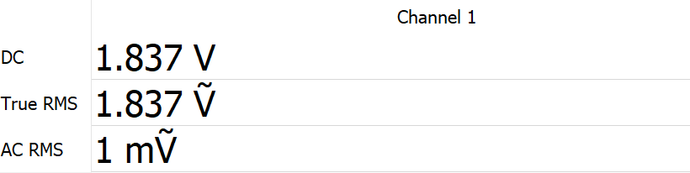
Discussion:
Always include a comparison of calculated, simulated, and measured. Describe how your analysis helped in your design.
RL (Ohm) | ΔVph (Calculated) (V) | ΔVph (Simulated) (V) | ΔVph (Measured) (V)
100 | 0.36 | 0.356 | -
2.5k | - | 1.90 | 1.837
10k | 1.21 | 1.21 | -

The measurement value differs slightly because the light source varied in intensity and the resistor values have some deviation from their expected value. However, the calculated, simulated, and measured values are sufficiently close that we can say that: (1) The light sensor can be accurately represented by a resistor, and (2) the voltage divider equation accurately predicts the output voltage. This analysis helped us determine which resistor to place in series with our photodetector to obtain a large change in output voltage.

Related to Completion of Project Goals
1 | 2 | 3 | 4 | 5 | 6
Preliminary exploration (unsure) | Preliminary exploration may lead to knowledge needed for project | Knowledge gained from concept may be slightly unrelated to project (somewhat unsure of use) | Knowledge gained from concept may be slightly related to project (somewhat sure of use) | Concept is related to project but slight changes depend on final implementation choices | Final concept needed Finish Project

Explain your rating: We have a choice of 5 different light sensors for our project. This is one proof of concept to test its feasibility in for our initial system design. We have multiple resistive sensors for our entire system so using a voltage divider to determine our resistive sensor output is relevant.

Optional Feedback from CE/PE:

Related to Curriculum and Knowledge from Courses
1 | 2 | 3 | 4 | 5 | 6
Definitely not related to anything I’ve learned in my discipline (heavy “Google” searching and online knowledge gained) | I am unsure if this relates to anything I’ve learned in my discipline | Slightly unrelated to something I have learned or am learning in my discipline | Slightly related to something I have learned or am learning in my discipline | Indirectly related to something I have learned or am learning in my discipline (foundation of concept is related) | Directly related to something I have learned or am learning in my discipline

Explain your rating (which topic and which course):
Voltage dividers, Circuits, Electronic Instrumentation
Optional Feedback from CE/PE:

