Experiment 3

**Inductors and Transformers**

**Purpose:** Partly as preparation for the next project and partly to help develop a more complete picture of voltage sources, we will return to considering inductors. The extension we are primarily concerned with is the mutual inductor or transformer. The transformer has three uses: stepping up or down voltages, stepping up or down currents, and transforming impedances. Like other devices we have considered, the transformer does not work in an ideal manner for all circumstances.

Background: Before doing this experiment, students should be able to

* Do a transient (time dependent) simulation of RC, RL and RLC circuits using *LTspice*
* Do an *AC Analysis* (frequency dependent) simulation of RC, RL and RLC circuits using *LTspice*, determining both the magnitude and the phase of input and output voltages.
* Determine the complex transfer function for RC, RL and RLC circuits and simplify for high and low freq.
* Be able to define what is meant by high and low frequencies in the context of RC, RL and RLC circuits.
* Identify whether an RC, RL or RLC circuit is a low-pass, a high-pass, a band-pass or a band-reject filter
* Find the corner frequency for RC and RL circuits and the resonant frequency for RLC circuits.
* Find a practical model for a real inductor and determine the range of frequencies in which the real inductor behaves nearly like an ideal inductor.
* Review the background for the previous experiment.

Learning Outcomes: Students will be able to

* Estimate the inductance of simple magnetic toroid using well-established analytic and empirical formulas.
* Build a simple toroidal inductor using enameled magnet wire and a ferrite magnetic core.
* Estimate the inductance of a toroid inductor by building a resonant RLC circuit and finding the resonant frequency.
* Do a transient (time dependent) simulation of a resistor loaded transformer circuit using *LTspice*
* Do an *AC Analysis* (frequency dependent) simulation of a resistor loaded transformer circuit using *LTspice*.
* Analyze a simple transformer using *LTspice* and demonstrate that it works as designed for some range of frequencies.
* Build a simple transformer from two windings on a toroidal core and demonstrate that it works as designed for some range of frequencies.

Equipment Required:

1. **M2K** (with Scopy)
2. **Oscilloscope** (M2K)
3. **Signal Generator** (M2K)
4. Breadboard
5. Enameled Magnet Wire
6. Ferrite Core & Its Spec Sheet
7. Electrical Tape
8. Sandpaper
9. Misc Resistors & Capacitors

## Helpful links for this experiment can be found on the links page for this course. Be sure to check all of the links provided for Exp 3.

**Pre-Lab**

*Required Reading:* Before beginning the lab, at least one team member must read over and be generally acquainted with this document and the other **required reading** materials listed under [Experiment 3](http://www.ecse.rpi.edu/courses/F21/ENGR-2300/EILinks.html#Exp3) on the EILinks page.

*Hand-Drawn Circuit Diagrams:* Before beginning the lab, hand-drawn circuit diagrams must be prepared for all circuits to be physically built and characterized using your M2K board.

## Part A - Making an Inductor

**Background**

*Calculating inductance:* An inductor consists of a wire of conductive material wound around a (usually) solid object called a core. The inductance of an inductor depends on the material and geometry of both the coil and the core. Inductors have larger values when the core material is a magnetic material like iron. The value of the inductance will also depend on the geometry of the core material. Each physical coil geometry has a unique equation to calculate its inductance. Just for simplicity, we will address only two standard geometries, cylindrical and toroidal cores. This produces the kind of inductors most often used in practice. The ones we have been using are cylinders potted in plastic, so you cannot see what the coil looks like. Search online for solenoid or solenoidal inductor and you will get a better idea of what such coils look like in practice. In some classroom demonstrations in physics, a simple open structure is used so that it is easier to see the geometry. An example of such a coil from Pasco is shown below along with a couple of other inductors like the ones we are using.

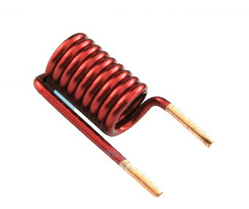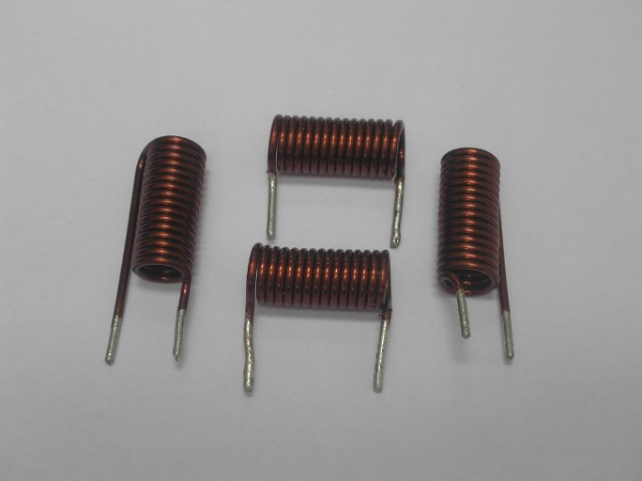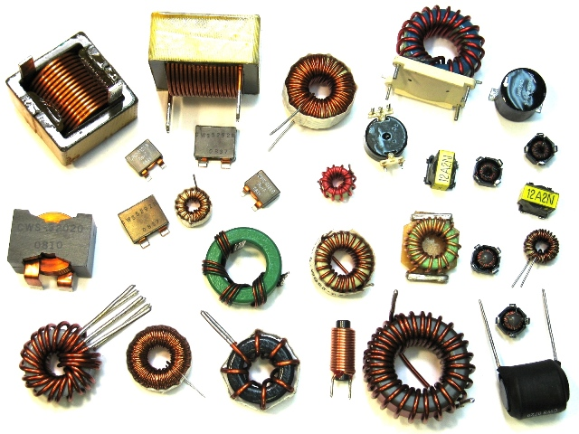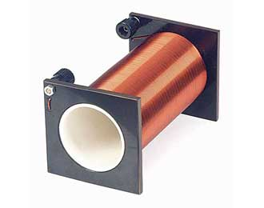

If the core cylinder has a radius equal to rcand we wind a coil *N* times around the cylinder to cover a length d, the inductor will, ideally, have an inductance equal to:

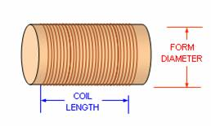

(= 2rc)

(= d)



where *μo* = 4π x 10-7 Henries/meter. If the core is not air, but rather some magnetic material, replace *μo* with *μ* which is usually many times larger than *μo*. By many times we can mean as much as 105 times larger. You should know that this formula only works well when the length *d* is much, much larger than the radius *rc*.

Note that the ideal formula above will not produce a result that agrees exactly with the actual inductance of the coil. They are useful to find ballpark values for inductance only.

A semi-empirical formula was developed by H. A. Wheeler in the 1920s. He was a distinguished electrical engineer who worked at the National Bureau of Standards (now NIST) and Hazeltine Corporation (headquartered in Greenlawn, Long Island and now part of BAE Systems). His formula, accurate to within 1% as long as *d>0.8rc*, gives the inductance in ***µH***, if the ***dimensions are in inches (first expression) or meters (second expression)***.

*µH*  or *µH*

This formula can be found in many places on the internet because it is useful for analyzing RF coils. There are even many calculators for evaluating the expression.

Toroidal inductors have some distinct advantages over cylinders. The magnetic field they produce is better confined to inside the magnetic material which cuts down on interaction between components and also makes transformers work better. A variety of toroidal core inductors are shown below, along with a few cylindrical inductors for reference.



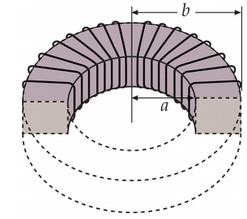Ideally, when the core is air or plastic. Otherwise replace µo with µ for the core material. *hc* is the height of the core material. *a* and *b* are inner and outer radii and are shown in the figure at the right.

It is generally not necessary to apply this formula for commercial cores. The manufacturer knows everything about the core except for the number of windings of wire we choose to add to it. Thus, in the spec sheet for most cores, **manufacturers usually include the inductance factor with typical values like a few µH per N2.** For roughly 30 turns of wire, the inductance will be a few mH. Since the spec sheet for the core used in class has this information, you will use the simpler approach to find the inductance.

*hc*

*Calculating Resistance:* When one makes an inductor, the wires used can have a large variety of cross sectional areas. There are some inductors made with very thick wires, while others are made with very thin wires. Thin wires permit one to wind many more turns of wire around a core and thus increase the inductance. Thick wires have lower resistance for any given length. All wires have a resistance given by the expression*Ω*, where *l* is the length of the wire, *Aw* is the cross sectional area of the wire (thickness), and *σ* is the conductivity of the wire material. For copper, the conductivity is about 6 x 107 Siemens/meter. The unit of Siemens is 1/Ω. Sea water has a conductivity of 5 Siemens/meter. There are many handbooks like the CRC Handbook of Chemistry and Physics that have the resistance of different diameter wires per mile (or another unit of distance). It is also quite easy to calculate the resistance of a piece of wire using the formula above. The links page contains several links to tables with conductivity information. One of the more useful tools for finding information like resistance per unit length of copper wire is the MegaConverter (<http://www.megaconverter.com/mega2/>).

*Other Losses:* Both air and magnetic core inductors have losses due to finite wire resistance. Magnetic cores also have hysteresis loss that occurs because they are magnetized and demagnetized over and over when they experience a sinusoidal current. As a result, higher frequency losses tend to be larger than DC losses. However, we will only be concerned with wire losses in this experiment, except to note when they are insufficient to account for all losses.

**Experiment**

*Build an Inductor*

In this part of our experiment, we will build an inductor and compare its calculated properties to measured properties. The inductor will be wound on a commercial toroidal ferrite core.

* Build an inductor from enameled wire using the following procedure.
  + Use a commercial toroidal ferrite core that came with the RPI components.
  + Again, use 30 – 40” (0.75 – 1m) of enameled wire. Measure and record the wire length.
  + Leave about 2 inches (5 cm) of wire as leads for making connections, and wrap it tightly around your core. Carefully keep track of the number of times you wind the wire around the core. This is the number of turns of your inductor, N. If you have good eyesight, you should also count the number of turns.
  + Secure the windings with tape. Also twist the leads as close to the toroidal core as you can.
  + Using sandpaper, remove some of the enamel from the ends of the wire (0.25 to 0.5 inch). The enamel is the insulation for this type of wire, so you cannot make electrical contact unless it is removed. There should be some sandpaper with the RPI components or you can use a knife. Use the plastic squares, DO NOT SAND ON THE TABLE TOPS.
* Calculate the properties of the inductor
  + 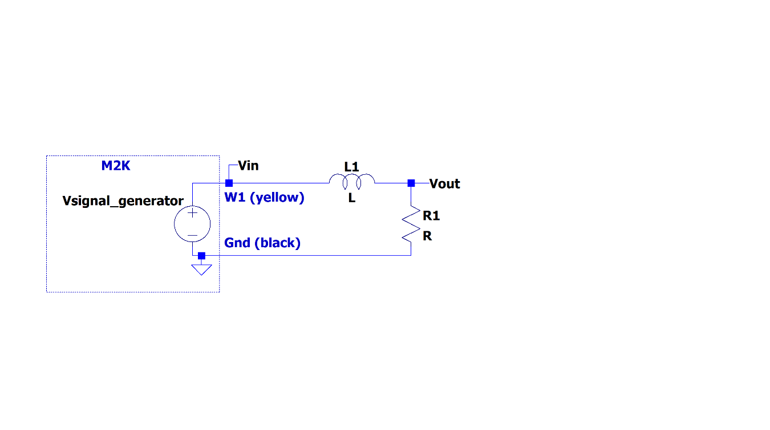Calculate the inductance of your inductor using the inductance parameter from the ferrite core spec sheet. See page 3 of this document.

For Spring 2023 the core has an inductance factor of 10.7 µH.

* Determine the inductance of the inductor using RL circuits
  + Build the RL circuit shown. This is very similar to the circuits we studied in Experiment 2. For this circuit, use a 100Ω resistor. When connecting your inductor, make sure the wire ends are sanded so that the copper is exposed. It may be necessary to sand the wire again since oxidation and/or carbonization can form a small layer on the surface of your wire. A more reliable connection can be made using alligator clips: clip one end of the alligator clip to one end of your inductor wire and the other end to a wire that is already inserted into your breadboard.
  + Set the Signal Generator, W1, to a 500mV amplitude sinusoid at a low frequency, 500Hz for this circuit.
  + Measure the both the input and output voltages at this frequency. The ratio should be close to 1.
  + Increase the frequency until the amplitude of the voltage across the resistor is 0.707 times the amplitude of the input voltage (the corner frequency from Laboratory 2).
  + This frequency relates to the RL circuit as, . Use this expression and your experimental result to determine the inductance.
  + Measure the inductance and resistance of the coil and compare that to the estimates above. Use the multimeter and the RLC meter on the center table.
  + How do the results compare to your calculated value(s)?

**Summary**

We can get an approximate expression for the inductance using an equation for an ideal model based on the geometry of the inductor and the materials from which it is made. The ideal model of the cylindrical inductor will generally over-estimate the inductance. We can get a larger inductance and also a more predictable inductance by winding the coil around a piece of iron or other magnetic material rather than something like a plastic tube. The permeability of iron is many times larger than that of air. We can also use an equation to estimate resistance.

**Part B - Measurement of Inductance**

**Background**

*Using LC circuits to estimate inductance:* Now we will use a different experimental method to estimate the coil inductance. In the circuit of Figure B-1, V1 is the M2K Signal Generator. R is a resistor added to both limit and measure the current from the signal generator. L is the inductance of the coil to be measured. C is a known capacitor chosen to make L easy to determine. D is a diode used to direct current toward the inductor and to shut off current when the source voltage goes negative so that the inductor can send its energy to the capacitor.

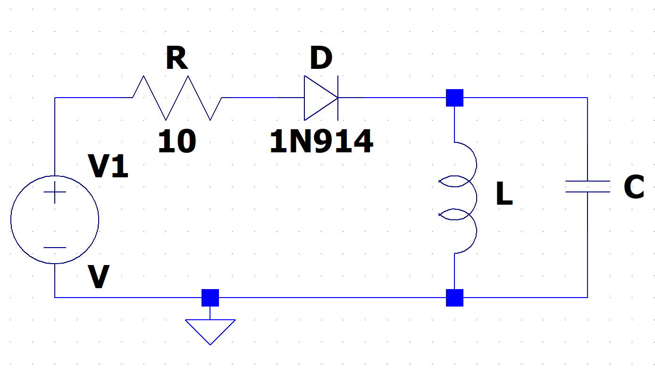

**Figure B-1. Note: the signal generator on the M2k has a 50Ω output resistance.**

Capacitors and inductors are both energy storage devices so that when they are connected together, they will trade energy back and forth at a characteristic frequency. They form a harmonic oscillator just like a spring-mass system that trades kinetic for potential energy (and vice versa) at a characteristic frequency. For an LC circuit, this frequency is given by the expression. Thus, if we can observe the decaying sinusoidal voltage across the capacitor and inductor and determine its frequency, we can determine L from our knowledge of C. To do this measurement and model the behavior of the inductor using *LTspice*, we have to modify the ideal circuit as shown below in Figure B-2.

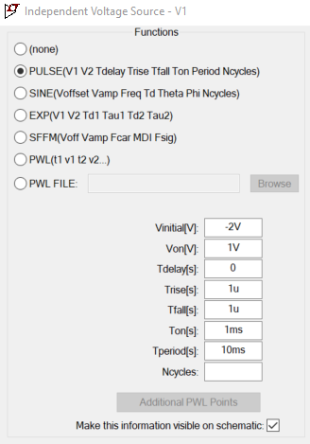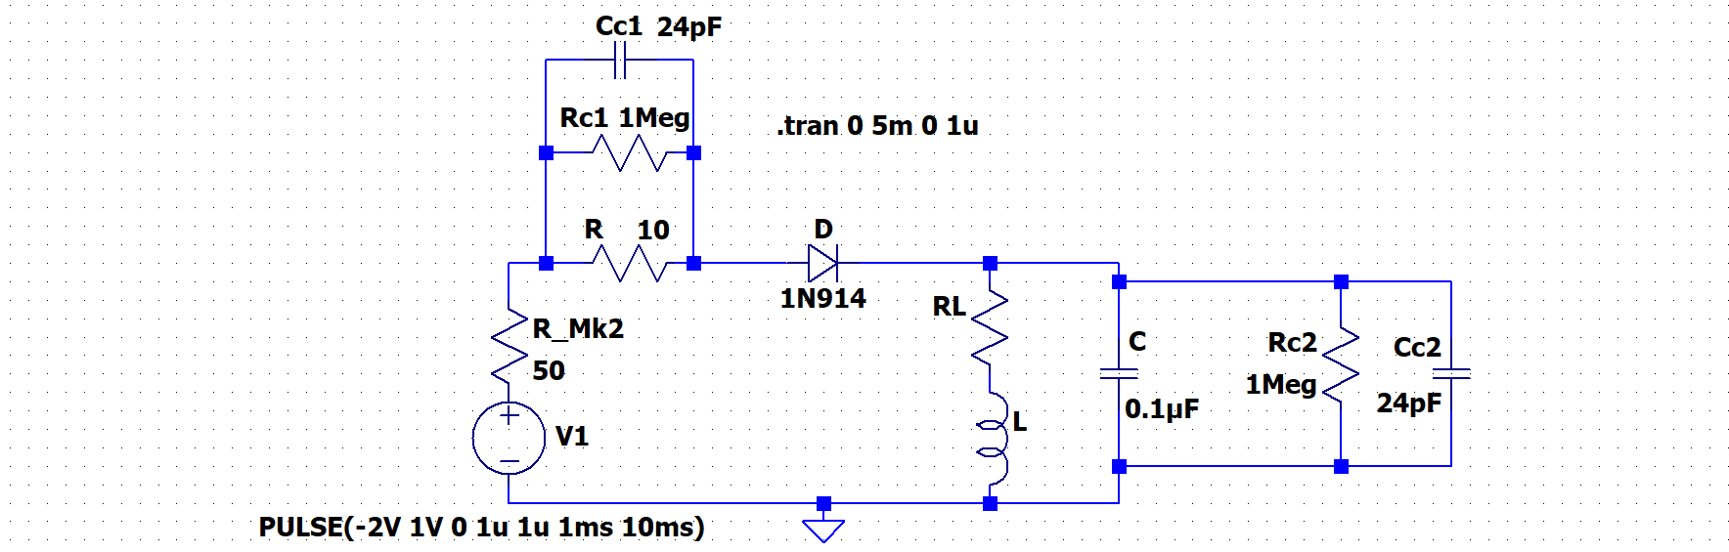

**Channel 2**

**Channel 1**

**Current-Limiting R**

**Inductor Model**

**Figure B-2.**

Inductors have finite resistance, so we have to add a resistor RL to our model of the inductor. The M2K Signal Generator can only deliver a limited amount of current or power to a load. Since the resistance of our coil is small, we have to add a resistor R to limit the current from the Signal Generator but this also allows a measurement of that current. Circuit components (Rc and Cc) representing the two analog input channels on M2K are also included for completeness. For this circuit, you are to use C = 0.1µF because it is one of the larger capacitors you have that is not electrolytic. Electrolytic capacitors usually have a relatively large ESR = equivalent series resistance, which can damp the decaying sinusoid out so fast you cannot easily read the oscillation frequency. R is chosen to be 10Ω. **You will adjust the amplitude of the signal generator so that the current from the signal generator is between 15mA and 25mA, less that the limit of 50mA**.

*Note: we will not study diodes until near the end of the semester. However, you will need to know one thing about diodes to answer this question. For the diode to turn on and conduct current, the voltage applied must exceed a value called the Forward Voltage. For the 1N914, VF is about 0.7V. Thus, when the diode is ON, the forward voltage applied to the circuit will not all appear across the remaining circuit components. Rather the voltage available will be V1 – 0.7V. The amplitude of V1 must be chosen to handle the possibility that the load (here L in parallel with C) may go to zero, because the impedance of C goes to zero at high frequencies and the impedance of L goes to RL (usually very small) at low frequencies. You now have enough information and can adjust V1.*

The inductor will have a positive imaginary impedance given by jωL while the capacitor will have a negative imaginary impedance given by  or equivalently. If we redraw our circuit at low and high frequencies, we can see that at both extremes, the output voltage will be small. At low frequencies, the inductor is nearly a short to ground. At high frequencies, the capacitor is a low impedance path to ground. At the resonant frequency,, the parallel combination of an ideal inductor and a capacitor has an infinite impedance. Real L’s and C’s have losses so the actual impedance is finite, but the magnitude of the impedance peaks at or near the resonant frequency. We can measure the resonant frequency and use this equation to solve for L.

**Experiment**

*The Resonant Frequency of a Circuit can be used to Find Inductance*

In this experiment, we will build an RLC circuit, find its resonant frequency, and use it to solve for an unknown inductance.

* Find the values for the actual components in your circuit.
  + Write down the mathematical values you calculated for the inductance in part A. We will call this inductance Lc. (Remember that we are treating the inductance as unknown, so we *cannot* use the inductance measured previously.)
  + Calculate an estimate for the resonant frequency,, using the capacitance you measured and the inductance you calculated.
* Find the experimental resonant frequency for the inductor you have built.
  + Set up the circuit in Figure B-1 on your Protoboard, but be sure that you include the 10Ω current limiting resistor R. Use the capacitor value and your DIY inductor. Use the 1N914 diodes in your parts kit (don’t lose it, you will need all four later in the course). Be careful to make sure that the inductor is making contact with the protoboard. Bad connections can be a common problem.
  + In Scopy: Set your Signal Generator output to a square wave, start with a 3Vp-p amplitude and an offset of -1V. **You will need to adjust the amplitude but keep the offset at -1V.** Set the frequency to be 200Hz. Observe the voltage across resistor R on Oscilloscope channel 1 and the voltage across the capacitor and inductor on Oscilloscope channel 2. Note that your channel 1 measurement is differential and not referenced to ground. Create a math channel to show the current by using channel 1 and the fact that the resistance is 10Ω. This math channel is the current through R.
  + **Adjust the amplitude of the Signal Generator to get the peak current through R to be approximately one-half the maximum, around 15-25mA. Keep the offset of the function generator at -1V.**
  + Triggering the oscilloscope in Scopy: Try setting the trigger to channel 1, falling edge, 0mV
  + After finding the appropriate voltage amplitude, when you observe a clear decaying sinusoidal voltage, determine the frequency of the signal. Calculate the frequency of the decaying sinusoid by counting cycles in a time window or by measuring the time between zero crossings. Don’t trust a frequency measurement from Scopy.
  + Save a picture of the measured current through R and the voltage across L & C.
  + What was the amplitude value of the signal generator that you use and what was the resulting current though R? Include this in your report.
* Calculate an estimate for the unknown inductance, Lest, using the equation . Use the exact resonant frequency you identified and the capacitance (used the measured value of C if you have access to the impedance bridge.) What value did you obtain for your unknown inductance? How close is this to the one you measured using the LR circuit on page 4? Include in-class measurement using the impedance bridge if you have access. Is it closer than the estimate you found using the inductance equations?

***Use a Simulation to get the Best Estimate of the Unknown Inductances***

In this part of the experiment we will use *LTspice* to simulate the circuit we built and get the closest estimate we can to the actual inductance and resistance for the inductor.

LTspice: The diode: Select the diode on the tool bar.

Place on schematic and right click on the diode. “Pick New Diode” and choose the diode of interest, use 1N914.

V1: V1 is a pulse source as shown will have Vinitial= -2V, Von=1V, Tdelay=0, Trise=1us, Tfall=1us, Ton=1ms, Tperiod=10ms. RL and L are the model of the inductor. Cc1 and Rc1 model the input R and C for channel one of the instrumentation board, Cc2 and Rc2 model channel 2. C=0.1uF. R_Mk2 represents the internal resistance of the signal generator of the M2k, which is 50Ω.  
Right click on V1 and select PULSE. **You must change the values of Vinitial and Von to match what you used in the experiment. What were the voltages as shown in the signal generator window in Scopy?**

* Simulate the circuit in Figure B-2 in *LTspice*. This is the same circuit as the one pictured in B-1 but the inductor (because it *does not* have an insignificant internal resistance) is more accurately simulated by two components, an inductor and a resistor. Components representing the Oscilloscope are also included, as is the internal resistance of the signal generator of the M2k.
  + Recall that inductors do not have negligible resistance. Therefore, in the *LTspice* model, the inductor you built looks like an inductor and a resistor in series. Use the value you calculated for the resistance of the inductor for RL and the inductance that you just calculated (Lest, above) for L.
  + Create a transient simulation that will duplicate what you measured with M2K. Adjust RL and possibly also L to obtain the best possible agreement.
* When you have found good values for RL and L, print out the plot of the simulation. Fully annotate your plot.

**Summary**

In this experiment, you have found an estimate for the impedance of the inductor you built by placing it into a circuit. By finding the resonant frequency of the circuit, you were able to find an estimate for L in two ways: by calculating it using the equation for resonant frequency and by simulating the circuit in *LTspice* and choosing the inductance and resistance values such that the resonant frequency and sinusoidal voltage decay matched observed experimentally. How do these values compare to the inductance estimates from the LR circuits on page 4 and to the R and L measured using the impedance bridge and multimeter?

**Part C - Transformers**

**Background**

*Inducing a current*: Inductors work by creating a magnetic field. When you run a current through an inductor it becomes an electromagnet. The direction of the magnetic field can be found by placing your right hand around the core in the direction of the coil. Your thumb will point in the direction of the magnetic field, as shown in Figure C-1.

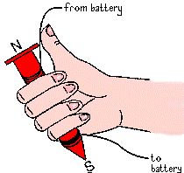

**Figure C-1.**

If one inductor is placed near another inductor, then the magnetic fields of the two inductors will interact with one another. If you have ever built an electromagnet, you will know that the magnets will attract or repel one another if the current in the coil is large enough. Even when we cannot sense that they are interacting, a current in one coil will induce a current in a nearby coil.

*Transformers:* A transformer is a device that takes advantage of the fact that one inductor can induce a current in another inductor. We use it to transform one voltage level into another. A “step up” transformer will make a small voltage larger and a “step down” transformer will make a large voltage smaller. We make transformers by winding coils of wire around some kind of a core material. Sometimes the core material is just air, as when we wind the wire around a plastic tube, for example. Most of the time, the core material is iron or some other magnetic material. To maximize this interaction, we usually wind the coils onto the same core and make them look as similar as possible.

In the transformer circuit in Figure C-2, the voltage source (VS) and the 50Ω resistor (RS) represent a sinusoidal voltage source like a standard Signal Generator. (The internal resistance of the M2K Signal Generator is zero so we have added the 50Ω resistor to see how a standard and much more expensive Signal Generator behaves.) RL is the load on the transformer represented by a single resistance and TX1 is the transformer. The primary (or source) inductor in the transformer, LS, draws a current from the source. The magnetic field created by LS induces a current in the secondary (or load) inductor, LL. This creates a new voltage to power the load, RL.

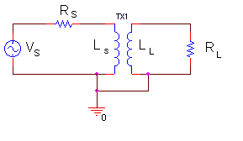

**Figure C-2.**

Transformers only work for time varying currents and voltages. Note that when the coils are as similar as possible, all the geometric terms in the formulas for the inductance will be the same for the primary and the secondary coils. Only the number of turns will be different. We can demonstrate this using our equation for the inductance of a long, thin coil.



Note that we will use *L1*= *LS* and *L2 = LL* interchangeably. Since we try to make μo*, rc* and *d* the same, these terms cancel out and the ratio of the inductances depends only upon the ratio of the number of turns squared.

*Transformer analysis:* To analyze just how a transformer works, we have to add an additional kind of inductance, called mutual inductance. If a coil of wire of inductance *L1* is very near another coil of inductance *L2*, there will be a mutual inductance *M* between the two coils, where *M2 = k2L1L2*. The constant k is the coupling coefficient. If the coils are perfectly coupled, *k = 1*. Usually *k* is a little less than *1* in a good transformer.

Referring to Figure C-2, the two loop or mesh equations that apply to the two current loops in the transformer circuit are



where *LS* is the inductance of the primary (source) coil and *LL* is the inductance of the secondary (load) coil. By convention, the coil connected to the source is called the primary coil and the coil connected to the load is called the secondary coil. The *L* and *M* terms have opposite signs because the loop currents go in opposite directions. Thus, the voltage generated by one coil will influence the other in the opposite direction. The input impedance is the impedance across the primary coil, *LS*. Since *V = IZ* and the current through all the elements in the primary coil is *IS*



(Note that *Rs* and *Zin* form a voltage divider.) We can solve the primary loop equation for Zin by solving for *(VS/IS)-RS*



If we solve the secondary loop equation for *IL/IS*, we can then substitute for this ratio in the equation above:



We know that by definition, *M2 = k2LSLL*, and for an ideal transformer, the coupling constant *k = 1*, so



Now, let both *LS* and *LL* or *ω* become very large (tend to infinity). The *RL* term in the denominator will drop out and



If we define a constant, *a*, that has the following property: *LL = a2 LS*, then

*Zin = RL/a2*

Thus, the transformer transforms the load resistance *RL* by the square of the turns ratio, *a = NL/NS* where *NS* is the number of turns in the primary coil and *NL* is the number of turns in the secondary coil. This is the first, and most stringent, relationship for an ideal transformer. Remember that *Zin* is the ratio of the input voltage to the input current. In any circuit that we build or simulate, we can determine *Zin* by finding this ratio.

The relationship between the primary and secondary currents in the transformer can be found from the second loop equation. Solving again for the case where the inductances become very large, we find that



Note that both the voltage and current relationships shown contain no sign information. Depending on how the transformer is wired, it is possible for minus signs to appear in these expressions. Thus, you should consider that they hold only for magnitudes. As with *Zin*, we can determine these ratios by measuring the voltages and currents separately and then taking their ratios. When we design a particular transformer, we usually have a turns ratio in mind. For example, in the DC power supplies that come with consumer electronics (also called wall warts), there is a step-down transformer that takes the *120Volt* line voltage and steps it down to a smaller voltage, like *6 or 12Volts*. In such devices, *NS/NL* is chosen to be *10* or *20*, depending upon the desired output voltage. This voltage is then rectified with a full-wave rectifier and sometimes regulated with a Zener diode to produce a DC voltage. You will learn more about rectifiers and Zener diodes later in this course.

*Working range of a transformer*: Although the equations for transformer behavior are quite simple, many assumptions need to be made in order to satisfy them. A transformer will not behave in a circuit according to the equations for all frequencies or load resistances. **In order for a transformer to be working properly, the following expressions must all be satisfied.** When *a*2 = *LL/LS* :



**Experiment**

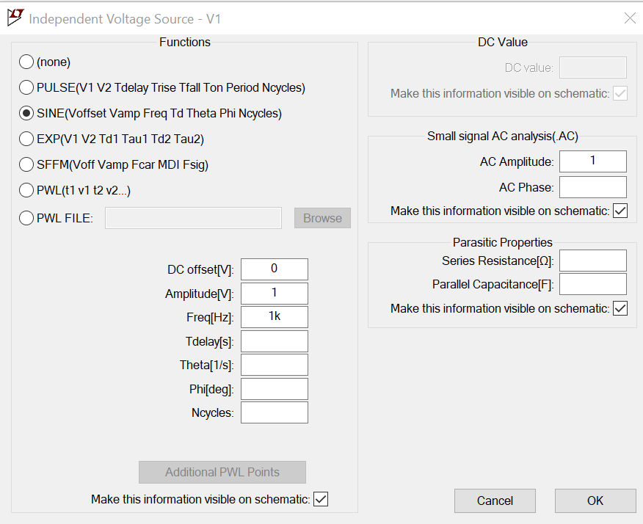*Simulation of a Transformer*

In this section, we will use *LTspice* to create a transformer circuit and find the input frequencies where it behaves according to the transformer equations.

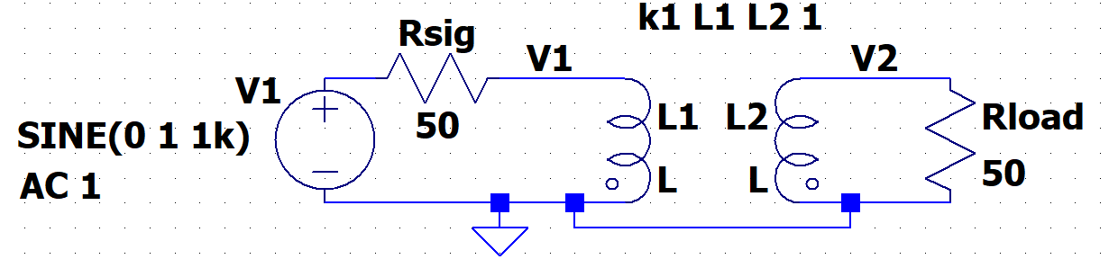

**Figure C-3.**

* Set up the circuit pictured in Figure C-3 in *LTspice*.
  + For the voltage source is still “voltage”. Right click on the symbol, Advanced, Sine … Be sure to include the AC Amplitude.
  + To create the transformer:

**Figure C-4.**

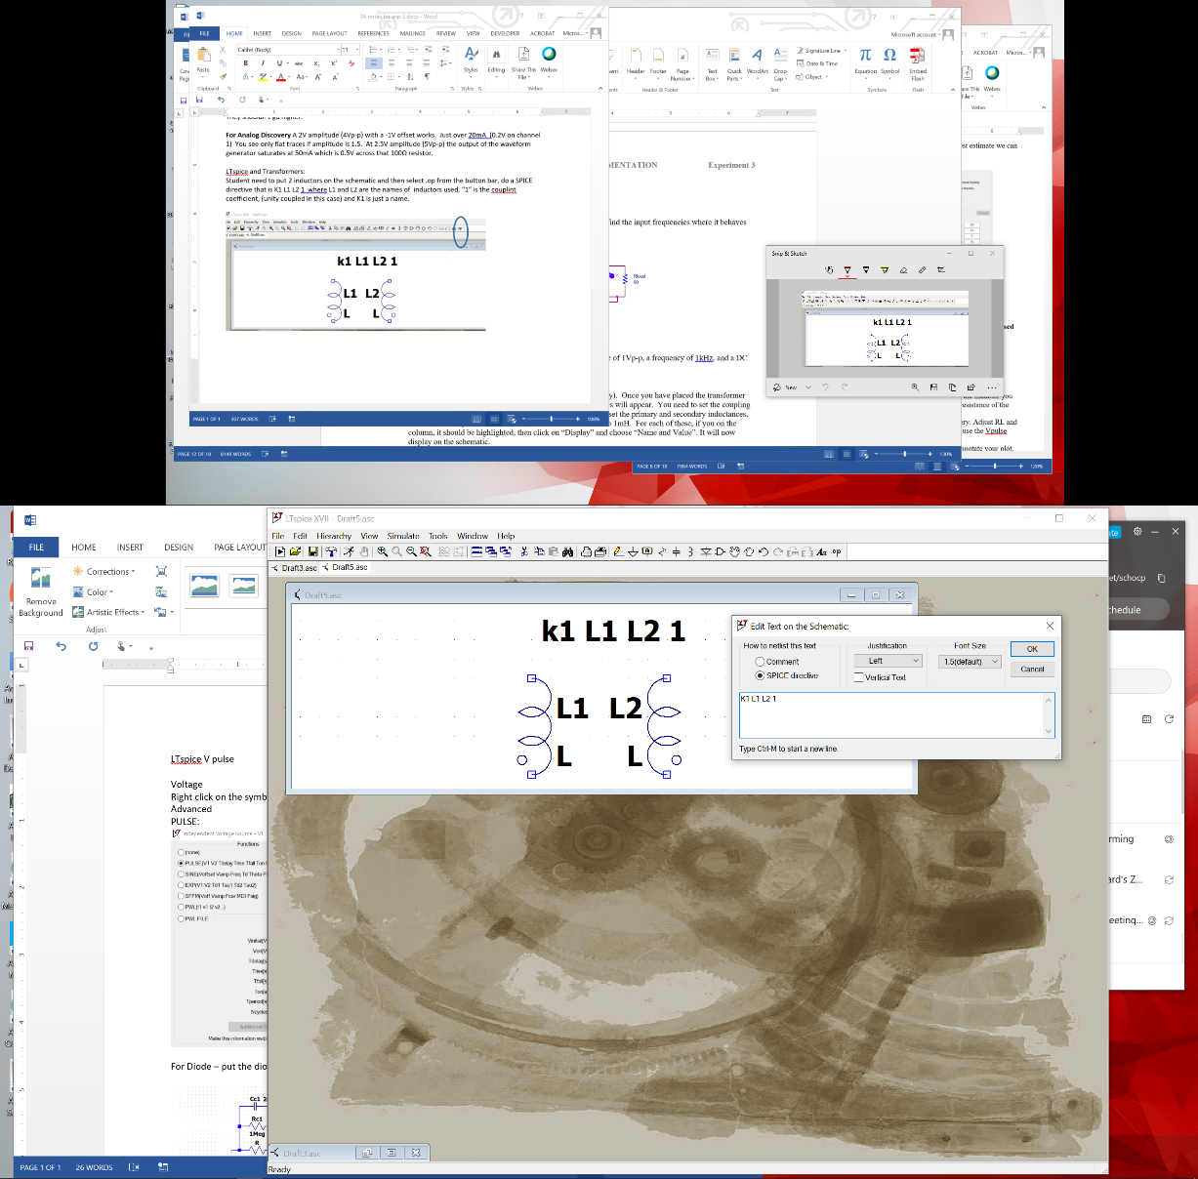

* + - Place two inductors on the schematic
    - Click on the .op button
    - Type K1 L1 L2 1
  + K1 is any name you want.
  + “1” is he coupling coefficient. Real values range from 0 (no magnetic coupling) to 1 (fully coupled.)
  + Rsig represent the resistance of the signal source and must be included for the simulation to work.
  + Set the load resistance, Rload, to 50Ω.
  + For your first simulation, set the inductance of L1 to 4mH and for L2 to 1mH.
  + Perform an *AC Analysis* from 1Hz to 1MegHz. Plot V1 and V2. To simplify the plot you can right click on the right vertical axis, the phase, and say to not plot the phase.
* LTspice allows us to mathematically manipulate traces. With LTspice running, click on Help > Help topics.
  + A document will open, expand LTscpice XVII, expand Waveform Viewer, and select Waveform Arithmetic. You should see something like figure C-5. 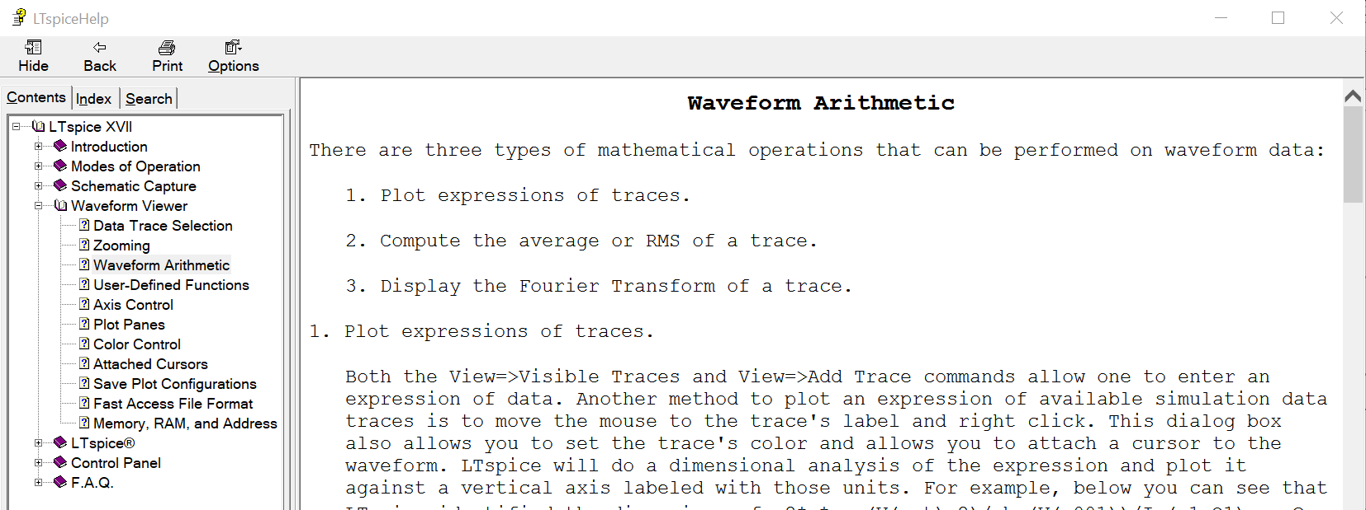

**Figure C-5.**

* + Explore the functions and options available in LTspice. You will use sqrt() next.
* In order to determine when the transformer is working correctly, we need to determine the frequencies where the relationships for Zin, V and I are satisfied. Recall this means that V2/V1and I1/I2must be equal to a constant, *a*. To find where our transformer works, we can plot the three relationships and determine where all three are satisfied. To avoid dividing by zero current, we will plot 1/*a*.
  + Find the constant, *a*, using the ratio of √L2 to √L1. Remember that the ratio of N2to N1 is determined from the ratio of the square roots of L2 and L1.
  + Add a trace of V1/V2, where V1 is the voltage across the primary coil and V2 is the voltage across the secondary coil. *If you have labeled your schematic as is shown in fig C-3 this will be V(v1)/V(v2).*
    - Plot Settings > Add trace > type in the expression
  + Add a trace of I2/I1, where I2 is the current through the secondary load resistor and I1 is the current through the resistor in the primary loop. Because *LTspice* is picky about polarities, this ratio may be negative. If it is negative multiply it by -1 or take the abs().
  + For the third criteria, we must solve Zin = Rload/*a*2 for 1/*a*. This means 1/*a* must be equal to sqrt(Zin/Rload). Zin is the impedance of the primary inductor, L1. It is equal to the voltage across L1 (V1 in Fig C-3) divided by the current in the source loop, for example I(L1). Therefore, to plot 1/*a*, we must plot sqrt(V(v1) /I(L1)). Add a trace of 1/*a*= sqrt(Zin/Rload)=SQRT((V(v1) /I(L1))/50).
  + Save one plot with all three ratios. Mark the frequency range where all three criteria are satisfied on the plot. You choose the criteria for “satisfied”, it could be “within 5%” or maybe “within 2%”.
* By trying a variety of values for L1 and L2, find a transformer for which the three relationships are satisfied and *a*=10 (1/*a*=1/10). In this case, the voltage across the primary coil will be 1/10 the voltage across the secondary coil and the other two expressions will also be satisfied. *Use the smallest possible inductances you need to make the transformer work properly at 1kHz and above.*  (To change the effective frequency, you must increase or decrease both L1 and L2, while keeping the ratio of the square roots the same (1/10).) Write down the values for L1 and L2 that you have selected and save your plot with the three ratios that demonstrate that the transformer works as specified.
* Now repeat the task of the last paragraph for frequencies of 100Hz and up. Write down the values for L1 and L2 that you have selected and save your plot with the three ratios that demonstrate that the transformer works as specified. What design advantages exist for circuits that are to work at higher frequencies rather than lower frequencies?

**Summary**

In this section you learned that the behavior of transformers is governed by simple proportions. However, real transformers only conform to those simple ratios under certain conditions.

## Part D - Making a Transformer

**Background**

*Designing a transformer:* To design a transformer for which the output voltage is the same as the input voltage, we must have the same number of turns on our output coil as on our input coil. Here we will design a transformer where the output voltage is half the input voltage. We must also find a range of frequencies for which our transformer actually works as it should. Since you already have one coil, the addition of a second coil will result in a configuration that can be used as a transformer.

**Experiment**

*Build a Transformer*

**Make a transformer by winding a second coil directly over the ferrite core inductor you built.**

* Wind a second coil on your ferrite toroid with *about* ½ as many turns as your first coil, using a wire that is about half as long. Record the wire length used and the number of turns. If we had used a coil wound on a plastic tube, we would only get decent coupling if the additional (secondary) coil’s geometry was as similar as possible to original (primary) coil’s. Because it would have an air core (with a very low permeability), it would be necessary to *wind the second coil directly on top of the first coil* and the lengths of the primary and secondary coils would have to be the same. *The good news for us is that, for the ferrite toroid, the primary and secondary coils can be located anywhere.* Once you get your transformer to work, you should try to move the coils around a bit to see if anything significant happens.
* As with your first coils, twist the leads on your secondary coil, so that you know how to hook the transformer up.
* Remove enamel from the ends of your second coil so you can make good electrical contact.
* You have now built a transformer where one of your coils is the primary and one is the secondary.
* Calculate the value of *a* using the number of turns in the two coils. How should this value affect the magnitude of your output voltage relative to your input voltage?
* Measure the inductance of your secondary coil with the impedance bridge.

*Find a Frequency Where your Transformer Works*

We know from our *LTspice* simulation that this transformer will only work at certain frequencies.

* Hook one of your two inductors to the Signal Generator, W1. Put a 47Ω resistor in series with the Signal Generator. This will be used to infer the current in the primary coil. It also limits the current draw at low frequencies. Set the amplitude of the Signal Generator to 0.5Vp-p. Connect the other inductor to a load resistance of 47Ω. (50Ω isn’t a standard value.) Note that the transformer wires don’t always contact well with the protoboard.
* Set the Signal Generator to 1kHz. Look at the ratio of the Vsecondary to Vprimary as was done for the simulation. Record this ratio is may be of use for the questions. Note that from the simulation that the ratio of voltage held up even at low frequencies. So it isn’t a good indicator of if the transformer is near ideal or not.

To get a better measure of how idea the transformer is working we will infer the primary and secondary currents by putting channel 1 across R1 and channel 2 across Rload. As shown in the figure below:

**Figure D-1.**

* The current in the primary can be determined by measuring the voltage across R1 and dividing by 47Ω. The current in the secondary can be done the same way by measuring the voltage across Rload and dividing by 47Ω. The ratio of Isecondary to Iprimary can then be determine by the ratio of V(Rload)/V(R1) since R1 and Rload have the same value.
* Set the Signal Generator to each of these frequencies: 500Hz, 2kHz, 5kHz, 10kHz, 20kHz and 50kHz. At each frequency determine the ratio of V(Rload)/V(R1). Include these ratios in your report as the ratio of the currents.
* Keep the plot for 10kHz*. Include this plot in your report.*
* Your turns ratio won’t be exact and the coupling isn’t perfect, so don’t expect to see ideal results.

*When you are done with the transformer, save the parts. You will be reusing the wire in Project 1 to wind coils for the Beakman’s motor. The left over copper wire will be recycled and the ferrite cores are to be returned if practical.*

**Summary**

In a transformer, the time-varying field is produced by an electromagnet with a time-varying current in it (coil #1) and sensed by a similar coil (coil #2). As far as a stationary coil is concerned, it is not possible to tell whether the time-varying magnetic field is produced by a stationary electromagnet or a moving permanent magnet, as long as the field produced oscillates in time. The time-varying magnetic field generates a voltage and current in the second coil. This is the basic principle of electrical generators. Electrical motors are mostly just generators run backwards. In the next project, we will build a motor using a permanent magnet and a coil like the ones you have just wound. You should recall the analysis done here when you do the project so you will be able to figure out the resistance and inductance of your motor coil.

**Checklist and Conclusions**

# The following should be included in your experimental checklist. Everything should be labeled and easy to find. Partial credit will be deducted for poor labeling or unclear presentation. ALL PLOTS SHOULD INDICATE WHICH TRACE CORRESPONDS TO THE SIGNAL AT WHICH POINT.

# Hand-Drawn Circuit Diagrams for all circuits that are to be analyzed using *LTspice* or physically built and characterized using your M2K board.

## Part A (12 points)

Answer the following questions:

1. What value did you calculate for the resistance of the inductor? How did this compare to the measured resistance, (only if you can make measurements)? (4 pt)
2. What value did you calculate for the inductance of the inductor? How did this compare to the measured inductance? (8 pt)

## Part B (30 points)

Include the following plots:

1. M2K plots of the input voltage, the current through resistor R and LC voltage of the RLC circuit. (4 pt)
2. *LTspice* plot of the transient response of your RLC circuit with the values of L and R that produce results close to those observed in the experiment. Plot the same parameters as above. (4 pt)

Answer the following questions:

1. What amplitude did you set for the function generator and what was the current through R? (2 pt)
2. What are the measured values for the capacitance of your capacitor C and the resistance of your resistor R? (2 pt)
3. What is your best estimate for Lest from part A? (2 pt)
4. What did you calculate for the expected resonant frequency of your circuit? (Please show what values you substituted into the equation.) (2 pt)
5. At what frequency did you actually measure the resonance of your circuit? (2 pt)
6. What value did you get for Lest using the measured resonant frequency? (Please show what values you substituted into the equation.) (4 pt)
7. What value of L did you get when you adjusted your *LTspice* circuit to match the experimental response of the circuit you built? (4 pt)
8. List all values you have found for your inductor. Based on these what do you think is the best estimate and why? Include the impedance bridge values. (4 pt)

## Part C (16 points)

Include the following plots:

1. *LTspice* plot of the initial 3 traces of the ratios for the transformer when L1 = 4mH and L2 = 1mH. (2 pt)
2. *LTspice* plot of the three ratios that prove the transformer works at 1kHz and up. (2 pt)
3. *LTspice* plot of the three ratios that prove the transformer works at 100Hz and up. (2 pt)

Answer the following questions:

1. In what frequency range did the original transformer function as it should? (2 pt)
2. Use your output traces and the three design criteria equations to describe how you know these values satisfy the criteria for an ideal transformer. (2 pt)
3. What are the values of L1 and L2 you chose to obtain correct transformer operation for the range of 1kHz and up? (2 pt)
4. What are the values of L1 and L2 you chose to obtain correct transformer operation for the range of 100Hz and up? (2 pt)
5. What design advantages exist for circuits that are to work at higher frequencies rather than at lower frequencies? (2 pt)

## Part D (14 points)

Include the following plot:

1. M2K plot with the R1 and Rload voltages of your transformers at 10kHz. (4 pt)

Answer the following questions:

1. What is the inductance of your secondary coil? Use measurement if available, if not estimate based on the primary coil inductance (Part B) and the turns ratio of your transformer. The best experimental turns ratio is the ratio of Vsecondary to Vprimary, (2 pt)
2. What is the value of *a* for your transformer? (2 pt)
3. List the ratio of the secondary (load side) current to the primary (source side) current in your transformer at the frequencies requested? Since both resistors have the same value this is equal to V(Rload)/V(R1). (3pts)
4. At what frequency did your transformers work as expected? How do you know this? To answer this question, you will need to analyze the signals observed and show how closely they satisfy the basic formulas for the transformer. (3 pt)

## Other (8 points)

1. Are all plots and figures included, labeled and are they placed in a logical order. Can they be fully understood without reading the associated text? (8 pt)

**List group member *responsibilities*. (0 to -4pts)** Note that this is a list of *responsibilities*, not a list of what each partner did. It is very important that you divide the responsibility for each aspect of the experiment so that it is clear who will make sure that it is completed. Responsibilities include, but are not limited to, reading the full write up before the first class; collecting all information and writing the report; building circuits and collecting data (i.e. doing the experiment); setting up and running the simulations; comparing the theory, experiment and simulation to develop the practical model of whatever system is being addressed, etc~~.~~

**Summary/Overview** (0 to -10 pts) There are two parts to this section, both of which require revisiting everything done on this experiment and addressing broad issues. Grading for this section works a bit differently in that the overall report grade will be reduced if the responses are not satisfactory.

1. 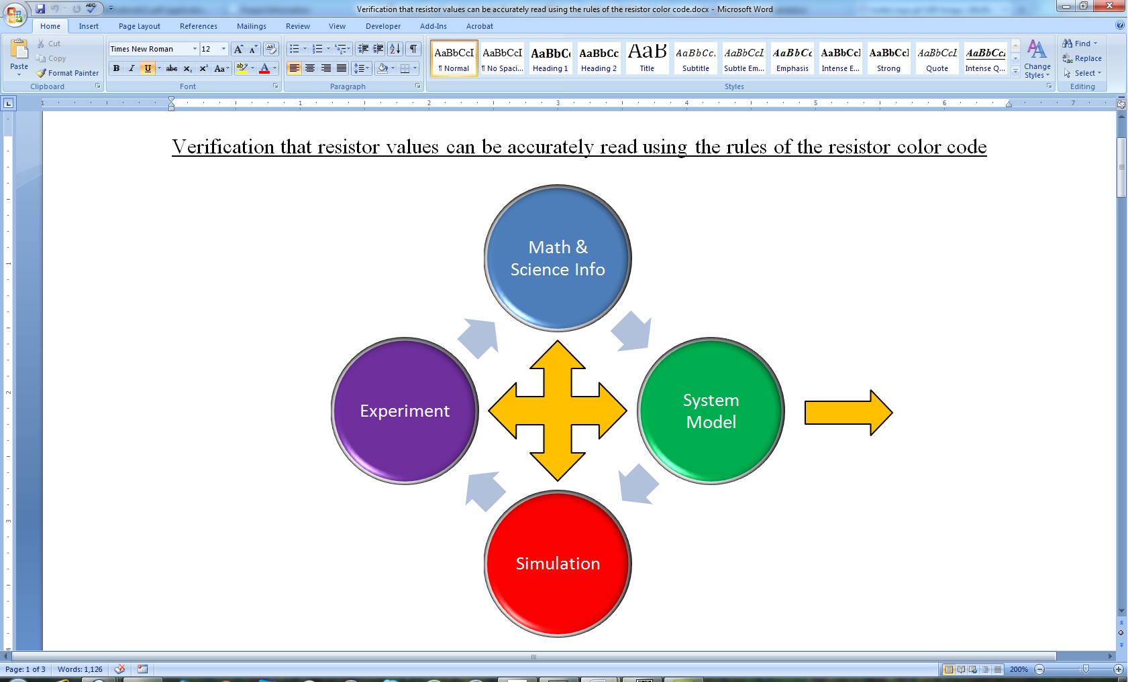Application: Identify at least one application of the content addressed in this experiment. That is, find an engineered system, device, process that is based, at least in part, on what you have learned. You must identify the fundamental system and then describe at least one practical application.
2. Engineering Design Process: Describe the fundamental math and science (ideal) picture of the system, device, and process you address in part 1 and the key information you obtained from experiment and simulation. Compare and contrast the results from each of the task areas (math and science, experiment, simulation) and then generate one or two conclusions for the practical application. That is, how does the practical system model differ from the original ideal?

Engineering Design Process

**Total: 80 points for experiment packet**

**0 to -10 points for Summary/Overview**

**20 points for attendance**

**100 points**

**Attendance (20 possible points)**

**2 classes (20 points), 1 class (10 points), 0 class (0 points)**

**Minus 5 points for each late.**

**No attendance at all = No grade for this experiment.**

***Experiment 3***

***Section: ______***

***Report Grade: ______***

***__________________________ Name***

***__________________________ Name***

***Checklist w/ Signatures for Main Concepts***

*For all plots that require a signature below, you must explain to the TA or instructor:*

* *the purpose of the data (using your hand-drawn circuit diagram),*
* *what information is contained in the plot and*
* *why you believe that the plot is correct.*

*Any member of your group can be asked for the explanation.*

**PART A: Making an Inductor**

**Questions 1-2**

**PART B: Measurement of Inductance**

* 1. **M2K plot of RLC at resonant frequency ________________**
  2. ***LTspice* of the transient RLC with value of L**

**Question 1 Value of Signal generator and current through R? _____________**

**Questions 2-8**

**PART C: Transformers**

1. ***LTspice* plot initial 3 traces of ratios when L1 = 4mH and L2 = 1mH**
2. ***LTspice* of three ratios at 1kHz and up**
3. ***LTspice* of three ratios at 100Hz and up ___________________**

**Questions 1-5**

**PART D: Making a Transformer**

1. **M2K plot of your transformer ______________________**
2. **Table of current ratios at different frequencies**

**Questions 1-3**

**Group Responsibilities**

**Summary/Overview**