Experiment 2
Complex Impedance, Steady State Analysis, and Filters

Purpose: The objective of this experiment is to learn about steady state analysis and basic filters.

Background: Before doing this experiment, students should be able to
- Determine the transfer function of a two resistor voltage divider.
- Determine the real and imaginary parts of a complex number, write complex numbers in polar form, and locate a complex number in the complex plane (real and imaginary axes)
- Determine the complex impedance of capacitors and inductors from the values of the components and the operating frequency of whatever power supply is being used.
- Determine the values of capacitors and inductors from the information printed on them. (Review the Quiz 1 formula sheet.)
- Review the background for the previous experiment.

Learning Outcomes: Students will be able to
- Do a transient (time dependent) simulation of RC, RL and RLC circuits using LTspice
- Do an AC Analysis (frequency dependent) simulation of RC, RL and RLC circuits using LTspice, determining both the magnitude and the phase of input and output voltages.
- Determine the general complex transfer function for RC, RL and RLC circuits and simplify for high and low frequencies.
- Be able to define what is meant by high and low frequencies in the context of RC, RL and RLC circuits.
- Identify whether an RC, RL or RLC circuit is a low-pass filter, a high-pass filter, a band-pass filter or a band-reject filter
- Find the corner frequency for RC and RL circuits and the resonant frequency for RLC circuits.
- Find a practical model for a real inductor and determine the range of frequencies in which the real inductor behaves nearly like an ideal inductor.
- Measure inductance and capacitance using a commercial impedance bridge.

Equipment Required

- DMM (Digital Multimeter) Not needed for online only students
- Analog Discovery (with Wave Forms)
- Oscilloscope (Analog Discovery)
- Function Generator (Analog Discovery)
- DC Power Supply (Analog Discovery)
- Impedance Bridge (located on center table) Not needed for online only students
- Components: 1kΩ resistor, 1μF capacitor, 0.1uF (104) capacitor, 1mH inductor, 0.068μF (683) capacitor
- Protoboard

Helpful links for this experiment can be found on the Links by Experiment page.

Pre-Lab

Required Reading: Before beginning the lab, at least one team member must read over and be generally acquainted with this document and the other required reading materials listed under Experiment 2 on the EILinks page.

Hand-Drawn Circuit Diagrams: Before beginning the lab, hand-drawn circuit diagrams must be prepared for all circuits physically built and characterized using your Analog Discovery board.

Part A –RC circuits, RL circuits, and AC Analysiss

Background

Complex polar coordinates: Complex numbers allow you to express a single number in terms of its real and imaginary parts: z = x + jy. j (the symbol i is used in mathematics) is used to represent the square root of -1. You can also represent a number in the complex plane in terms of polar quantities, as shown in Figure A-1. The length of the line segment between a point and the origin and the angle between this segment and the positive x axis form a new complex number: z = Acosθ + jAsinθ where
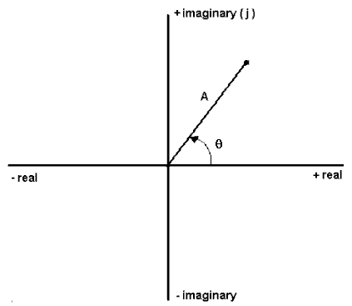
Figure A-1.

Impedance and basic circuit components: Each basic circuit component has an effect on a circuit. We call this effect impedance. You should remember that impedance causes a circuit to change in two ways. It changes the magnitude (amplitude) and the phase (starting position along the time axis) of the voltages and currents. When a resistor is placed in a circuit, it affects only the amplitude of the voltages. When capacitors and inductors are placed in a circuit, they influence both. We can use complex polar coordinates to represent this influence. A capacitor will change the amplitude by 1/ωC and shift the phase by -90°. An inductor will change the amplitude by ωL and shift the phase by +90°. (Recall that ω is called angular frequency and is equal to 2πf.) We can represent these changes easily in the complex polar plane. We represent impedance by the letter Z. Therefore,

Experiment

The Influence of a Capacitor
In this section, we will examine how a capacitor influences a circuit using LTspice.

- Create the simple RC circuit shown in Figure A-2 in LTspice
  - Locate the voltage source as a component, just start typing Voltage and it should appear in the default library.
    - Place the source on the schematic, hit escape to avoid placing more than one source
    - Right click on the source, select Advanced
      - SINE, 500mV Amplitude, 1kHz Freq
  - Locate the resistor (R) and capacitor (C) on the tool bar.
    - For each right click on the symbol. Enter 1k for the resistor and 1uF for the capacitor [In LTspice, u represents micro, μ (10⁻⁶).]
  - Don’t forget the ground. Select the Ground from the tool bar. Place it on the schematic.
  - Wire the circuit.
  - Label the input and output points. Select the Label on the tool bar and place labels on the schematic. Change the names to be appropriate.
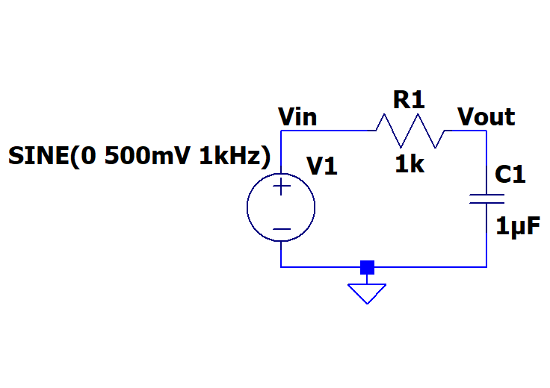
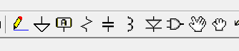
Wire Ground Label Resistor Capacitor Component

Figure A-2.

- Set up a simulation for this circuit.
  - Simulate > Edit Simulation Command
  - Transient, Stop time 4ms, Maximum Timestep 4us.
  - Place the .tran statement anywhere on the schematic

- Run the simulation by either clicking on the runner symbol on the tool bar or Simulate > Run
- We wish to see both the input and output voltage traces.
  - Hover over the Vin label or the wire. A red voltage probe will appear. Left click.
  - Do the same on Vout.
- You should get an output with two sinusoids on it. You should see that the circuit has influenced both the amplitude and the phase of the input. How close is the phase shift to -90°? Note: Use one of the later cycles to determine this. Copy both the schematic and the voltage plot and include it in your report.

Hint/Suggestion: The impedance expressions above for R, L and C work in steady-state. That is, they will describe the behavior of the voltages and currents only after the circuit has gone through its initial transients and settled into the state it will remain in forever (its steady-state). Thus, when we are using transient analysis to help understand steady-state, we ignore at least the first cycle or two of the sinusoids and focus on the latter part of the signal. You will find at times that the signal does not reach its steady-state in the number of cycles you are displaying. To be sure you are in steady-state, you can set up your simulation profile so that it begins at 10ms and runs to 14ms or even start at 100ms and run to 104ms. Because the circuits we analyze in this course usually have only a small number of components, the extra time necessary to run to 14ms is usually not large. For now, try starting at 10ms and see how things look. For reference, the full simulation of the processor in your computer can take several computer years to complete. This is usually done with many computers and still can take weeks.
- Simulate > Exit Simulation Cmd or just right click on the .tran statement
  - Stop time: 14ms
  - Time to start saving data: 10ms
  - Leave the Maximum Timestep as it was.
  - Run the simulation again. By the start of data collection the transients should have decayed.
Figure A-3 Transient analysis starting after 10ms to look for AC steady state behavior.

AC Analysis:
LTspice has another type of analysis that lets you look at the behavior of a circuit over a whole range of frequencies. It is called an AC analysis, also referred to as a frequency sweep. We know that the influence of the capacitor depends on ω and this is related to the frequency of the input signal. Should the behavior of the circuit change at different frequencies? Let’s set up an AC Analysis and find out.
Figure A-4
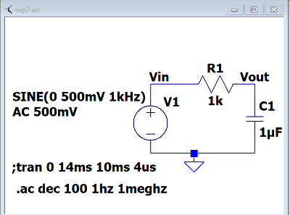
- Simulation > Edit Simulation Cmd
  - Select AC Analysis
    - Type of sweep: Decade
    - Number of points per decade: 100
    - Start frequency: 1hz
    - Stop frequency: 1Meg
    - Click ok and place anywhere on the schematic
      - Note that the tran statement now starts with a semicolon. It is now a comment. If you wish to use it again replace the semicolon with a period.
      - The .ac statement is now the analysis statement.
    - We need to tell the voltage source what to do as we scan the frequency
      - Right click on V1. On the right you will see “Small signal AC analysis (.AC)”
      - AC Amplitude: 500mV Click OK and you should see a line added as shown on Fig. A-4
- Run the simulation

- You should see 4 traces. These traces are showing you the amplitude and phase of your input and output at all frequencies between 1 and 1MegHz. Note that the horizontal scale of the plot is now in Hertz. The amplitude traces are solid lines with the scale on the left and the phase traces are dashed lines with a scale on the right. The input is constant with frequency as should be expected. You must include the input in your plots. This will become important when measuring the real circuits.
  - The left scale is in dB, decibels. We wish to see it in volts.
    - Right click on the left scale.
    - Select linear
- The input trace is a straight line at 500mV and phase of 0°. This makes sense because the amplitude of the input is 500mV at all frequencies. The amplitude of the output, however, changes with frequency. For what range of frequencies is the amplitude of the output equal to the amplitude of the input? For what range of frequencies is it near zero? What is the amplitude at 1kHz? Does this match the amplitude of the transient you plotted at 1kHz?

- Now look at the dashed lines, the phase, using the scale on the right. Note that this axis is in degrees. The input phase does not change. It is always zero because the sine wave in LTspice is drawn starting at zero by default. However, the phase for the output over the capacitor does change with frequency. At what frequencies is the phase of the output the same as the phase of the input? At what frequencies is the phase shift -90°? What is the phase shift at 1kHz? Does this correspond with the phase shift of the later cycles that you got in your transient at 1kHz? Copy the AC Analysis plot of the amplitude and phase of your RC circuit and include it in your report.

The Influence of an Inductor
In this section, we will repeat the procedure above for the simple circuit with an inductor shown in Figure A-5 below.
- Save the RC simulation
- Create the RL circuit in LTspice. You can just do a “save as” with the above simulation and give this simulation a new name. This allows you to be able to return to the RC simulation.
  - Delete the capacitor in your circuit.
  - Locate the inductor in the tool bar. Place it in the schematic. Set the value to 100mH.
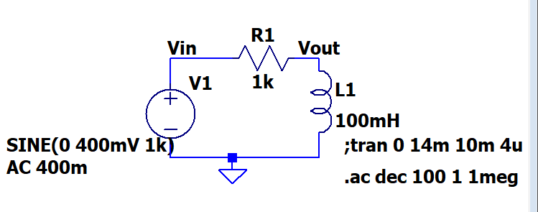
Figure A-5
Note: It is better to create a new schematic file for each circuit you analyze rather than just modifying the same one over and over. The circuit project models are very small so they will not take up much space on your computer and it will be easier to compare notes with your partners and re-run things, if necessary, when you are writing your report.

- Transient simulation: You can use the same method as you did for the RC simulation or if you based this on the RC simulation you might still have the ;tran statement shown as in figure A-5.
  - Right click on the tran statement and replace the semicolon with a period.
  - Only one simulation can run at a time. So if there is an “.ac” statement, edit that and replace the period with a semicolon.
  - As for the runtime: If you wish to see the initial circuit transients change the runtime and start times. Or to see the steady state behavior just keep the values used for RC analysis.

- Run the transient simulation. Again, the circuit has influenced both the amplitude and the phase of the input. How close is the phase shift to +90°? Note: Use one of the later cycles to determine this. Copy this plot and include it in your report, be sure to include the schematic also.

- Now return to your AC Analysis. This can be done by making the tran statement a comment (replace the period with a semicolon) and making the ac statement a simulation (replace the semicolon with a period). Or Simulate > Edit simulation Cmd > AC Analysis. Type of sweep is Decade, Number of points per decade (100 is a good number but feel free to play), start frequency is 1Hz and stop frequency is 1meg. You are free to play with the start and stop frequencies. Run the simulation.

- If the traces aren’t shown, hover over Vin to get the voltage probe and click. Do the same for Vout. As with the RC circuit you should see 4 traces. If it is displaying the amplitude in dB, right click on the left scale and choose linear. At what frequencies is the amplitude of the output equal to the amplitude of the input? At what frequencies is it near zero? What is the amplitude at 1kHz? Does this match the amplitude of the transient you plotted at 1kHz? How is this sweep different than the sweep you created using the circuit with the capacitor? At what frequencies is the phase of the output the same as the phase of the input? At what frequencies is the phase shift +90°? What is the phase shift at 1kHz? Does this correspond with the phase shift you got in your transient at 1kHz? Copy the AC Analysis plot of the RL circuit and include it in your report.

Summary

In this part of the experiment, you have learned that capacitors and inductors influence the behavior of a circuit. They change both the phase and the amplitude. The degree of influence depends on the frequency of the input source. You also learned how to examine the behavior of a circuit over a range of frequencies using the AC Analysis feature in LTspice.

Part B – Transfer Functions and Filters

In this section, we will continue our analysis of the two simple circuits we created in part A and introduce the concepts of transfer functions and filters.

Background

Transfer functions: We know that a circuit with only resistors will behave the same at any frequency. A voltage divider with two 1k resistors divides a voltage in half at 10Hz as well as it does at 100kHz. We also know that circuits containing capacitors and/or inductors behave very differently at different frequencies. What if we could find a function that, when applied to any input signal, would give you the output signal? This cannot be done easily in the time domain, however, it is quite simple in the complex polar domain we introduced in part A. We can define a function H(jω) for any circuit such that

Finding transfer functions: For a simple series circuit, we can find the transfer function using a concept similar to the voltage divider rule. We simply need to expand the idea of resistance to include complex impedance. How and why we can do that is discussed in detail in the course notes. Now, we can combine impedances in the complex polar domain in just the same way that we combine resistances in the time domain. Now we can also easily define our transfer function using the voltage divider rule, as illustrated in Figure B-1.
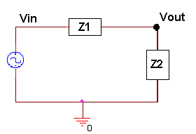
Figure B-1.

Filters: Most electrical signals are made up of many frequencies. In the first experiment, you learned that sound waves within human hearing range cover a range of frequencies from very low to very high. Sometimes we may not want to include all these frequencies in our signal. We may want to filter out the very high frequencies that sound like noise, for instance, so that we only hear the part of the sound that we want to. In electronics a circuit that filters out certain frequencies while allowing others to remain unchanged is called a filter.
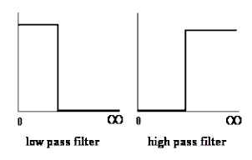
Figure B-2.

The two basic types of filters we will consider in this part are low pass filters (LPF) and high pass filters (HPF). An idealized representation of these two types of filters is shown in Figure B-2. Low pass filters filter out high frequencies while allowing low frequencies to pass through unchanged. High pass filters block out low frequencies while allowing high frequencies to pass through unchanged. In an ideal world, the transfer function would be 1 for the frequencies that you want to remain unchanged (a signal multiplied by 1 is the same) and 0 for the frequencies you want to filter out (a signal multiplied by 0 is 0). In an ideal filter, the transition between 1 and 0 is instantaneous. In a real filter, this transition is less exact.

Using transfer functions to determine filter behavior: We can determine what kind of filter the simple RC circuit pictured in Figure B-3 is, by finding the transfer function and examining its behavior at low and high frequencies. First do the complex algebra to determine the capacitor voltage. You will notice that once again we have a voltage divider circuit, except that one of the impedances is imaginary and one is real. For an operating frequency , the impedance of the capacitor C1 is equal to , while the impedance of the resistor R1 is .
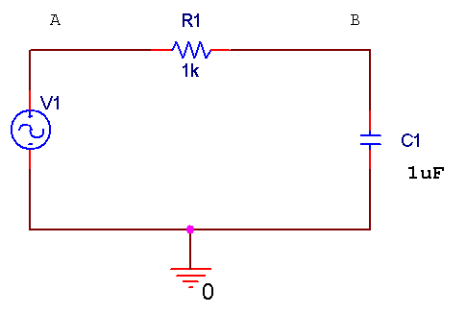
Figure B-3.

Applying the usual voltage divider relation for this series combination of two impedances gives us
(Equation 1)

Note that the relationship between the input voltage V_{A} and the output voltage V_{B} is now complex.

It is useful to be able to set up these expressions and then simplify them for very low and very high frequencies. We will be able to use the resulting expressions to see if our LTspice plots make any sense. We will first look at very low frequencies. We cannot set frequency equal to zero, since parts of our formula will blow up. Rather, we will assume that the frequency is very small, but not zero. Then the capacitive impedance Z_{C1} will be very much larger than the resistive impedance Z_{R1} and we can neglect the latter term. We have then, at low frequencies, that or, more simply, that . Note that the input and output voltages are essentially identical. At high frequencies, the capacitive impedance will be the small term, so we can neglect it in the denominator. We cannot neglect it in the numerator, since it is the only term there. Thus, at high frequencies,
or that . This ratio clearly goes to zero as the frequency goes to infinity. It is also negative imaginary and, thus, has a phase of –90º.

Note about “Low” and “High”: It may seem that terms like low and high, when applied to something like frequency, are fuzzy, ill-defined terms. However, that is definitely not the case. Here, we mean something quite specific by the expression low frequency. A frequency is only low when the capacitive impedance is so much larger than the resistive impedance that we can neglect the resistive term. We usually need to define the required accuracy to make a statement like this. For example, we can say that a frequency is low as long as the approximate relationship we found between the input and output voltages is within 5% of the full expression. Most of the parts we use in circuits are no more accurate than this, so there is no particular need to do our calculations with better accuracy. In other applications we might need better accuracy.

Corner frequency: When we design a high or low pass filter, we only need to know three things: how it behaves at low frequencies (0 or 1), how it behaves at high frequencies (0 or 1), and at what frequency it switches (0 to 1 or 1 to 0). For a simple RC or RL filter, the frequency at which it switches is called the corner frequency. It is defined as the point at which the magnitude of the transfer function is equal to 1/√2.

AC Steady State Circuit Analysis: Simulation and Experiment
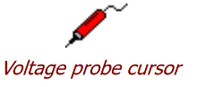
You have been using the Voltage probe cursor with just a red probe. When you do this the ground node is considered the reference point. The track will be the voltage at a circuit node relative to the ground. We now wish to measure the voltage across a component. This can be done by using a differential probe:
- Hovering over the schematic at point you wish to have the red (positive) probe.
- Left click and hold
- Drag the mouse to the point where you wish to locate the black (negative) probe.
- And release.
You now have a trace of the voltage across the two points. It will be the voltage of the location of the red probe minus the voltage of the location of the black probe. It is that same as using red and black probes of a multimeter.

The Transfer Function Equation
In this section we will explore the impedance of the capacitor circuit. If we want to apply the voltage divider equation to form the transfer function, then the voltage drop over the two components must add up to the input voltage at all frequencies.

- In LTspice, load the capacitor circuit (Figure A-2) or recreate it. To test the validity of applying a voltage divider to complex impedances, we want to show that, just like with the voltage divider made with resistors, the source voltage (V1) is equal to the sum of the voltages across the resistor and the capacitor (V_{R} + V_{C}). To determine V_{R} and V_{C}, use we will use voltage differential markers.
  - Rerun the transient analysis from Part A (4ms with a step size of 4us).
  - Place a differential probe marker across the resistor. Hover over the Vin location, you should see a red probe. Left click and hold. Drag to the Vout location. You should see a black probe, and release.
  - Try the same to put a differential probe across the capacitor. You will see that since one end of the capitor is at ground that LTspice knows that and just lets you place the red probe.
  - Place a regular voltage marker at the input (next to the source).

- You will now see three voltages traces. To see the sum of V_{R} and V_{C,} we must add a trace in LTspice.
  - Notice the names given to the traces in the plots. Yours might be different. This discussion will use the ones generated by the exact circuit as figure A-2. Change the labels to match your circuit
  - In a blank area of the plots: Right click and select Add Traces, or in the menu bar: Plot Setting > add trace
    - Add Traces to Plot box appears
    - At the bottom type in an expression that will add the trace across the resistor and the trace across the capacitor.
    - In my case, and yours could be different, this is V(Vin,Vout)+V(vout).
    - Click OK

- When have added the trace correctly, you should see that the sum will equal the source voltage. This is a little difficult to see because the sum trace is exactly the same as Vin, as it should be. Copy a plot of your results, and include it in your report.

- Run a transient simulation for frequencies of 10Hz (Stop time = 400ms and Maximum Timestep =400us) and 10kHz (Stop time = 0.4ms and Maximum Timestep=0.4us). Place the trace of V_{R} and V_{C} on each plot. Verify that the voltages add as expected. Copy these plots and include them in your report.

- Since we have a series circuit, we know that the current, I, is the same through all the components. Therefore, V=IZ for each component and for the entire circuit. This means that the transfer function, H=Vout/Vin, becomes independent of current, and simplifies to an expression in terms of the component values only.

(Equation 2)
Transfer Function of the Capacitor Circuit
In this part, we will find the transfer function of our capacitor circuit from part A and determine the type of filter.
- Return to the RC simulation. Use the scissors to remove traces if any are displayed.
- Run the AC Analysis (from 1 to 1MegHz at 100 points per decade) of the capacitor circuit (Figure A-2).
- Hover on the schematic and click to display both the input and output voltages. You should have both amplitude and phase traces for both the input and output.
- We know that H(jω) is the ratio of the output voltage to the input voltage. We can observe this directly by adding a trace take is the ratio between the two traces we have on our plot.
  - Either right click in a blank space in the plots and select “Add Traces” or use the Plot Setting button and select “Add Trace”.
  - Create an expression that is the input divided by the output. It might be as simple as V(vout)/V(vin).
  - Click OK
- 2 traces should appear on your plot. These are the amplitude and phase of H(jω). For now we will concentrate on just the amplitude.
  - Right click on the angle scale on the right side of the plot.
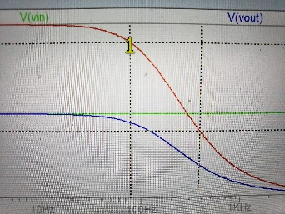
  - Click on “Don’t plot Phase”, OK

- The corner frequency of the circuit is the frequency at which the transfer function is 0.707. Use the cursors to mark this location on your plot. LTspice has 2 cursors which can be assigned to the traces in the plot.
  - In the plot left click on the trace name for H(jω), it is V(vout)/V(vin) for the Figure B-4. This puts a cursor on the trace.
Figure B-3 Showing cursor 1
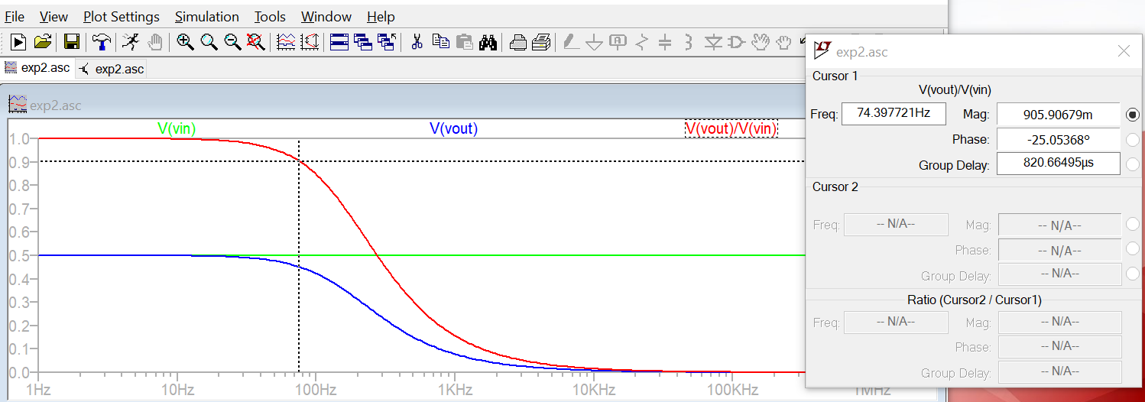
  - Hold the mouse over the point where the cursor is locate and a “1” will appear, shown in Figure B-3. Left click and drag and you can move the cursor.
Figure B-4 Grid has been turned off for clarity, Control G. Both cursors are shown. Locations are listed in box.
  - There is a box the gives you the cursor trace values at the cursor location. 74.4Hz and 906mV in this case.
  - Move the cursor a point where the magnitude of V(vout)/V(vin) is close to 0.707. Record the numbers from the box. What is the corner frequency? Copy this plot and include it in your report.

- In the video lectures or lecture slides you were given an expression for the corner frequency of an RC circuit: ω_{C} = 1/RC. Calculate the corner frequency. Don’t forget that f (in Hertz) is ω/2π. How does this compare to the frequency you found with LTspice?
- The equation for the transfer function of a series circuit is . Use this expression to find the transfer function of the capacitor circuit. Take the limit of this function at high and low frequencies. Does the plot you made with LTspice behave the same at low and high frequencies?

Transfer Function of the Inductor Circuit
In this part, we will find the transfer function of our inductor circuit from part A and determine what type of filter it is.

- In LTspice, recreate the inductor circuit (Figure A-5) by replacing the capacitor with a 100mH inductor. Run the AC Analysis.
- Create the transfer function by adding a trace that is the output voltage divided by the input voltage.
- Is the transfer function 0 or 1 at low frequencies? Is it 0 or 1 at high frequencies? What kind of filter is this?
- Use the cursors to mark the location of the corner frequency on your plot. What is the corner frequency? Record and report that information. Copy this plot and include it in your report.
- Can you derive the equation for the corner frequency of this circuit? Calculate the corner frequency using the equation you derived. Don’t forget that f (in Hertz) is ω/2π. How does this compare to the frequency you found with LTspice?
- Find the transfer function of the inductor circuit using the equation for H(jω). Take the limit of this function at high and low frequencies. Does the plot you made with LTspice behave the same at low and high frequencies?

Build the circuit

Now you can build one of these circuits on your protoboard, hook it to the function generator and compare its behavior to the simulation. You may find the cursors and the Measurements view will be useful.

- Build the capacitor filter circuit (Figure A-2) on your protoboard using a 1uF capacitor and a 1k ohm resistor.
- Set the function generator (WaveGen Channel 1) to a 1kHz signal with an amplitude of 500mV, (1Vp-p).
- Display the input signal on channel 1 of the Oscilloscope (the orange wires and the yellow trace) and the output signal on channel 2 of the Oscilloscope (the blue wires and the blue trace). Copy the image of this signal with the edit function in the software and include it in your report. (We will call this the Camera Function of the software.) How does the output of this circuit compare (amplitude and phase) with the transient analysis you made of this circuit at this frequency?
- You should notice that the amplitude and phase of this circuit changes as you change the frequency. At what frequencies does the output look roughly the same as the input? At what frequencies does the output essentially disappear (the amplitude is so small it looks like a ‘flat’ line?

- At the corner frequency, the transfer function is equal to 0.707. The transfer function is defined as Vout/Vin. If Vin is 200mV, what should the amplitude of the output be at the corner frequency? Adjust the frequency of the input signal until the output amplitude is 70.7% of the input amplitude. Record this frequency and take a picture of the signal with the camera function in the software and include it in your report.

- The corner frequency for an RC circuit is given by f_{C}=1/(2πRC). How close is the corner frequency of the circuit you built to the calculated one?

Summary

Transfer functions relate the output voltage to the input voltage for all frequencies of a circuit. You can use transfer functions to determine the type of filter a circuit represents. You can derive the transfer function for a series circuit by using circuit analysis rules to combine the complex impedances into a ratio H = Zout/Zin.

Part C – Transfer Functions, Filters and RLC Circuits

Background

Phasors: Circuits, like most engineering systems, can be divided up into basic building blocks, each with its own function. If we assume that the function of such a building block is to change a voltage in some way (i.e. filter it, amplify it, etc.), then we label the input voltage as V_{in} and the output voltage as V_{out}. Since it is easiest to reference the phase of the input to zero, we can write a sinusoidal input voltage as
V_{in} = V_{o} cos(ωt) and the output voltage as V_{out} = V₁ cos(ωt + φ_{o}) where ω = 2πf.

When working exclusively with AC steady state conditions, it is generally easier to analyze circuits using what is called phasor notation. Euler's identity tells us that exponentials with imaginary arguments can be related to sines and cosines by e^{j(ωt + φ)} = cos(ωt + φ) + jsin(ωt + φ) that permits us to write the output voltage, for example, in the equivalent form V_{out} = Re{V₁ e^{j(ωt + φ)}} = Re{V_{out} e^{jωt}} where V_{out} = V₁e^{jφ} is a complex number and is called the phasor form of V_{out}. Much of the time we find it convenient to consider the real and imaginary parts of this complex representation separately V_{out} = V_{Re} + jV_{Im} where V_{Re} = V₁cos(φ) and V_{Im} = V₁ sin(φ)

Thus, we will also be keeping track of the real and imaginary parts of voltages and currents. When we run LTspice simulations, we will be able to add voltage markers that will do this for us. One can access these markers by starting at the LTspice menu, then going to the Markers menu and, finally, the Advanced menu or use Add Trace on plots.

If we apply the phasor form to the equations that characterize voltage and current for capacitors and inductors, we obtain the following V_{L} = Re{V_{o} e^{jωt} } = L dI_{L}/dt = L (d/dt) Re{I_{o} e^{jωt} } = jωL Re{I_{o} e^{jωt} } = jωL I_{L} or more simply, V_{L} = jωL I_{L} and, following the same kind of analysis, I_{C} = jωC V_{C}

Thus, instead of a differential equation, we obtain the same kind of algebraic relationship we had for resistors, Ohms Law, except that the impedances (a generalization of resistance) of inductors and capacitors are given by Z_{L} = jωL and Z_{C} = 1/(jωC). For resistors, Z_{R} = R, while in general Z = R + jX.

RLC circuits: Circuits with resistors, inductors and capacitors are called resonant circuits. They find wide application in electronics because there are many circumstances in which we wish to produce or block a single frequency. There are two common types of resonant circuits, parallel and series combinations of a resistor, an inductor and a capacitor. This figure shows series RLC circuits with 4 possible input-output choices.
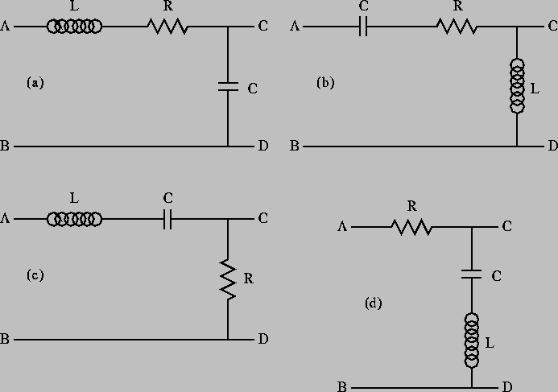
Figure C-1.

Oscillating systems usually have such a natural resonance. This frequency, where the inductive and capacitive impedances cancel, is called the resonant frequency. The expression for the resonant frequency is .

More complex filters: Simple RLC circuits can be used to create more types of filters than simple RC or RL circuits. You can create any of the four generic circuit types shown in Figure C-2.
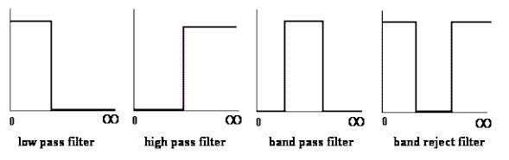
Figure C-2.

Each of the above circuits has a low frequency and a high frequency approximation, found in the same manner as we have seen for RC and RL circuits. Looking at the limiting cases of H(jω) for frequencies near zero and for very large frequencies, we can determine which type of filters they are. For example, note that at both high and low frequencies, the transfer function for case C-1(d) is equal to one, and thus the input voltage appears unchanged at the output. [If you want to verify this, redraw the circuit at low and high frequencies replacing the capacitor and the inductor by the appropriate approximation (short or open). You should be able to see that in each case, the output point, C, is at the same voltage as the source. This means that the input signal is appearing at the output. The circuit is “passing” very low and very high frequencies.] Also, since the impedance of a capacitor is negative imaginary and that of an inductor is positive imaginary, there will be a frequency ω_{o} where the net impedance across the output terminals C and D will be zero. Near this frequency, the output voltage will be zero or at least very small. These frequencies are “rejected” by this filter. It must be a band-reject filter.

Modeling electrical components: When we build circuits, we use a function generator to produce the input voltage, a resistor, an inductor and a capacitor. However, we cannot use just a voltage source and three other components when we model them in LTspice, since real devices usually cannot be modeled by a single parameter. Let us go through each of the four components of circuits and see what is necessary for realistic analysis or simulation.
- Function Generator – Most commercial function generators have an internal resistance of 50Ω. Thus, in a realistic circuit, we must use an ideal sinusoidal voltage source and a resistor to represent the function generator. In the case of the FG on the Analog Discovery this resistance can be neglected.
- Resistor – Except at very high frequencies, resistors behave in an essentially ideal manner. Thus it is almost always sufficient to represent the resistor in a circuit as a single resistor.
- Inductor – Since inductors are made with a long piece of wire, they usually have a significant resistance, in addition to their inductance. Thus, we must include an additional resistor to model the resistance of a real inductor.
- Capacitor – A capacitor typically consists of two large metal plates separated by a thin insulator. If the insulator is very good, almost no current will flow between the plates. Then, like the resistor, the capacitor will behave in an essentially ideal manner and we don’t need to add any extra components in a circuit to represent a capacitor.
No components we can make are really ideal. Resistors also have inductance and, sometimes, capacitance. Inductors have capacitance. Capacitors have resistance and inductance. Fortunately, we have figured out how to make these devices so that they behave in a nearly ideal manner for quite a broad range of frequencies. However, when we push the limits of a circuit, we have to remember that it may behave as if it consists of more components that we can see when we build it. When the RLC circuit is built, we will only see the three components R1, L1 and C1.

Simulation of an RLC Circuit
In this section, we will use LTspice to simulate an RLC circuit and plot the magnitude and phase of its transfer function.
The LTspice model of the inductor must include both L1 and R1

- Set up the circuit as shown in Figure C-3 below.
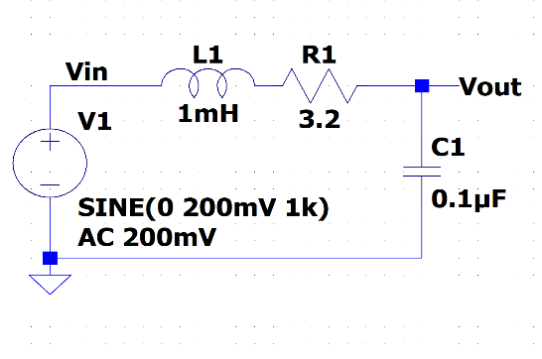
R1 is the intrinsic resistance of L1.

Figure C-3.
We will set the amplitude of V1 is 200mV, (400mVp-p). We assume that the impedance of the signal generator to be zero, this is a poor assumption for the M2k but a good one for the Analog Discovery 2. We get around this issue by measuring the both Vin and Vout. For the M2k, this is a case where Vin won’t be constant with frequency. Again we state that R1 represents the resistance of the 1mH inductor. When you build the circuit you don’t put an R1 in the built circuit. But it must be in the model for LTspice.

- Build this in LTspice. Add net labels for Vin and Vout to make it easier to track traces. Perform an AC Analysis from 1kHz to 100kHz. Since we have now done AC Analysis several AC times now, can you explain why we do Decade sweeps rather than Linear sweeps?
- Display the traces for Vin and Vout. There should be 4 traces, 2 for magnitude and 2 for phase. Vin will show constant magnitude and phase.
- We wish to look at H(jω)=Vout/Vin but we would like to use different scales than that used to plot Vin and Vout.
  - Right click in a blank area of the graph
  - Select Add Plot Plane
  - In that plot plane
    - Right click and Add Traces
    - Create the function for the output divided by the input. For figure C-3 it would be Vout/Vin.
  - You should have both a magnitude and phase plot for H(jω)
  - Use the cursor to find frequency, magnitude and phase at the resonant frequency (extreme point) for H.
  - Use Notes and Annotations to label these on the plot
  - Copy these plots and the schematic and include them in your report.

Annotations: Be sure that you are in the plot window. Plot Setting > Notes and Annotations: You are able to add text, lines and shapes. Use this to put a text box on the plot listing the resonant frequency, the magnitude and the phase.
You should also calculate the value for the theoretical resonant frequency and mark it on the plot.
  - Note that this calculation isn’t exact. It gives you a simple mathematical way to get close to the resonant frequency of a circuit. The exact value of the resonant frequency can be found by examining when denominator of the transfer function goes to zero. We do not go into these details in this class. For us the approximation is sufficient.
- In the next section you will build the circuit and experimentally find the actual resonant frequency.

- What type of filter is this?

Build the Circuit
Now you can build the circuit in Figure C-3 on your protoboard, hook it to the Signal Generator and compare its behavior to the simulation. The inductor is labeled 102, 10x10^2 or 1000uH, 1mH

- Before you build the circuit, you should measure the exact values of the components.
  - Measure the DC resistance of the inductor’s resistor using the DMM. Do not use the impedance bridge for this measurement.
  - Measure the inductance of the inductor and the capacitance of the capacitor using the impedance bridge on the center table. The connectors may be a bit loose. Be sure they are making good contact.

- If you have actual measurements of the parameters, change your LTspice simulation. If not just change capacitance value to be 10% higher. Run the AC Analysis again to see what it looks like now. Copy the AC Analysis plot and include it in your report. Are there any significant differences between the two simulations?

Build the circuit on your protoboard. Remember that you need only two components: the 1mH inductor (with an internal resistance of about 3.2Ω) and the 0.1μF capacitor. The 0.1μF capacitor will have 104 written on it. Remember that R1 represents the resistance of the 1mH inductor. DO NOT add a separate resistor to your circuit for this.

- Find the resonant frequency of the circuit. This is the point where the voltage of the output is at a maximum. It will exceed the input voltage at this point. You should find it is close to the resonant frequency you found using LTspice and the one you calculated using the theoretical equation. It may not fall in exactly the same place because of errors introduced by the tolerances of the components and the influence of other parts of the circuit. Mark the actual resonant frequency on the AC plot you generated using the theoretical component values. Note that depending upon how you found the resonance, the same circuit gave you three similar, but not exact, values.

- Use 5 frequencies related to the resonant frequency, set at close to 10%, 90%, 100%, 110% and 1000% of the resonant frequency these represent low frequency, a point between low frequency and the resonant frequency, the resonant frequency, a point between the resonant frequency and the high frequency, and high frequency.

- At each frequency, determine the ratio of the input and output amplitudes (magnitude of the transfer function) and the phase shift. There is no magic button for determining either the transfer function or the phase shift between two signals. You will have to do this by displaying the input and output voltages on the scope and manually determining the ratio of the amplitudes and the phase shift. Cursors will be useful.

- Put the values that you measured on the LTspice AC Analysis plot you made using the actual component values.

Summary

In this section, you extended your knowledge of transfer functions and filters to include circuits with all three component types: R, L and C. These circuits are called resonant circuits. For these circuits the center of the band for band pass and band reject filters occurs at the resonant frequency. In high and low pass filters, the resonant frequency can be used to determine the location of the transition between passed and rejected frequencies.

Checklist and Conclusions

Provide the following packet. Include the cover/signature page attached to the end of this handout. The signatures are required for all statements with a signature line next to it. They must be signed by TAs or Professor(s) after seeing the results on the computer screen. Give all required results and answer the questions concisely. It is intended that these be quick to write.

The following should be included in your experimental checklist. Everything should be labeled and easy to find. Partial credit will be deducted for poor labeling or unclear presentation. ALL PLOTS SHOULD INDICATE WHICH TRACE CORRESPONDS TO THE SIGNAL AT WHICH POINT.

Hand-Drawn Circuit Diagrams for all circuits that are to be analyzed using LTspice or physically built and characterized using your Analog Discovery board.

Part A –RC circuit, RL circuits, and AC Analysiss (22 points)

Include the following plots:
- LTspice transient plot of RC circuit (in Figure A-2). (2 pt)
- LTspice AC Analysis plot of the RC circuit voltage. (2 pt)
- LTspice AC Analysis plot of the RC circuit phase. (2 pt)
- LTspice transient plot of RL circuit (in Figure A-3). (2 pt)
- LTspice AC Analysis plot of the RL circuit. (2 pt)
- LTspice AC Analysis plot of RL circuit phase. (2 pt)

Answer the following questions:
- What is the amplitude and phase of the output of the RC circuit at 1kHz? (2 pt)
- In what frequency range is the amplitude of the output of the RC circuit about equal to the input amplitude? In what frequency range is the amplitude of the output about zero? (2 pt)
- In what frequency range is the phase of the output of the RC circuit about equal to the input phase? In what frequency range is the phase of the output about -90°? (2 pt)
- What is the amplitude and phase of the output of the RL circuit at 1kHz? (2 pt)
- In what frequency range is the amplitude of the output of the RL circuit about equal to the input amplitude? In what frequency range is the amplitude of the output about zero? (1 pt)
- In what frequency range is the phase of the output of the RL circuit about equal to the input phase? In what frequency range is the phase of the output about +90°? (1 pt)

Part B - Transfer Functions and Filters (26 points)

Include the following plots:
- LTspice plot of capacitor and resistor sum adding to the input voltage at 1kHz. (2 pt)
- LTspice plot of capacitor and resistor sum adding to the input voltage at 10Hz. (1 pt)
- LTspice plot of capacitor and resistor sum adding to the input voltage at 10kHz. (2 pt)
- LTspice plot of transfer function of RC circuit (Figure A-2) with corner frequency marked. (2 pt)
- LTspice plot of transfer function of RL circuit (Figure A-3) with corner frequency marked. (2 pt)
- Wave Forms picture of RC circuit at 1kHz. (1 pt)
- Wave Forms picture of RC circuit at corner frequency. (1 pt)

Answer the following questions:
- Write out the mathematical expressions for the output voltage of the capacitor for the first RC circuit case you considered (plot 1). Write it in the form V(t)=A Sin(ωt+φ). (1 pt)
- What kind of filter is the RC circuit? (1 pt)
- At what frequency did you find the corner on the LTspice plot of the transfer function of the RC circuit? What frequency did you calculate using f=1/(2πRC)? How do the two compare? (3 pt)
- Find the transfer function of the RC circuit in terms of R, C and jω. Take the limit of this function at very low and very high frequencies. Show that these results are consistent with the LTspice plot of the transfer function. (3 pt)
- What kind of filter is the RL circuit (Figure A-3)? (1 pt)
- Derive the equation for the corner frequency of the RL circuit. (2 pt)
- At what frequency did you find the corner on the LTspice plot of the transfer function of the RL circuit? What frequency did you calculate using the equation you derived in the previous question? How do the two compare? (3 pt)
- At what frequencies did the output of the RC circuit you built look roughly the same as the input? At what frequencies did the output disappear into the noise? (1 pt)

Part C (16 points)

Include the following plots:
- LTspice plot of the transfer function of the RLC circuit in Figure C-3 (magnitude and phase), with three resonant frequency values marked [LTspice value, calculated value, experimental value] (original component values). (3 pt)
- LTspice plot of the transfer function of the RLC circuit in Figure C-3 (magnitude and phase), with the resonant frequency marked (real component values). Also put the 5 experimental points on this plot. (3 pt)

Answer the following questions:
- Why is it necessary to plot the phase and the magnitude of the transfer function separately, rather than on the same plot? (1 pt)
- For the three RLC circuits labeled (a), (b) and (c) in Figure C-1 indicate what type of filter the circuit is (high pass, low pass, band reject, or band pass filter) and explain why each is the filter it is. [Filter (d) is discussed in the Background section for part C.] Recall that a capacitor can be modeled as an open circuit al low frequencies and a short at high frequencies. Also recall that an inductor can be modeled as a short at low frequencies and an open circuit at high frequencies. Redraw the circuits at low and high frequencies and consider the value of the output between C and D for each case. You can check your answers in LTspice if you want. (3 pt)
- What is the phase shift between the output and input of plot 1 above at low and high frequencies? Does the phase shift change when you adjust the values of the components to create plot 2? Why or why not? (2 pt)
- Determine the resonant frequency of the RLC circuit you analyzed with LTspice. (This occurs at the extreme point.) Calculate the resonant frequency with the equation f = 1/[2π√(LC)]. How similar are they? What factors do you think account for the discrepancy? (3 pt)
- Why do you suppose it is that, in practice, we generally use filters designed with capacitors and not inductors? (1 pt)

List member responsibilities (4 pt) Note that this is a list of responsibilities, not a list of what each partner did. It is very important that you divide the responsibility for each aspect of the experiment so that it is clear who will make sure that it is completed. Responsibilities include, but are not limited to, reading the full write up before the first class; collecting all information and writing the report; building circuits and collecting data (i.e. doing the experiment); setting up and running the simulations; comparing the theory, experiment and simulation to develop the practical model of whatever system is being addressed, etc.

New Summary/Overview Section There are two parts to this section, both of which require revisiting everything done on this experiment and addressing broad issues. In this experiment, you must complete this section and you will receive feedback on your work, but no formal grade. That will begin with Exp3.
Engineering Design Process
- Application: Identify at least one application of the content addressed in this experiment. That is, find an engineered system, device, process that is based, at least in part, on what you have learned. You must identify the fundamental system and then describe at least one practical application.
- Engineering Design Process: Describe the fundamental math and science (ideal) picture of the system, device, and process you address in part 1 and the key information you obtained from experiment and simulation. Compare and contrast the results from each of the task areas (math and science, experiment, simulation) and then generate one or two conclusions for the practical application. That is, how does the practical system model differ from the original ideal?

Example from Experiment 1:

- One of the key circuit configurations we will see is the voltage divider. You should be on the lookout for it in every experiment and project because almost all circuits involve some combination of components in series. Most applications of a voltage divider use this device to provide a reference voltage. For example, in a thermostat, a temperature sensor will output a voltage proportional to temperature. This voltage must be compared to a reference to see if a furnace or air conditioner should be turned on. If the sensor voltage is above he reference then the A/C is turned on, etc. This can also be used for a light sensor system or for the control of anything that can be measured by a sensor that outputs a voltage.
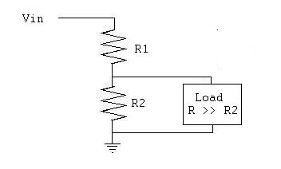
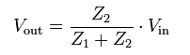
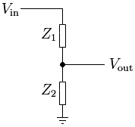
- The ideal operation of a voltage divider can be easily derived from Ohm’s Law and simple circuit analysis. For the configuration shown at the right, the relationship between the input and output voltages is given by this equation. If you have a voltage source V_{in}, then a reference voltage at any level from V_{in} to 0 can be produced by this circuit. In practical application, it is necessary to measure the voltage V_{out} in order to use it to control something like a lamp or furnace. In both simulation and experiment, connecting an oscilloscope or meter across Z₂ will add a resistor to the circuit in parallel with Z₂. Both the experiment and simulation showed that this additional resistor must be much larger than Z₂ or the reference voltage will be changed. Thus, from experiment and simulation, we conclude that a more complete model of the practical voltage divider (at least at this point in this course) should include the load and the restriction that the load resistance must be much larger than the divider resistors. The ideal divider info comes from Wikipedia and the loaded divider from a website at Tufts. The loaded divider is the practical system model that gives us confidence to reliably use the divider in a real world application.
Experiment 2
Section: ______
Report Grade: ______
____________________________________ Name
____________________________________ Name
Checklist w/ Signatures for Main Concepts
For all plots that require a signature below, you must explain to the TA or instructor:
- the purpose of the data (using your hand-drawn circuit diagram),
- what information is contained in the plot and why you believe that the plot is correct.
Any member of your group can be asked for the explanation.

PART A: RC circuit, RL circuits, and AC Analysis
  - LTspice transient of RC circuit
  - LTspice AC Analysis plot RC voltage _______________________
  - LTspice AC Analysis plot RC phase
  - LTspice transient of RL circuit
  - LTspice AC Analysis plot RL voltage
  - LTspice AC Analysis plot RL phase _______________
Questions 1-6
PART B: Transfer Functions and Filters
- LTspice plot of capacitor and resistor at 1kHz
- LTspice plot of capacitor and resistor at 10Hz
- LTspice plot of capacitor and resistor at 10kHz
- LTspice plot of transfer function of RC circuit marked corner frequency
- LTspice plot of transfer function of RL marked corner frequency
- Wave Forms picture of RC circuit at 1kHz _____________
- Wave Forms picture of RC circuit at corner frequency ___________
Questions 1-8
PART C: Transfer Functions, Filters, and RLC Circuits
- LTspice plot of transfer function of RLC circuit (see above for markings)
- LTspice plot of transfer function of RLC circuit (see above for markings)
Questions 1-5
Member Responsibilities

