Omega Exploration Map

Please fill out the following sections of your map for your project. Many of you will learn skills or concepts that are beyond the Intro to ECSE concept list. Please provide references, links to website, pictures or screenshots of how you explored in your project!

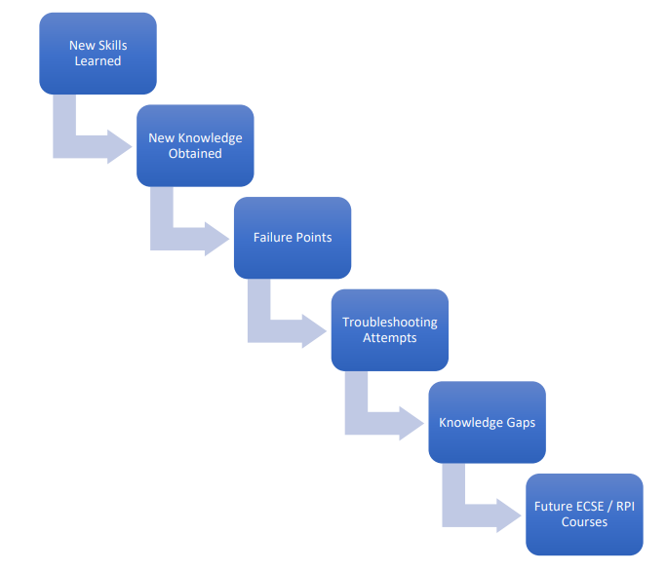
Contents
New Skills Learned 2
New Knowledge Obtained 2
Failure Points 3
Troubleshooting Attempts 3
Knowledge Gaps 4
Future ECSE/RPI Courses 4

New Skills Learned
Did you learn a new skill or use a skill you know a bit about in a different way?

New Knowledge Obtained
Did you obtain or use new knowledge? If so where did you get the information?

Failure Points
Did you see any failures through the process? What were those failures?

Troubleshooting Attempts
How did you attempt to troubleshoot and iterate through those failures?

Knowledge Gaps
What is some knowledge that you need to obtain to finish, calculate, understand, or improve your design?

Future ECSE/RPI Courses
Can you find any course that might help you in the future to make a better design? Explain how it will if you can.

Exploration Map Grading
Exploration Map Standards
- Exploration Completed

