Experiment 1

**Signals, Instrumentation, Basic Circuits and *LTspice***

**Purpose:** The objectives of this experiment are to gain some experience with the tools we use in EI (i.e. the electronic test and measuring equipment and the analysis software) and to gain some fundamental understanding of voltage dividers.

Background: Before doing this experiment, students should be able to

* Determine the values of series and parallel combinations of resistors
* Identify the audible frequency spectrum in humans
* Identify the value of standard, low wattage resistors from the color and pattern of their stripes
* Download and install software on a Windows machine

Learning Outcomes: Students will be able to

* Build, test and simulate a simple resistive voltage divider and demonstrate conditions under which measurement devices (oscilloscope) significantly affect the operation of the circuit. Then, use the changes in voltages caused by the measurement devices to determine the resistance of the measurement device.
* Be able to build simple resistive circuits driven by constant and periodic voltage sources using a small protoboard (aka breadboard).
* Use an oscilloscope to measure and display the voltages in a simple resistive circuit driven by a sinusoidal voltage from a signal generator.
* Simulate and display the voltages in a simple resistive circuit driven by a sinusoidal voltage source.
* Fully annotate voltage plots obtained both from physical and simulated experiments, including such signal characteristics as frequency (both types), period, amplitude, average or DC offset, etc. and identify where on a standard circuit diagram the voltages are found.
* Articulate a series of questions posed about simple circuits and answer the questions using fully annotated data obtained both from physical and simulated experiments.
* Develop the circuit model of a physical battery using an ideal voltage source and an ideal resistor.
* Calculate the power delivered by a battery and dissipated in a resistor.

Equipment Required

1. **M2K (ADALM2000) Instrumentation Board from Analog Devices** (With Scopy GUI)
2. **Oscilloscope** M2K
3. **Signal Generator** M2K
4. **DC Power Supply** M2K & Batteries
5. Two 100 Ohm resistors, two 1M Ohm resistors and two 1k Ohm resistors.
6. **Protoboard**

Helpful links for this experiment can be found on the **Links by Experiment** page. Be sure to read over all required info and ask for help when you need it.

**Pre-Lab**

*Required Reading:* Before beginning the lab, at least one team member must read over and be generally acquainted with this document and the other **required reading** materials listed under [Experiment 1](http://www.ecse.rpi.edu/courses/F21/ENGR-2300/EILinks.html#Exp1) on the EILinks page.

*Hand-Drawn Circuit Diagrams:* Before beginning the lab, hand-drawn circuit diagrams must be prepared for all circuits that will be physically built and characterized using your M2K board.

**Part A – Sine Waves and Hearing**

In this exercise, a signal generator will be used to produce electrical signals with various shapes, including sine waves. Our objective is to learn about the basic properties of sine waves and related signals by seeing them, hearing them and analyzing them with the oscilloscope and audio output capabilities of the M2K. You will need a set of ear buds or something similar to hear the audio. We will also demonstrate some interesting facts about human hearing and speech.

**Background**

*Equipment:* What formerly would require the use of an entire workbench of equipment can now be accomplished using the M2K (ADALM2000) (see Figure A-1 below) and a computer running the Scopy GUI. This board, coupled with the Scopy software, can produce the same functionality as each of the following pieces of equipment: a two channel oscilloscope (scope), a digital voltmeter (DVM), two DC power supplies, a two channel signal generator, and a 16 channel digital IO board. The digital voltmeter (DVM) has 2 channels (Here we use the oscilloscope Channel 1+ (Orange) and oscilloscope Channel 2+ (Violet)). The oscilloscope is a measuring device that lets you view a plot of a voltage signal vs time. The DC power supplies generate constant DC voltage signals (like a battery). The signal generator creates a voltage signal that varies with time. The PC is an integral part of the equipment setup. You use it to simulate many of the circuits you will build (using LTspice), as well as to operate the M2K.

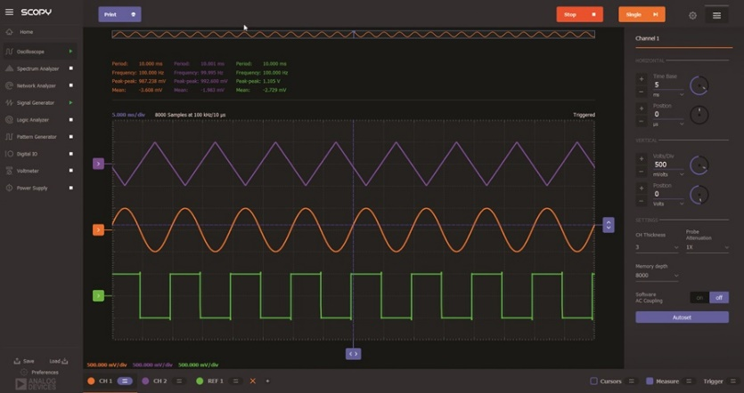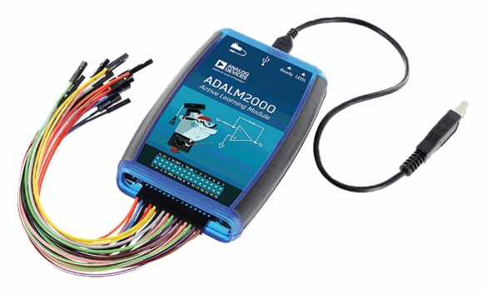

Figure A-1

In this experiment we will use the signal generator and the oscilloscope. The signal generator is used to create electrical signals with various shapes, including sine waves. The signal generator can be programmed to generate waves with specified amplitude and frequency. Ear buds and speakers convert an electrical signal to sound that we then can hear. The oscilloscope analyzes an electrical signal and displays a picture of the signal. The combination of the oscilloscope and audio output allows us to see with our eyes what we are hearing with our ears. We can also determine a mathematical representation of the sound that can then be used for system analysis. The two signal generators are labeled as Analog Output 1 W1 (Yellow) and Analog Output 2 W2 (Yellow/White). We will only need one of the signal generators in this experiment (Analog Output W1). See Figure A-2.

*The sine wave equation:* All of us should have studied the sine and cosine trigonometric functions in math and physics classes. A sine wave is described by an equation of the form v (t) = A sin (2πft) = A sin (ωt), where the variable t represents time. We use the term "wave'" because the shape is similar to a water wave that you might see on an ocean or a lake. As shown in Figure A-3, a sine wave is characterized by two parameters, called amplitude (A) and frequency (f). The amplitude A determines the maximum value that the sine wave achieves along the vertical axis. The sine wave takes on values between +A and -A at various times.

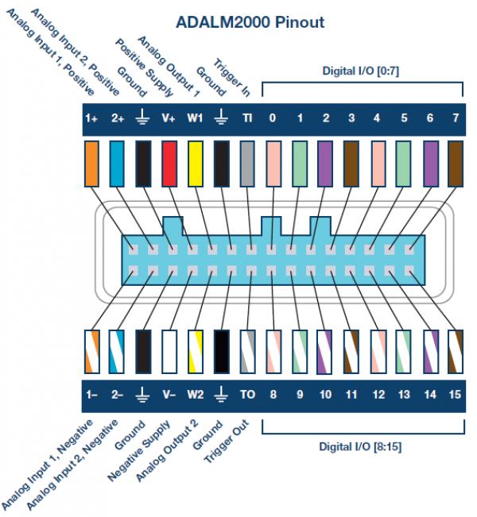

Figure A-2 Pin-out diagram, same pins and colors for M2K and Analog Discovery

The frequency f of the sine wave can be understood as follows. Notice that the sine wave reaches its peak value of +A at regular intervals. The time between adjacent peaks is called the period of the sine wave. The period is denoted by the letter T and it is measured in units of seconds (sec). The frequency is defined as the number of times per second that the sine wave achieves the peak value of +A. Since adjacent peaks are separated by T sec, the wave achieves 1/T peaks per second. Hence the frequency f is equal to 1/T, and the units of frequency are sec-1. Another name for the unit sec-1 is Hertz, or Hz for short. It is usual to denote the product 2πf as ω, where ω is called the angular frequency in electronics. (In physics, this is the rate of change of the angle in a rotating system, called angular velocity.) Note that one of the most common mistakes made in this class is confusing f and ω.

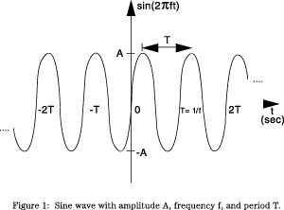

**Figure A-3. Sine wave with amplitude A, frequency f, and period T.**

*Adding a DC offset*: If we add a DC offset voltage to the sine wave signal, as shown in Figure A-3, it moves the wave such that it is centered around the DC offset. The equation becomes v (t) = A sin(2πft)+VDC. In electronics, the AC and DC parts of a signal can be treated as two mutually exclusive entities.

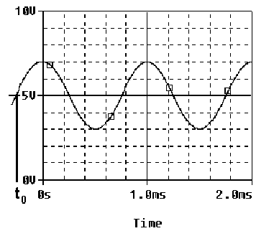

**Figure A-4.**

*Scalar measurement of sine waves*: Measurement devices do not usually give us the voltage amplitude A directly. Rather they determine VP-P (the peak-to-peak voltage) or VRMS (the RMS voltage). The peak-to-peak amplitude is the difference between the largest positive value of the sine wave and the largest negative value of the sine wave, so it should be nearly equal to A - (-A) = 2A. The RMS value is determined by taking the square root of the average of the square of the voltage. Since the voltages here are sinusoids . Note that in electronics the RMS voltage depends only on the time-varying amplitude and not on any offset.

*Impedance and resistance:* You are probably familiar with the term *resistance*. It is a measure of the degree to which a resistor resists the flow of electrons. Circuits that have a combination of components (some of which are not resistors) also affect the flow of electrons. However, the behavior of these circuits is more complicated because it varies with the frequency of the signal. We call this complicated response “*impedance.”* Both resistance and impedance are measured in Ohms, Ω, and the terms are often used interchangeably.

*Human hearing*: We are exposed to a wide variety of sounds every day. We hear a sound after our brain processes the sensations recorded by our ears. Two attributes that are commonly used to characterize sounds are loudness and pitch. Loudness, of course, refers to how loud or intense we perceive the sound to be. Pitch refers to whether we perceive the sound to be high or low. For example, the sound of an ambulance siren has a higher pitch than the sound of a fog horn. Keep in mind that your ear is a biological system. It is designed to hear certain pitches better than others even though, technically, they have the same loudness.

**Experiment**

*A.1) Setting up a Sine Wave on the Signal Generator*

For the first experiment, we need to set up a sinusoidal voltage.

After correctly installing the Scopy software and connecting the M2K, open the software. Clink on the M2K image, click connect. Scopy will do a calibration and then display the tools. Select the Signal Generator and the Oscilloscope. If you left click, hold and slide you can detach each instrument to be able to see both at the same time. You can also double click to detach if this is allowed in your Preferences . First we will set the frequency. The frequency of the signal generator is adjusted as follows:

1. Make sure that you choose the channel you are setting up by using the buttons on the lower left corner:
2. You only need one signal generator in this experiment.

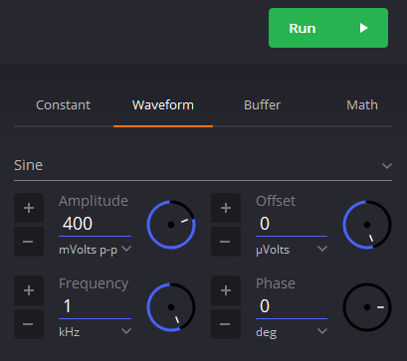

**Run Button**

1. Select “Waveform”
2. Use the pull down menu to choose Sine
3. Amplitude: 400 mVolts p-p
4. Frequency: 1kHz
5. Other settings can be left as they are.
6. Make sure that you press the green Run button.
7. Reference: <https://wiki.analog.com/university/tools/m2k/scopy/siggen>

* On the scope (oscilloscope) select channel 1, CH 1 on the lower left corner. The voltage and time scale settings are found on the right hand side of the oscilloscope window.
* Horizontal – set to 200us/div, 0 for position. Set Vertical to 100mV/div, 0 for position.
* Reference: <https://wiki.analog.com/university/tools/m2k/scopy/oscilloscope>
* To make a measurement, connect the source (W1) to oscilloscope input (1+) and oscilloscope input (1-) to ground.
* When you are ready, press the “Run” button on the Signal Generator and the “Run” button on the oscilloscope. If you cannot see a signal on the oscilloscope, double-check to make sure all of the settings are correct.
* Change the frequency up or down as desired. How does this change the signal on the oscilloscope? The purpose of this step is to see what kind of signals this setup can produce. You should play around a little with different frequencies, voltage amplitudes, signal shapes, etc.
* Set Signal Generator back again so the display reads 1kHz and the amplitude is 400mV p-p with no offset. Use the ‘Print’ button to create a pdf of the oscilloscope screen. **The image in the pdf will be used in your report document. For the report you must clearly label both the amplitude and period of the signal you have measured**.

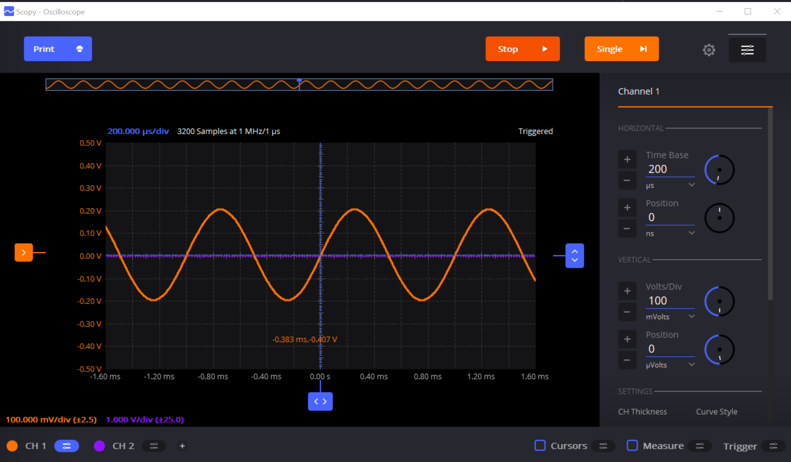

**Time and voltage scales**

**Run Button**

*A.2) Using the Output from M2K* *(Building our first circuit.)*

We now wish to connect a simple circuit using the speaker in the parts kit.

SPEAKER

Black

Wire

C1

220uF

Solid Yellow

Wire

M2K

(ADALM2000)

|  |  |
| --- | --- |
|  |  |
| Schematic Layout | Physical Layout |

* **Start by building the circuit using your protoboard**. If you have not used a protoboard look at the “How to use a breadboard” link under the Experiment 1 on the course website. The circuit we will build is shown on the left in the above figure. It consists of a sinusoidal source, Vs, a capacitor and a speaker. The 220μF capacitor is in your parts kit. It is an electrolytic capacitor, which means there is a conductive media in the can (as opposed to the ceramic capacitors). On the side of the capacitor, you should see the value written as 220μF. The capacitor also has polarity, which means one side should be negative and the other side should be positive. You can identify the negative side by looking for the ‘grayish/whitish’ stripe with a ‘minus’ sign in it. That side should be connected to the speaker. We will violate the polarity rule for electrolytic capacitors but with low voltages over short periods of time. There will be reverse leakage current which in other situation could cause the circuit or the capacitor to fail.  
  Question: why do we need a capacitor in this circuit (an audiophile question)? The speaker in your parts kit should be large and pretty easy to identify.
* The figure on the right is the physical layout for your protoboard. The sinusoidal source and ground shown in the schematic are provided by the M2K. In effect, everything inside the ‘dashed box’ of the schematic is hidden from you. Connecting the solid yellow wire to the capacitor and the black wire to the speaker implements the sinusoidal source and the ground.
* Once you have the circuit built, set your Signal Generator Channel 1 (the solid yellow wire) to a 250Hz, 0.5V amplitude sinusoidal wave. Listening to the speaker, adjust the volume of the signal by changing the amplitude of the signal. Find the minimum voltage that allows you to hear the speaker. Increase the amplitude and find a volume that you find most comfortable, neither too loud or too soft. **What is the value of the voltage amplitude that you have selected?**
* Let us investigate how our perception of loudness changes as the frequency of the sine wave is varied. With the sine wave amplitude fixed at your comfortable level, vary the frequency over the range from 100Hz to 10,000Hz. Try cycling through the following frequencies, without changing the signal amplitude: 100, 200, 300, 400, 500, 600, 700, 800, 900, 1000, 2000, 3000, 4000, 5000, 6000, 7000, 8000, 9000, and 10,000Hz. Which frequency do you hear the loudest? Is there any variation among the members of your group? If you have problems discerning significant differences in loudness, try changing the amplitude of the sinusoid.
* Generate a tone at the frequency that appears loudest. Does the pitch of this tone seem to be one that you commonly hear in speech, music, and automobile traffic? Use the website on the links page to verify this.

*Experiment with the Equipment*

At this point, you will have put the signal generator and oscilloscope through some basic tasks. Experiment with the other features of the signal generator and see what happens. For example, change the DC offset, the shape of the signal, add some phase/time delay, etc. Some very interesting and annoying waves can be produced. Play around a little and then find a particular set of operating conditions that you find the most interesting. Under what circumstances might you experience the sounds you have produced or generally when might you encounter a waveform like the one you have displayed on your oscilloscope?

**Summary**

You should now know how to set up voltage signals with the signal generator feature, connect the signal generator output to the oscilloscope input and display them using the oscilloscope feature. You should understand the pitch/frequency and amplitude/volume relationships, and know how these relate to human hearing. ***Review the report write-up section at the end of this document. Make sure that you have all the data required to complete the write-up.***

**Part B – Voltage Dividers and Measuring Equipment**

In this part of the experiment you will be learn that equipment isn’t ideal and that “real” behavior must be taken into account when making measurements. You will look at batteries and measure the effective internal resistance; they aren’t ideal voltage sources. You will also look at the behavior of two voltage dividers when a DC voltage and an AC voltage are applied. You will use circuit analysis to examine the behavior of these circuits.

**Background**

*Impedance*: Every piece of electrical equipment has an effect on the circuit you connect it to. Just as it is impossible to design a dynamic mechanical system without friction (that resists motion), it is impossible to design an electrical system without impedance (that resists the flow of electrons). Impedance has two effects on an electrical system. It changes its magnitude (the value of the voltage) and its phase (voltage behavior over time). If the impedance affects only magnitude, then we call it resistance. Each electrical measurement device has an internal impedance, and this is also true for the M2K. The impedances we will concern ourselves with in this class are listed in table B-1 below: (These values aren’t exactly correct, but they still can be used to make the point.)

|  |  |
| --- | --- |
| **Device** | **impedance (magnitude only)** |
| M2K oscilloscope input | 1MegΩ |
| DMM (DC voltage) | 10MegΩ |
| DMM (AC voltage) | 1MegΩ |
| signal generator M2K | 50Ω |
| DC power supplies (any) | negligible |
| Batteries | 0.4 to 32Ω |

Table B-1

Note that presently we are only concerned about the effect of the equipment on the magnitude (resistance component) of the impedance. Also note that the devices in the studio are designed to have minimal effect on any circuit they are connected to. In this part of the experiment, we will examine how much of an effect the equipment has.

*Voltage dividers*: In order to analyze the effect of the equipment, we need to understand a fundamental concept of circuit analysis called a voltage divider. Basically, when a voltage in a circuit is with two or more resistances, it divides up in a manner proportional to the resistances. That is, a larger resistance will have a larger voltage drop and that voltage drop will be proportional to the size of the resistance divided by the total resistance of a circuit.

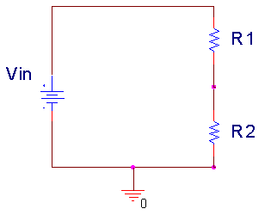

**Figure B-1.**

In Figure B-1 above, Vin is divided between R1 and R2. Mathematically, this can be expressed:



Note that R1+R2 is the total resistance of the circuit. We can use a voltage divider to determine how much effect a device has on a circuit, or in this case, the effect that a circuit has on a device. In the simple electrical model of the battery shown in Figure B-2, the internal resistance of the battery depends on the battery size and chemistry. This is a simple model that ignores much of the internal chemistry including changes as the battery is discharged. The default assumption normally is that the voltage output of a battery doesn’t change with the load. We will investigate how this works in an actual circuit.



**Figure B-2.**

The output of the battery is measured using the M2K with and without a load resister. Remember that Rbat represents the internal model of the battery. ***You do not add this resister to the circuit***. Rload represents the load, or combined resistance of whatever circuit you place on the source. Using the voltage divider rule, we know that the voltage drop across the load is given by: .

*Series and parallel circuits*: Another fundamental concept we need to understand in order to analyze the circuits we will build is how to mathematically combine resistances. If any number of resistances are connected in series, you simply add them to find the total resistance. If any number of resistances are wired in parallel, the total resistance is the reciprocal of the sum of the reciprocals of all of the resistances. This is summarized in Figure B-3.

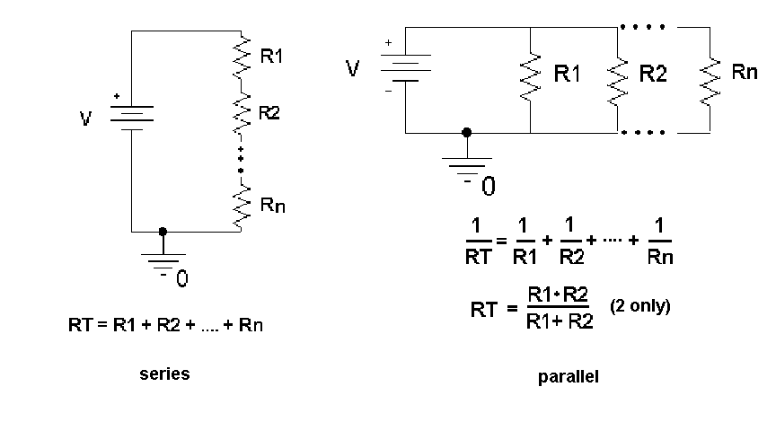

**Figure B-3.**

Note that the voltage divider rule applies only to series circuits. Any time we use our measuring devices to measure the voltage across a device, as illustrated in Figure B-4, we are combining that device in parallel with the resistance we are measuring. So just connecting the oscilloscope will affect the quantity to be measured. In this case the effective load resistance on the battery is Rtotal and it is the parallel combination of the oscilloscope impedance (1MegΩ) with the resistance of the load resistor (Rload). This results in total load resistance, Rtotal.

Vbat

Rbat

Rload

Rscope

1Meg

Vbat

Rbat

Rtotal

=

**Figure B-4.**

Once you have the total load resistance, RT, you can use the voltage divider rule to find the internal resistance of the battery. Note that, since the voltage drop across any number of resistors in parallel is the same, VRtotal is equal to VRload.

*Other basic circuit components:* There are two other basic circuit components: capacitors and inductors. To combine capacitors in series take the reciprocal of the sum of the reciprocals. To combine capacitors in parallel, simply add the capacitances. [Note: This is the opposite of combining resistors.] Inductors combine like resistors. To combine inductors in series, you add them. To combine them in parallel, you take the reciprocal of the sum of the reciprocals.



**Experiment**

# *B.1) Some DC Measurements*

We will look at what happens when we apply a load to a battery. We will be using batteries extensively in this course, so understanding their basic electrical properties is critical. We will be making DC measurements, like we do with a typical multi-meter. For this section, shut off the oscilloscope, go to the main Scopy window and select Voltmeter. When this is enabled, it will use the inputs for the oscilloscope channels, but it is better to have the oscilloscope off to avoid confusion.

1. **Measure the voltage of a 9V “Heavy Duty” battery without any lo**ad. If you don’t have a 9V batter, choose any convenient battery. Simply take wires touching the battery to the protoboard and connect the leads from the protoboard to the 1+ (Scope Channel 1 Positive (orange)) and 1- (Scope Channel 1 Negative (orange-white)). Note that, when we make most measurements in this course, they will be single-ended (referenced to ground). Then you need to touch the 1+ wire to the point of interest. To do this, **the negative input 1- and GND must be connected.**  When we make what are called differential measurements, we use the two wires but do not connect the ground. We will return to that in a future experiment. In this case the load is an open circuit (infinite resistance) because we have added no load to the battery; the input resistance of the M2K is also so large compared to the range of battery resistance listed above, that it can also be ignored. Record the value of the voltage you measure. (It will also be useful to check your measurement with a multi-meter if you have one. This extra step is not required.)
2. **Now add a load to the battery, as in Figure B-5.** The load is two 100Ω resistors in series. We will discuss why two resistors are used a little later. Set up the circuit so that you can add and remove the load quickly, leaving it disconnected unless you are making a measurement. This just means wire it so that it is easy to pull out and reinstall one end of one resistor. **You should only connect the load to the battery for a short moment (a second or two)** long enough to make the measurement. If you leave the resistors connected, your battery will drain down quickly and will definitely not last a full semester. Record the voltage displayed in the Voltmeter window of the M2K with the resistive load disconnected. **Then connect the resistors, quickly record the new voltage, and quickly disconnect the load.** You may want to repeat this a few times to find the typical change of voltage with and without the load. Remember to record the unloaded battery voltage as well as the change in voltage. In the figure, A1+ is 1+ and A1- is 1-. The A reminds us this is an analog measurement.



**A1-**

**GND**

**A1+**

**Figure B-5.**

Use the results from this experiment to determine the value of Rbat.

1. Repeat the experiment with a different battery (with a different voltage). If you do a low voltage battery it may be wise to load the battery with only one 100Ω resistor.
2. Share data with others in your team so that you have numbers for at least 4 battery types.

*B.2) Some AC Measurements*

The part above showed that the load can affect the equipment, in this case a battery. Now we will look at how the instrument can affect the circuit. The M2K oscilloscope can load the circuit and affect the circuit to be measured. Now you can shut off the Voltmeter and turn on the Oscilloscope again.

1. Use the signal generator, W1, of the M2K to put an AC signal on a resistor divider circuit shown in Figure B-6. Set the Signal Generator to 1kHz and Amplitude to .5 V (since the goal is 1VP-P) . Use R1 = 1kΩ and R2 = 1kΩ. Take data and plot the output using Excel.



**W1**

**A1-, A2-**

**A2+**

**GND**

**A1+**

**Figure B-6.**

Make all the connections on the protoboard. In the circuit above, A1+ is analog input + which is 1+ for M2K. A1- is 1-, A2+ is 2+, A2- is 2-. GND is Ground. The Signal Generator output is W1. Only one ground connection has to be made from the M2K because the Signal Generators (W1 & W2) are connected internally to ground.

* Calculate the ratio of the voltage measured on 2+ to the voltage on 1+.
* Repeat the experiment using R1 = R2 = 1MegΩ resistors. Again create a plot of the voltages and calculate the ratio of the voltages.
* The more exact model of this measurement is given in Figure B-7, were RA1+ and RA2+ represent the effective internal input resistances of the analog input channels of the M2K. The effective input resistance of A1+ can be ignored (Do you know why?), but the input resistance of A2+ effects the measurement. Using the measurements above, estimate the value of RA2+.



**A1-, A2-**

**W1**

**GND**

**RA1+**

**A1+**

**RA2+**

**A2+**

**Figure B-7.**

Useful Hints:

* You can copy an image of the plot to a pdf using the Print button and then copy that to Microsoft.
* You can save the data in a csv file, which you can open in Excel, using “Export.”
* You can change the thickness of the line segment by scrolling down the Channel control on the right hand side of the oscilloscope tool.

# *B.3) Power Calculations and Impedance Matching*

Now we will look at the power associated with the battery circuit

* Power Ratings: In part B.1 you used two resistors in series. The effective resistance of resistors in series is simply the sum of the resistances. So why use two 100Ω resistors in series when we could use one 200Ω resistor? Power rating is the answer.  where P is the power, V, I, and R are the voltage, current, and resistance of the load. The power is in Watts if you use Volts, Amps and Ohms. Our resistors have a power rating of ¼ watt.
  + Calculate the total power out of the battery for part B.1 for just the 9V battery (or other battery) measurements.
  + Calculate the power per resistor. Ask for help if it isn’t now clear as to why we used 2 resistors rather than one for this measurement.
  + Calculate the total power out of the battery for part B.1 for the other battery you used.
* Impedance matching: Impedance matching is important with weak signals, not with batteries. Even so, the concept can be demonstrated using our circuits. Don’t wire this circuit; it would cause excessive heating and a rapid discharge of the battery.

For this part assume that you have a 9V battery with an internal resistance of 30Ω. Using Figure B-2, calculate the voltage that would be measured across the load if the load resistance is 100Ω, 60Ω, 30Ω, 20Ω, and 15Ω. For each load resistance, determine the power that would be dissipated in the load resistor. Plot the power dissipated vs. the load resistance.

If you did this correctly, you will see that the maximum power in the load occurs when the load resistance is equal to the internal battery resistance. This is call impedance matching.

**Summary**

You should now understand how to calculate the effective resistance of resistors in series and/or in parallel. You have an appreciation of AC and DC signals, and that the load and/or the equipment affects the voltages and currents in the circuit. Lastly you should be comfortable with using the M2K, including the signal generator, the oscilloscope and the voltmeter.

**Part C – Introduction to *LTspice***

In this section we will learn about the circuit analysis software we will use as our primary simulation tool. You should download and install this software on your laptop. The download is located near the top of **Links by Experiment** page on the course website. You should also review the other *LTspice* links on this webpage. It is recommended that you install the latest version. Note: The color scheme for LTspice has been modified for the figures used. In particular when plotting signals, the background has been changed from black to white as this will use less ink when printing.

**Background**

The software we will be using to simulate the operation of circuits in this course is called *LTspice*. The *LTspice* software serves to both enter a schematic and analyze that circuit using a standard called spice. Figure C-1 shows buttons used to edit a schematic in *LTspice* and Figure C-2 shows a simple circuit with an output voltage. *LTspice* takes circuit information and analyzes how it will behave. The display of the output similar to what you would see if you hooked the circuit to an oscilloscope.

Note: Use the latest version of LTspice, presently LTspice XVII. Figures shown here might be from an older version but the important items are covered.

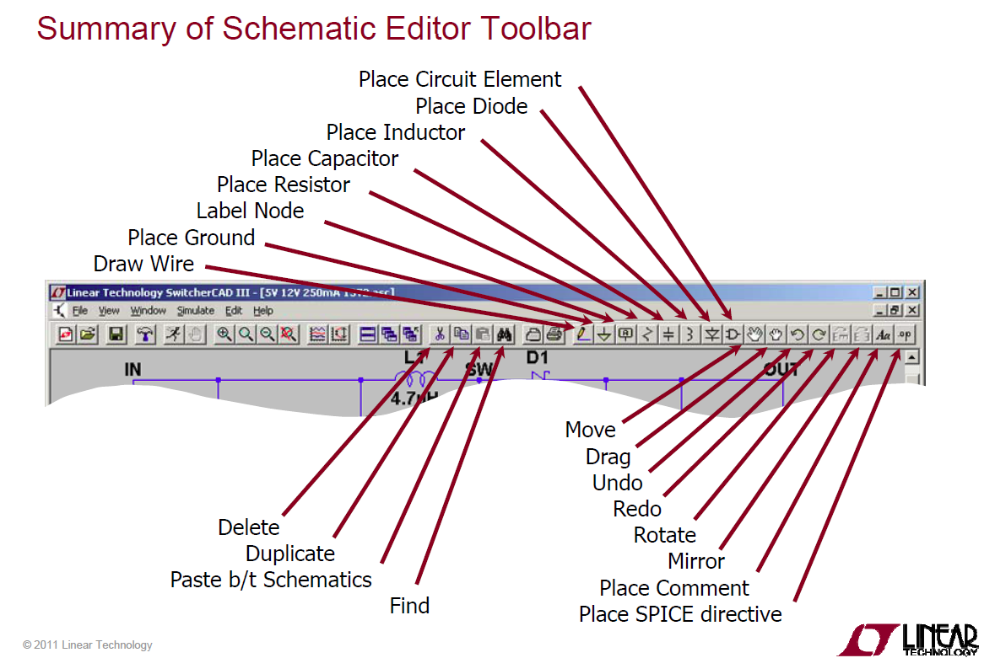

Figure C-1 summary of schematic tool editor, page 26 of LTspiceGettingStartedGuide

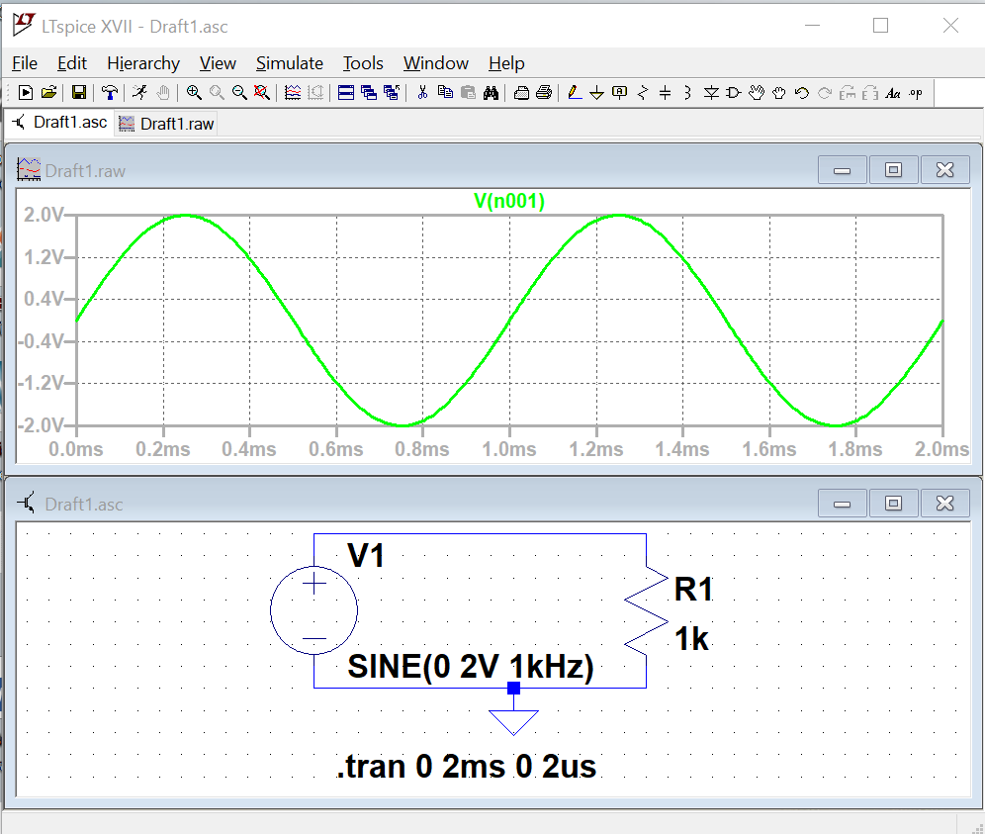

Figure C-2

**Experiment (Simulation)**

*Creating a schematic in LTspice:*

In this part of the experiment, we will use *LTspice* to draw the simple circuit we have been studying, a combination of resistors and a sinusoidal voltage source.

* Select the *LTspice* app
* Click on the *File* pull-down menu and select *New Schematic or click on left most icon*. A empty grid will appear.

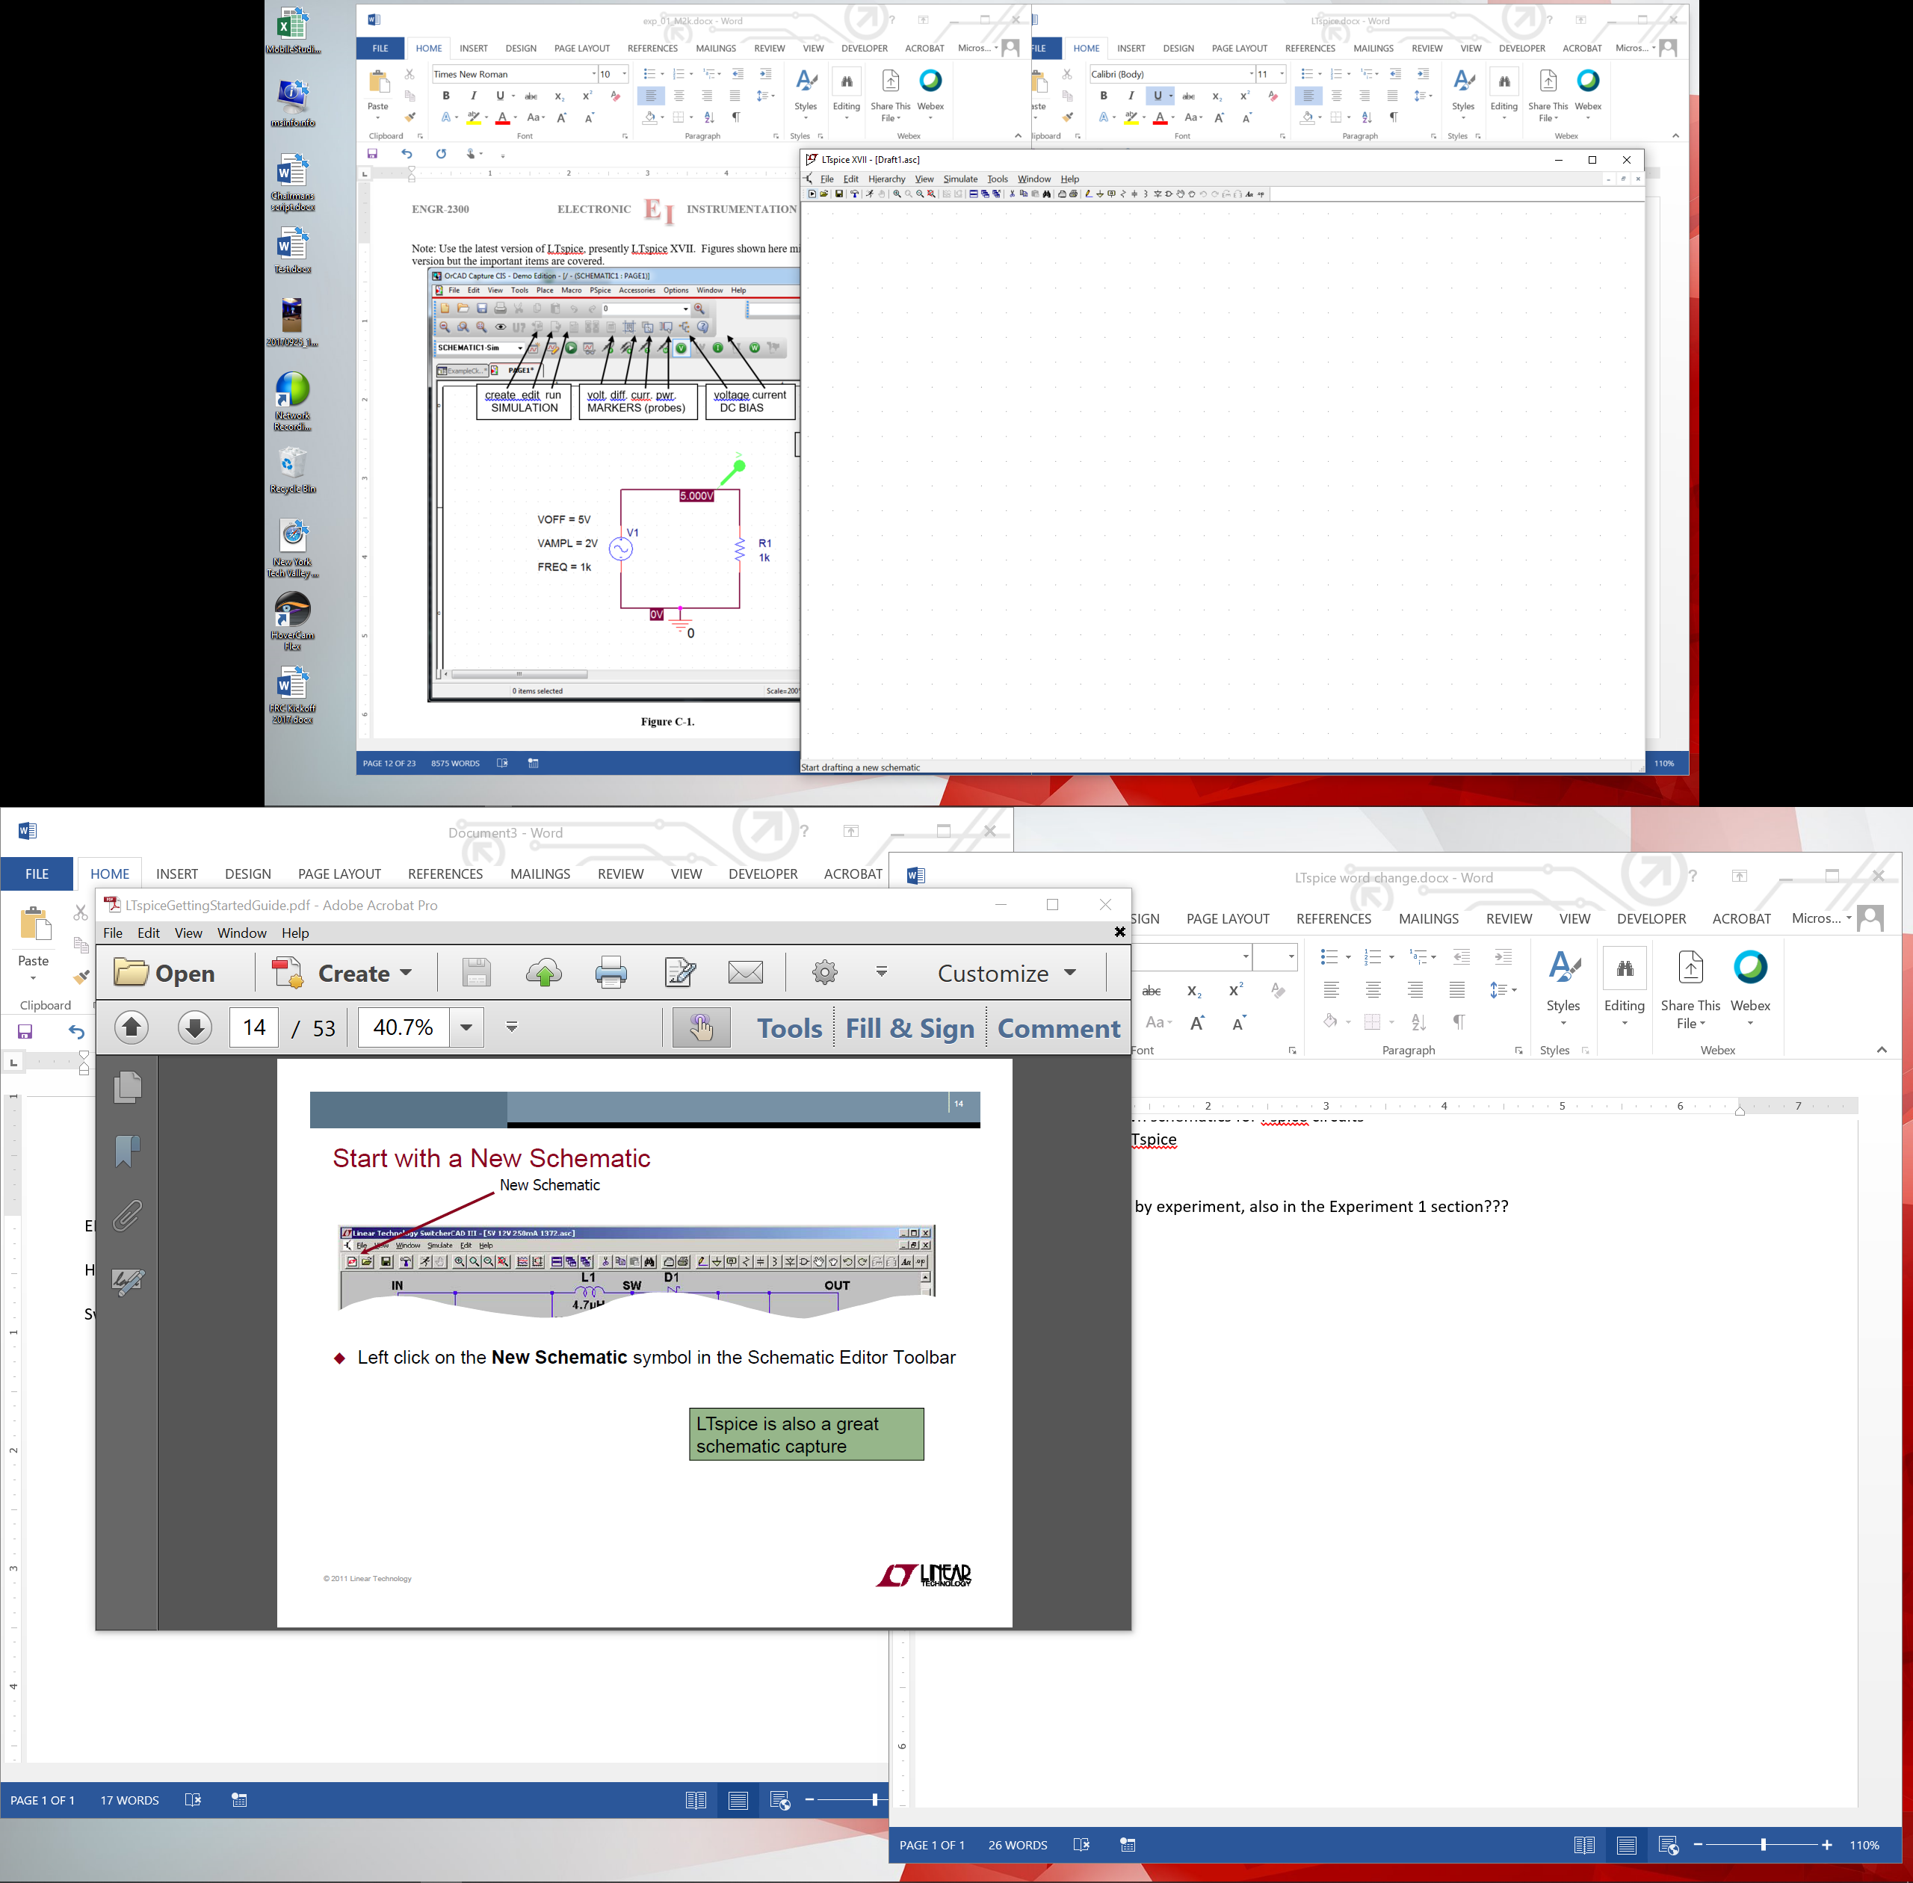

create new schematic

Run simulation

**Figure C-3. Icon on left creates a new blank schematic**

* Give your project a recognizable name, such as *EXP1-C.*  For a location, it is recommended that you create a directory in which you store all of the files you will generate in this course from *LTspice, M2K, Word, Excel, etc.* *LTspice* might involve 20 files per experiment, so a folder for each experiment is a good idea.
* Now you should see the main *LTspice schematic* screen. You are ready to draw a circuit.

*Drawing a Circuit*

***Note: Color Preferences have been changed for the figures shown to reduce ink usage if you print this document. For your reports color choices are personal preferences.***

Figure C-4 is a picture of the *Capture* main screen with the circuit we will be drawing. Note that this is the circuit used in Figure B-7 including the input resistance of one channel of the M2K.

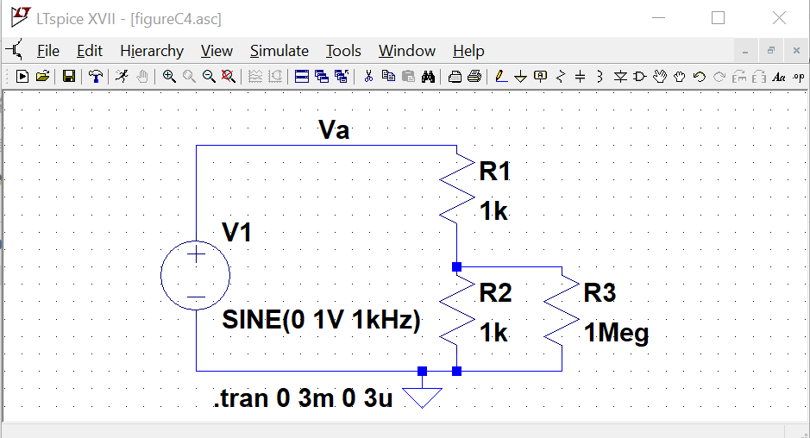

**Figure C-4.**

In the circuit shown in Figure C-4, we have some resistors, an AC voltage source, a ground and some wires. To create this diagram, we will use the command buttons. For the resistors we will click on the button that looks like a resistor and for the voltage source use the button that looks like a logic gate:



Voltage Source

Resistor

* Click on the resistor symbol and you can place the resistors where you want them by moving the mouse around and clicking at the appropriate location. Once you have placed the all the resistors you need, hit the escape key. You will notice that each resistor has a name, such as R1, and a default value which is just R at this point. You can edit the name by right clicking on the name, and edit the value by right clicking on the value.
* You must edit all of the values for LTspice to be able to run a simulation. **Change R1 and R2 to be 1k and R3 to be 1Meg.** Spice doesn’t recognize capitals so a mega ohm must be entered as meg, or Meg or MEG. If entered as 1M spice sees it as 1 mili ohm, the same as 1m.

The voltage source:

* Click on the component symbol, the logic gate. A box will appear that looks like the figure in C-5.
* You have 2 options to find the voltage source:
  + Type “voltage” into the search box
  + Look at the components to the far right in the lower library box
* Place the voltage source on the schematic. Hit escape to avoid placing extra sources.

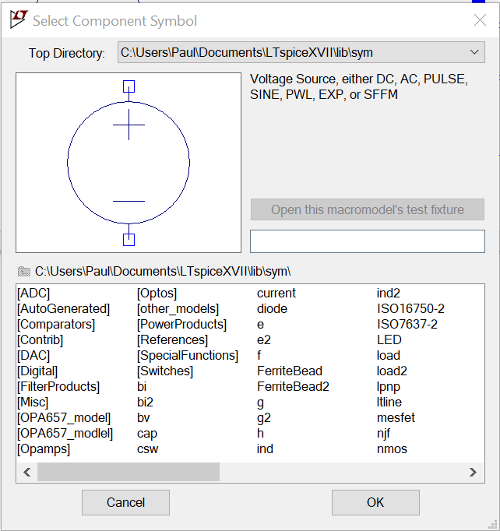

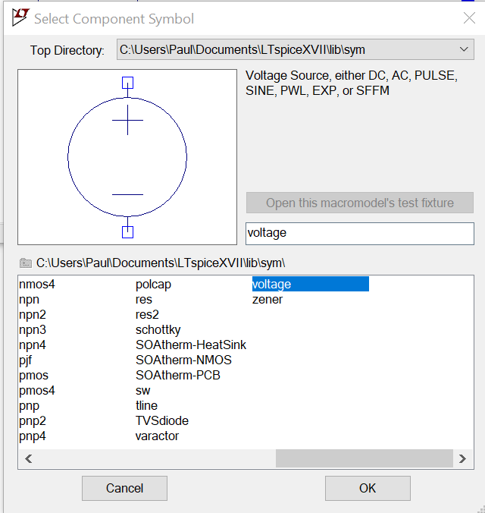

**Figure C-5.**

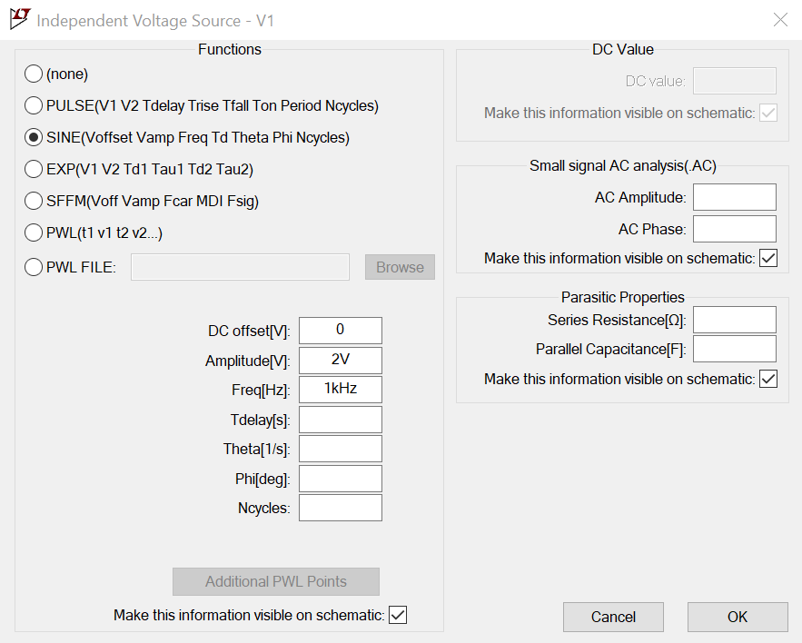

**Figure C-6.**

Configure the Voltage Source:

* Hold the mouse over the Voltage Source symbol and right click. A dialog box opens as shown in figure C-6.
* Select SINE
* At this point we only need to set the Amplituce and the Frequency. Use 2V and 1kHz as shown.
  + V for Volts and Hz for Hertz are optional.
* Hit OK and place the statement anywhere on the schematic: 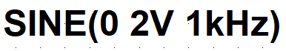



Wire

GND - ground

**Figure C-7.**

* Add a ground. All schematics must have a ground reference.
* Wire the schematic. Start an open box with a left click. Left click again to set points were the wire makes right angle bends. End on a box.

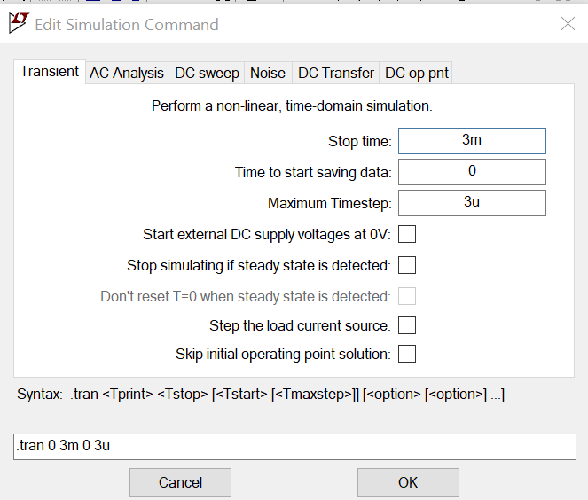

You need to tell *LTspice* what type of analysis is to be done.

* Click on the “Simulate”.
* Click on “Edit Simulation Cmd”
* We wish to see the circuit behavior over a few cycles of the 1kHz sinewave, so 3ms should give us 3 cycles.
* It is recommended that a “Maximum Timestep” is set to have high resolution. A simple guide line is to set it at factor of 1000 smaller than the run time.
* Click OK and place the simulation command anywhere on the schematic page.

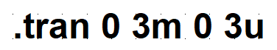

**Figure C-8.**



**Figure C-9.**

Run the simulation. Either click on the runner button or choose to run in the “Simulate” menu.

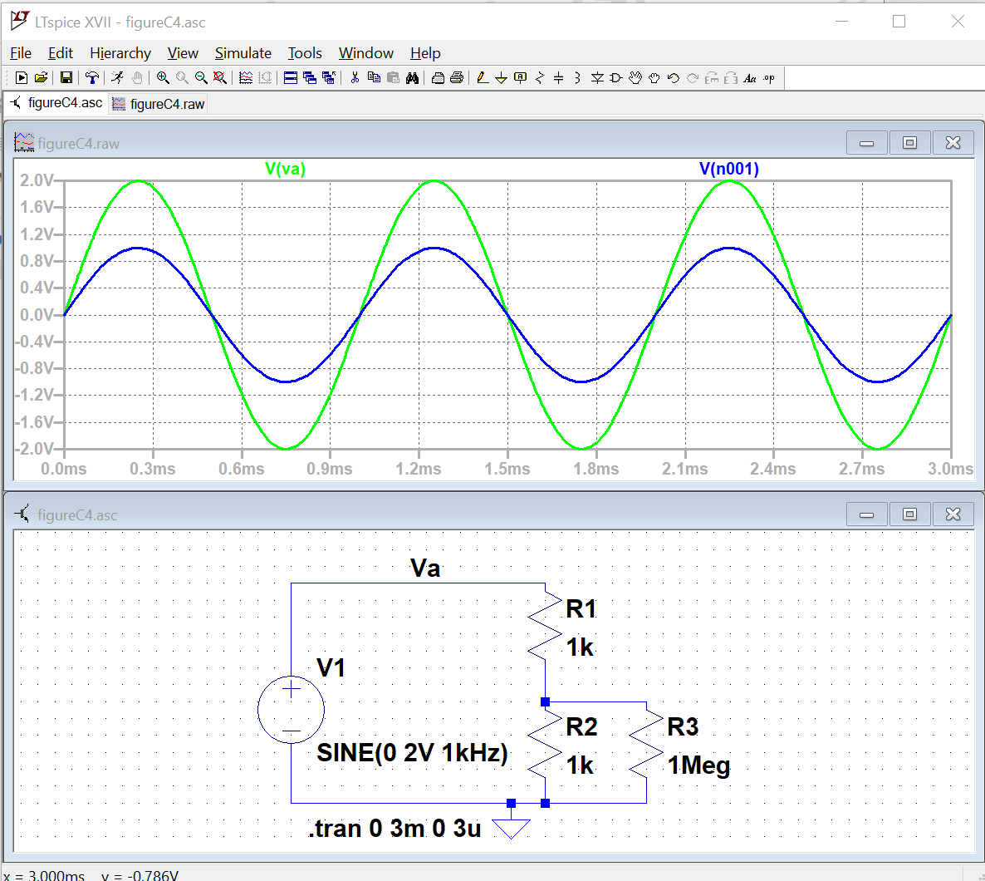

**Figure C-10. *Note: Color Preferences have been changed for the figures shown to reduce ink usage if you print this document. For your reports color choices are personal preferences.***

Hover the cursor over a wire in the circuit. A voltage marker will appear. Click and a voltage trace for the voltage at the point will appear in the plot box. If you hover the cursor over on end of a component and a current marker will appear, clicking will cause a current trace to appear in the plot box.

Using plots and schematics in reports:

You can print or copy a bit map of either the schematic or the plot box. Click in the window of interest. Use the File menu to print or use the Tools menu to copy the bitmap to the clipboard.

Exporting data:

The data for traces can be exported as text using the file menu. The text file can be opened with other programs such as MatLab or Excel.

Control Panel:

In the Tools menu – there is Control Panel. You can change the trace width, trace colors, fonts, and much more.

Name Nodes:

A node is a connection in the circuit. Each wire is assumed to be ideal so any point on a wire will have the same voltage, so each wire is part of a node. Spice names the nodes with node numbers such as n001. These aren’t very informative. You can gave a node another name using the “Label Net” button. A name Va is shown in Figure C-4.

Label Net

* Plot the input and output voltage traces.  *Save or print this plot and the schematic.* Include them in your report.
* Change the values of the resistors in the voltage divider, R1 and R2, to 1MEG and rerun the simulation. *Save or print voltage plot as well.* Both plots should have two traces: the source voltage, and the voltage across the resistor closest to ground. Do the plots agree with your results from part B? What happens if you set the resistor values to the exact measured values of your resistors in part B? Are the results closer? Try varying the frequency, amplitude and offset of the VSIN source one at a time and rerun the analysis. What happens to your signal? Does it make sense based on your knowledge of sine waves and voltage dividers?

**Summary**

*LTspice* is a very powerful simulation tool meant to address the circuit simulation needs of all engineers who must do circuit design and analysis. Thus, there are many, many opportunities to make what seem like silly mistakes that prevent the analysis from working properly. In your first attempt at using these tools, it is likely that you have already made some of these mistakes. You should also have heard about some of them in class. What mistakes did you make?

# Checklist and Conclusions

Provide the following packet. Include the cover/signature page attached to the end of this handout. The signatures are required for all statements with a signature line next to it. They must be signed by TAs or Professor(s) after ***seeing the results on the computer screen while the experiment or simulation is running***. Give all required results and answer the questions concisely. It is intended that these be quick to write.

# The following should be included in your experimental checklist. Everything should be labeled and easy to find. Partial credit will be deducted for poor labeling or unclear presentation. ALL PLOTS SHOULD INDICATE WHICH TRACE CORRESPONDS TO THE SIGNAL AT WHICH POINT and the key information contained in the plot should be labeled so the reader can fully understand the data without referring to the report text.

# Hand-Drawn Circuit Diagrams for all circuits that are to be analyzed using LTspice or physically built and characterized using your M2K board.

**Part A: Plots for Sine Waves and Hearing (14 points)**

Part A1: *Setting up a Sine Wave on the Signal Generator*

1. Printed output plot of signal measured by the oscilloscope with a peak-to-peak amplitude of 400mV(Amplitude of 200mV) (TA ***MUST*** see this live on your computer screen to sign checklist) (5 pt)
2. On the plot, mark the period and amplitude and denote the calculated frequency (1 pt)
3. Briefly comment on any differences between the FG settings, the Measurement window results, and the results from the oscilloscope plot (1 pt)

Part A2: *Using the Audio Output from M2K*

1. When listening to the audio, what does the oscilloscope measure for the peak-to-peak amplitude when the speaker is producing a comfortable level of sound? (4 pt)
2. What is the period of the tone at the frequency that appears loudest when you scanned through the entire range of frequencies? *Note: There is a range of acceptable answers to this question since it depends on the hearing of the person listening and the frequency response of the circuit*. (3 pt)

**Part B: Voltage Dividers and Measuring Equipment (48 points)**

Part B1: *DC Measurements*

1. Create a table of data for all four battery types. Remember that you only need to measure 2, and then collect data from other groups to complete the table. The table must have a) battery type, b) unloaded battery voltage, c) loaded battery voltage, d) the total load resistance of the test, and e) the calculated value of Rbat. Show the formula you used to calculate the value of Rbat. (20 pt)
2. Find one reference that states the expected internal resistance of one of the batteries used. In most cases we assume you will find one using a web search. Battery company web sites might be a place to look. Give the source and the value stated. Compare it to the measured value. (4 pt)

Part B2: *AC Measurements*

1. Printed M2K oscilloscope plot or the plot copied to a Word doc of input and output from the 1k voltage divider. (TA ***MUST*** see this on your computer screen to sign checklist) (4 pt)
2. Printed M2K plot or the plot copied to a Word doc of input and output from the 1Meg voltage divider. (4 pt)
3. Calculate the value of RA2+. (4 pt) Show your work. (4 pt)

# Part B3: *Power Calculations and Impedance Matching*

1. List the power out of the 9V battery and the power per resistor. Also state the power out of the AA battery pack. (4 pt)
2. Plot the predicted power into the load vs. Rload for a 9V battery assuming the battery has an internal resistance of 30Ω. *Note: There should be a maximum power (matched impedance)* (4 pt)

**Part C: Introduction to *LTspice* (14 points)**

Part C1: *AC Measurements*

1. Printed *LTspice* transient plot of voltage divider with 2 1k resistors (two traces). (4 pt)
2. Printed *LTspice* transient plot of voltage divider with 2 1MEG resistors (two traces). (TA ***MUST*** see this “live” on your computer screen to sign checklist) (4 pt)
3. How does the signal you generated with *LTspice* using the 1k voltage divider compare to the one you generated with the M2K oscilloscope? (3 pt)
4. How does the signal you generated with *LTspice* using the 1Meg voltage divider compare to the one you generated with the M2K oscilloscope? (3 pt)

**Responsibilities (4 points)**

**List group member *responsibilities*.**  (4 pt) Note that this is a list of *responsibilities*, not a list of what each partner did. It is very important that you divide the responsibility for each aspect of the experiment so that it is clear who will make sure that it is completed. Responsibilities include, but are not limited to, reading the full write up before the first class; collecting all information and writing the report; building circuits and collecting data (i.e. doing the experiment); setting up and running the simulations; comparing the theory, experiment and simulation to develop the practical model of whatever system is being addressed, etc.

**Total: 80 points for experiment packet**

**+20 points for attendance**

**100 points**

**Attendance (20 possible points)**

**2 classes (20 points), 1 class (10 points), 0 class (0 points)**

**Minus 5 points for each late.**

**No attendance at all = No grade for this experiment.**

**Notes:**

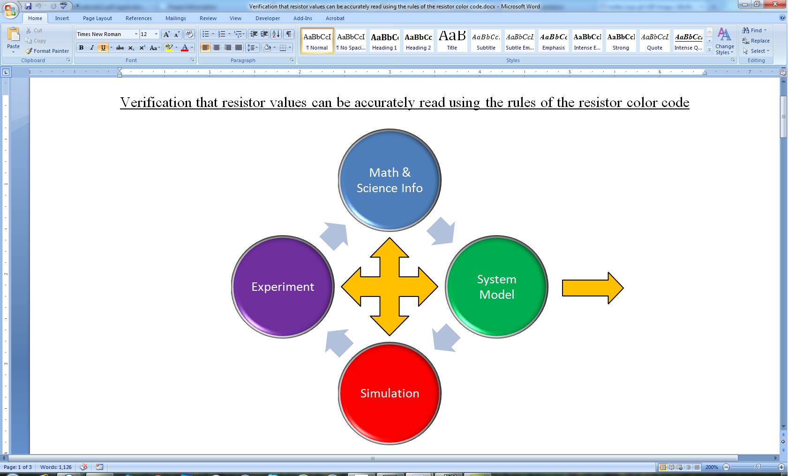There will be an additional task in all subsequent experiments to identify practical examples of the content from the experiment that one encounters as a consumer, an engineer, a physician, etc. Since this is the first experiment, it is not necessary to address this issue. However, one of the key circuit configurations we will see over and over and over (could really go on forever here) is the voltage divider. You should be on the lookout for it in every experiment and project because almost all circuits involve some combination of components in series. Make sure that you fully understand the voltage divider in the context of the engineering design process as represented graphically by the diagram. That is, what is the basic theory (background info)? How do you set a divider up to analyze it through simulation and experiment? What are the practical issues associated with it? For the last question, you should be able to explain, from the results of this experiment, how adding a load to a voltage divider can significantly change its performance. We will revisit this issue many times, but especially in the experiment on Op-Amps.

Engineering Design Process

***Experiment 1***

***Section: ______***

***Report Grade: ______***

***____________________________________ Name***

***____________________________________ Name***

***Checklist w/ Signatures for Main Concepts***

*For all plots that require a signature below, you must explain to the TA or instructor:*

* *the purpose of the data (using your hand-drawn circuit diagram),*
* *what information is contained in the plot and why you believe that the plot is correct.*

*Any member of your group can be asked for the explanation.*

**PART A: Plots for Sine Waves and Hearing**

**A1:** Setting up a Sine Wave on the Signal Generator

* 1. **Signal Vp-p 400 mV _________________________**
  2. **Mark plot**
  3. **Comment**

**A2:** Using the Audio Output from M2k

1. **Comfortable sound peak to peak value**
2. **Loudest frequency: value of period**

**PART B: Voltage Dividers and Measuring Equipment**

**B1:**  DC Measurements

1. **Battery table**
2. **Internal resistance reference**

**B2:**  AC Measurements

1. **1k voltage divider plot ____________________**
2. **1 Meg voltage divider plot**
3. **Calculated RA2+**

**B3:** Power Calculations and Impedance Matching

1. **Power of batteries**
2. **Predicted power plot 9V battery**

**PART C: Introduction to *LTspice***

**C1:**  AC Measurements

1. ***LTspice* transient 2 1k resistors**
2. ***LTspice* transient 2 1Meg resistors ________________**
3. **Comment comparison scope/ *LTspice* 1k**
4. **Comment comparison scope/ *LTspice* 1 Meg**

**Group Responsibilities**