Hardware Switch Debouncer/Counter
This is a team project. Divide up the work. Using the Exp 7 555 timer and counter circuit will save time.

In this project, we will design a hardware switch debouncer to reliably produce a signal that can be counted by a 4-bit counter circuit. The basic ingredients for this project were covered in Experiment 7: a monostable multivibrator built with a 555 timer and a counter circuit. It is a good idea to leave the very last configuration you built in Experiment 7, your 555 astable multivibrator and counter circuits as a starting point for this project.

Switch Bounce: Shown below is a voltage signal produced by a very bouncy switch. The red dashed lines show how the pulse was supposed to behave and the blue lines (measured by an Analog Discovery board) show what was actually produced. It will generally not be possible to count this as one pulse because counters respond to the rising or falling edge of a pulse and this has several of each.

Figure 1. Switch Bounce signal

Goal: Design, model, implement and test a circuit that reliably counts the number of times a pushbutton switch is pressed by eliminating switch bounce. The only new components you will need for this are some resistors and capacitors and a pushbutton switch. The switch should be returned at the end of the project. You can keep the capacitors and resistors. The requirements for the report are simple: collect and present information necessary to demonstrate that your design meets the requirements.

Note: In Embedded Control (aka LITEC), switch debouncing is done in software. Here we use hardware. Both are viable solutions to a significant problem. Engineers must almost always choose between hardware and software solutions (or a combination of hardware and software) to the design problems they face on the job. The approach chosen is based on what ends up making the most money for the company. This assumes that there aren’t ethnical or safety issues that might supersede a cost only determination.
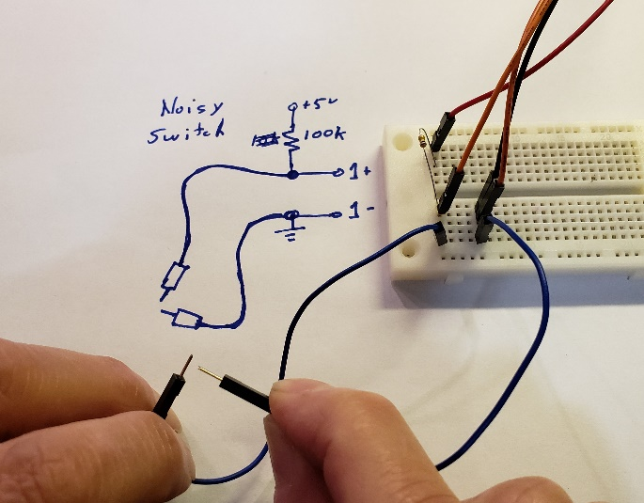
Experiment: Build a noisy switch. Switches weren’t included in the kit of parts so make one by touching 2 wires together as shown in the picture. To make it very noisy hold the wires about 2cm away from the tip and swipe the floppy wires across each other. For a less noisy switch, do the same but hold each wire near the tip.
Figure 2. Noisy Switch circuit
As shown you need +5V, GND, and channel 1 connections to the instrumentation board. When the wire tips aren’t touching the resistor brings 1+ to +5V. When the wires touch 1+ will be connected to ground and be 0V. This is flipped compared to Figure 1 but it is the signal needed for this project. This is shown with a 100kΩ resistor but it also works well with 10kΩ.
A.1 Run the oscilloscope with a time scale of 20ms/div. Trigger settings of: Normal, Channel 1, raising edge, trigger level of 2V.
Swipe the 2 wires so that they briefly make contact. This is a switch closure. Try both with holding near the wire tips and holding far back allowing the tips to be floppy. Run several contacts and save one that clearly is noisy, one that looks somewhat like the signal in Figure 1. Include this in your report. Comment in the report if you see the swipes as less noisy if you hold near the tips.
A.2 Now change the time scale to 50us/div and swipe the wires again. You will likely only see the beginning or the end of the switch pulse and that is fine. Do the swipes again holding near the wire tips, what should have been the less noisy signal in part A.1 Do at least 10 swipes and keep one that still shows noise. Include this in your report and comment on if the recorded trace from A.1 could have detected this noise. If all swipes just show a nice clean rise without noise, then back off where you are holding the wires to allow more bounce. Several team members should try this and become familiar with how it behaves.

Back to theory: What makes this a good example of a practical engineering design task is that the goal is to build a circuit that responds only once when a pulse appears by trading off response time for accuracy. If what should be counted as a single pulse is really a sequence of smaller pulses (as in Figure 1 and also with your noise switch A.1) we should build a circuit that is triggered by the first pulse it sees and then ignores all of the other ups and downs of the input signal until we are sure that the pulse sequence is over. The process is shown generically in the figure below, where the bounces have been idealized as shorter square pulses. For design purposes, the exact details of the bounces are not important. Our model only needs to have a main pulse proceeded by and followed by a few short pulses. The goal should be clear – produce one pulse (like the one on the right) from a pulse made up of smaller pulses (like the one on the left). Because the pulse produced will be longer than the full pulse train, the maximum speed of the counter will be reduced. This is the design tradeoff where we sacrifice speed for accuracy.

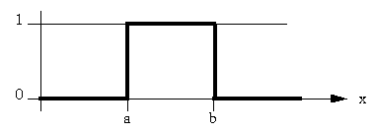
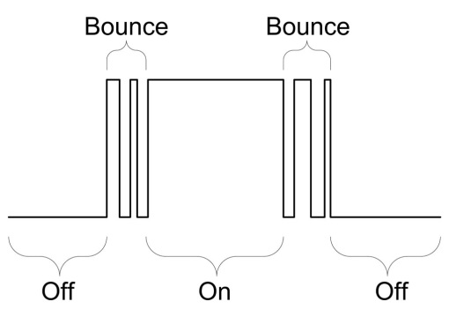
Figure 3.

For background, do a web search on ‘555 timer switch debouncer’ and you will find many different options, most of which look about the same. (There are many different ways to debounce a switch, but we will only use designs based on the 555.) Choose a particular configuration and model it in LTspice. To model a pushbutton switch, use the combination of five pulsed voltage sources shown below. (The pulse parameters are also listed in the table for clarity.) This is cumbersome, but does produce pulses that include characteristics seen when a switch bounces. This complicated pulse will be used for the experiment too. The input values are flipped from figure 1 and 3 but will match your built noisy switch.

Source | Vinitial | Von | TD | TR | TF | Ton | Tperiod
V1 | 3 | 0 | 0 | 1u | 1u | 100ms | 400ms
V2 | -3 | 0 | 5ms | 1u | 1u | 90ms | 400ms
V3 | 3 | 0 | 7ms | 1u | 1u | 84ms | 400ms
V4 | -3 | 0 | 15ms | 1u | 1u | 70ms | 400ms
V5 | 3 | 0 | 17ms | 1u | 1u | 66ms | 400ms

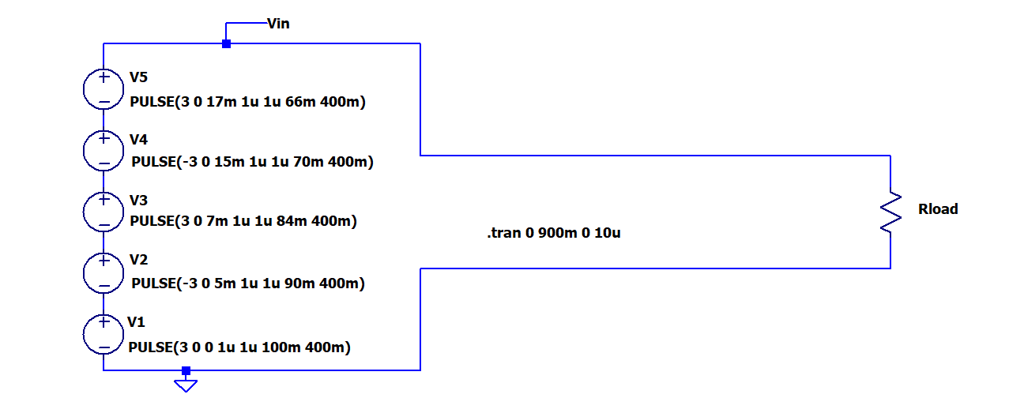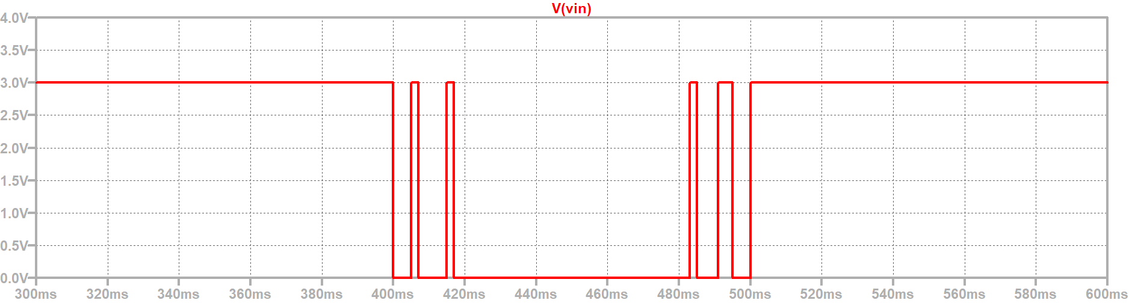
Debouncer Circuit
Figure 4
Note that the pulses are displayed after a significant delay of 380ms. This is to provide the circuit the opportunity to find its steady-state condition (LTspice assumes initial conditions that may not be physical. Delaying the display of the output voltage removes any sensitivity to the assumptions.)

The input voltage has the given form because of the way input switches are configured in circuits. A standard switch configuration is shown at the right. The switch connects to the voltage source for the circuit (V_{CC}) by way of a pull up resistor (R1 in the circuit). When the switch is open, the input voltage will be equal to V_{CC} because there is no current in R1. When the switch is closed, the input voltage will be equal to zero. Thus, the input pin for the circuit (pin 2 for debouncers based on 555 timer chips) will either see a voltage of V_{CC} or 0V. That is why the input voltage is usually high (3V in the circuit above) and goes to zero to model the button being pushed. To use this source to model the switch, it should be connected directly to pin 2 of the 555 chip and no additional pull up resistor should be needed. If your circuit has a coupling capacitor on the trigger you do want a large pull up resistor on pin 2.
Input

Next, build your debouncer. For initial tests, use the same model input voltage that was used for LTspice. How this is done depends on which instrumentation board you are using. For the Analog Discovery the file is used by the Wavegen instrument in Waveforms. For the M2k, a different file is used by the Signal Generator instrument in Scopy.

Instructions for Analog Discovery: (for the M2k skip to “Instructions for M2k and Scopy”). For the Analog Discover you will make use of the Custom feature of the Wavegen instrument. Begin by downloading http://www.ecse.rpi.edu/courses/F21/ENGR-2300/AD/fakebouncedatafromAD2.csv and placing it in a convenient directory where you can easily find it. Next, open the Wavegen. Select Custom from the Basic menu, as shown below. Set the frequency to 4Hz, offset and amplitude to 2V. The overall pulse will have a slightly smaller duration than the one used in the LTspice simulation and will be a low enough frequency to easily follow the counting. Again, do not use the pull up resistor in this configuration. That is used only when you have an actual mechanical switch in your circuit. You must add the pull up resistor when you test your circuit with a switch.

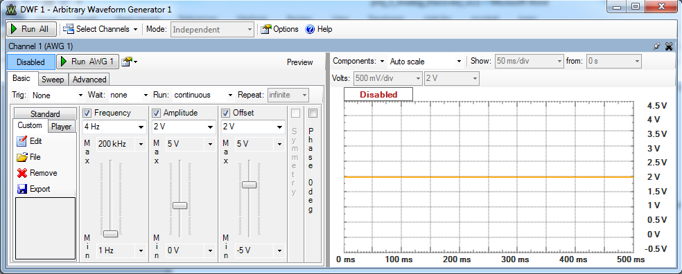

Select File in the Custom window. Use the Browse button to find the downloaded csv file, and open it. Highlight the second column name C1(V) and you should see something like the figure below. Select Open and you should return to the Wavegen window with a new type of signal selected, as shown on the next page.

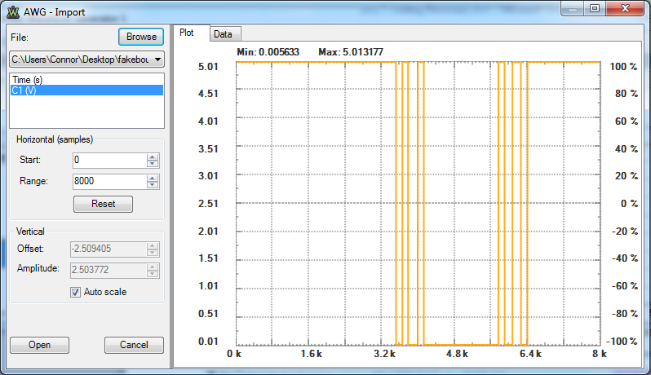

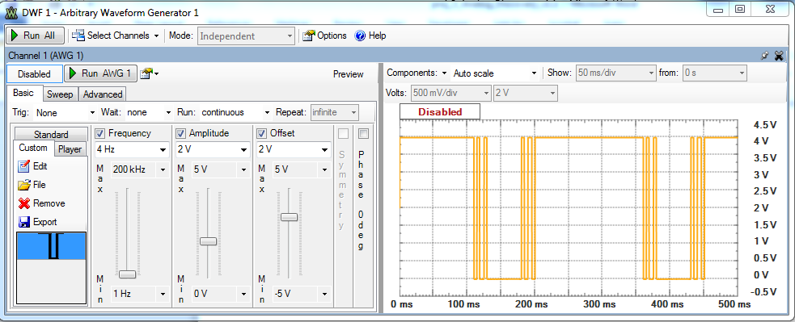

If you are using the Analog Discovery board, skip down to the “The remainder of the document applies for both the Analog Discovery and the M2k.”

Instructions for M2k and Scopy: For the M2k you will load a data file into a buffer used by the Signal Generator in Scopy. Begin by downloading http://www.ecse.rpi.edu/courses/F21/ENGR-2300/M2k/fakebouncedataM2k.csv and placing it in a convenient directory where you can easily find it. Next, in Scopy open the Signal Generator. In CH 1, select Buffer, select Load file, and find the file you downloaded from the course website.
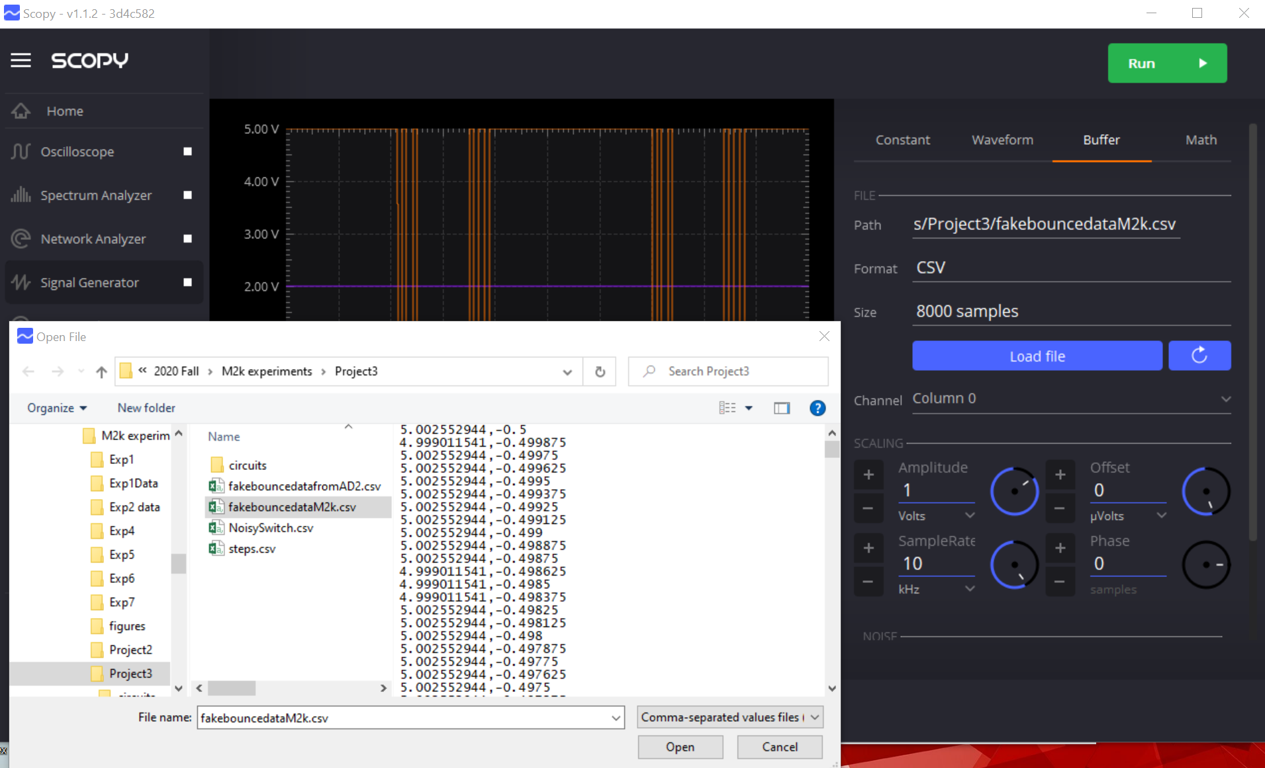

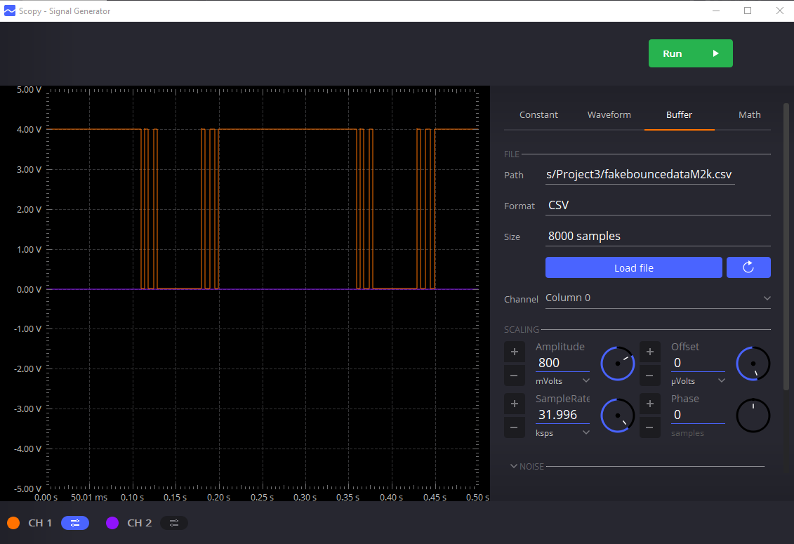
Go to Scaling and set the Amplitude to 800mV and the frequency to about 32 ksps.

The remainder of the document applies to both the Analog Discovery and the M2k.
Do not use the pull up resistor in this configuration. You must add the pull up resistor when you test your circuit with a mechanical switch.

Now you can use the W1 (yellow wire) to drive your debouncer circuit while you build and test it. Once you have your debouncer circuit working, with this signal as the input, measure the input and output voltages, showing a small number of events (3 or 4). Specifically, you should generate LTspice plots of the voltages that change in the 555 circuit (pin 2, pin 6, pin7, pin 3). Once you have built the circuit and demonstrated that it works, also measure the same voltages that you simulated with LTspice and verify that your simulation and experimental measurements are consistent. Get all data and your circuit verified by a TA, in real time (not just plots). Power your debouncer circuit using the V+ = +5V (red wire, V+) and ground from any of the available grounds.

A secondary goal (also to be achieved for this project), is to select parameters so that your circuit uses the minimum possible power. There are limits to how big or small components can be to produce a working circuit. You should choose them to meet this goal. Whatever you choose, you will have to demonstrate that the circuit counts reliably. It is not necessary to find the optimum choice of circuit parameters. Rather, you should provide two designs, show that your circuits work reliably and that one of your designs uses less average power than the other. In your report, you should include your analysis for power use and plots (both from LTspice and the Analog Discovery/M2k) that demonstrate performance. Be sure to discuss the information in the plots and why your data show a successful design. Also remember that it is the power used by the entire circuit that must be assessed. Sometimes this process is called a power or energy inventory, but, like many other good engineering terms, the expression has been adopted by too many other disciplines to be all that useful anymore. Note that it is much easier to evaluate the power used from the LTspice simulation rather than the Analog Discovery experiment. This is one of the many reasons we do both simulations and experiments in engineering design. By benchmarking your simulation against your experiment (by comparing, where possible, measured vs predicted voltages), you can justify using the more detailed information from the simulation to assess your circuit performance.
It should be obvious that, just as in the experiments, you must collect information from three sources: ideal theory, simulation and experiment. List the three types of information separately and then compare and contrast what they tell us about how your system should work and does work.

For your final test, replace the function generator input W1 with your noisy switch, part A.1. Then connect the output of your debouncer to the counter in the same manner you connected the astable multivibrator in Exp 7 (Figure C-4, page 11, of Experiment 7). Then demonstrate reliable counting to a TA and have them sign your data or a signature sheet.
Input

Extra Credit – Use the circuit to count events for some simple mechanical system. For example, you can count swings of a pendulum or rotations of a wheel (please choose something that interests you). This could be a rotation counter for a Beakman Motor. Points will be given for simplicity, difficulty and creativity.

Examples of switch bounce are shown below:
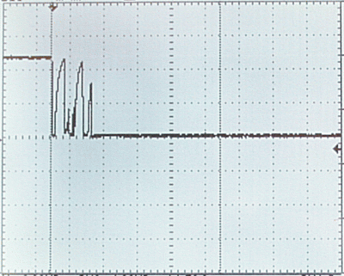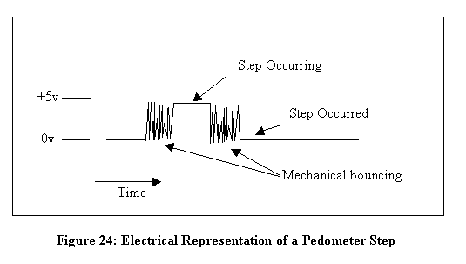
http://www.micahcarrick.com/05-15-2006/avr-tutorial-switch-debounce.html http://lapierre.jammys.net/
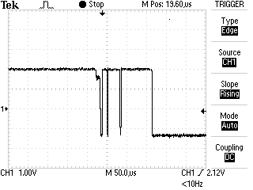
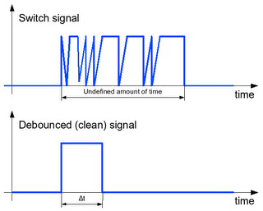
http://carlitoscontraptions.com/ http://www.labbookpages.co.uk/electronics/debounce.html

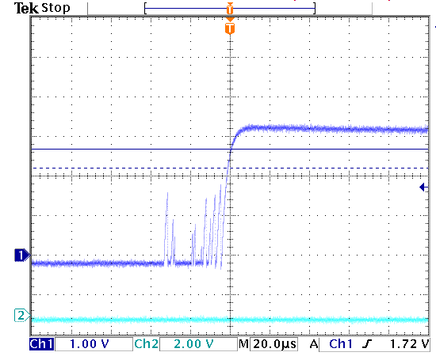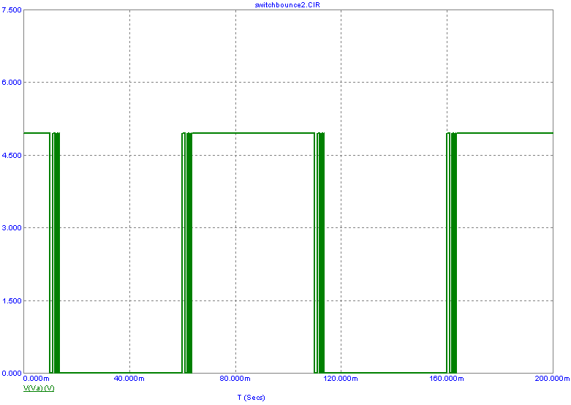
http://www.spectrum-soft.com/news/summer2008/switchbounce.shtm

http://www.engscope.com/pic-example-codes/basic-io-button-debounce/

References
- A Guide to Switch Debouncing: http://www.eng.utah.edu/~cs5780/debouncing.pdf
- Debouncing Switches: http://web.engr.oregonstate.edu/~traylor/ece473/lectures/debounce.pdf

Your Group Report (80 points)

The following should be included in your written report. Everything should be clearly labeled and easy to find. Partial credit will be deducted for poor labeling or unclear presentation.

Introduction (5 points)
State the purpose of the project and describe the process used to demonstrate that the purpose has been achieved

Theory (15 points)
Describe the basic theory and analyze the expected performance of your design.

Simulation (15 points)
Describe the simulations you have performed (LTspice, Matlab, etc). Present and discuss the results you obtain.

Experimentation (20 points)
Describe the experiments you have performed. Include plots of the noisy switch. Present and discuss the results you obtain.

System Design (10 points)
Compare and contrast the three types of information you have obtained and then describe the final design of your system including all practical considerations for successful performance. Include the simplest possible explanation of your design and the simplest approach to designing something similar, should someone wish to use your information in their own application.

Personal Effort (5 points)
Unlike like the experiments, now list the percentage efforts of the team members. Who did the simulations, the circuit building and measurements, report writing, …

References
No points are assigned to references, but no report will be accepted without clear and complete reference to all information used. Online information is acceptable even though that is not generally the case with journals, books, etc. References will be checked by the grader.

Appendices
Include any additional information you think adds to your study, but be sure that whatever you include actually helps make your case.

Extra Credit (≤5 points)
The extra credit task is described above.

Your grade will also include a general assessment of project understanding and quality worth up to 10 points.

Total: 70 points for project report
+10 points general assessment
+20 points attendance
100 points

Attendance (20 possible points)
3 classes (20 points), 2 classes (10 points), 1 class (0 points)
Minus 5 for each late
No attendance at all = No grade for project

