Project 1
Instrumented Beakman’s Motor
Team Project

The Projects are done in teams of 4 students. Find another pair to partner with. If you have been doing the T-P-S, think – partner – share, sheets with another pair, they may be your best option.
There will be one report per team. Read ahead and divide the work among the group members. One or two members should start on the report on the very first day, keeping track of what is required for the report.

What is required?
- Initial design - Each pair of students build a motor. There should be at least 2 motors initially. Provide a picture of each motor. Provide a plot of the voltage across the motor leads for each motor and state who worked on each motor.
- Final design without springs, only 1 for the full team - Based on the motor’s voltage plots and experience gain, submit a final design without springs.
  - Speed must be 18Hz or greater.
  - This could be one of the initial design motors if it is fast enough.
  - More typically it is a motor with a new coil built based on knowledge gained in building the initial designs.
  - Make sure that between the group members that you save a “poor” motor (initial design) and an “improved” motor (final design).
  - Discuss within in the group why you believe the improved motor runs better. Is it balance, orientation, or other? This is a required part of the report.
- Final design with springs, only 1 for the full team – use the same motor as the one without springs. The springs are just a method to improve the contact by exerting slight pressure on the leads of the coil.

The team creates your own checkoff sheet. You determine key points where you show your results to one of the instructors. At a minimum you want to demonstrate the initial, improved without springs and improved with springs versions.

One team member submits the report to Gradescope. When submitting that person must tell Gracescope the names of the other team members or else they will not get credit. After it is submitted have all group members confirm that they have a submission. Before the deadline the report can be resubmitted.

Beakman’s Motor (shown on the TV show Beakman’s World) makes a very interesting little project. We use this motor in the ECSE course Fields and Waves I because it involves some fundamental electromagnetic concepts. It has also been used in Mechatronics because it is a simple example of a complex electromechanical system. There is some excellent background information and some construction hints at the sites listed on the Experiment and Project Links page under Project 1. It is possible to specify several project goals for this motor, depending on its application. Here, you are asked to make the motor go faster and demonstrate reliable speed measurements.
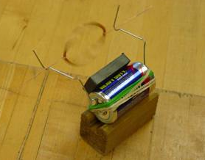
Figure 1. Beakman’s Motor.
Note the basic components: a D-Cell battery, a rubber band,
two paper clips, a ceramic permanent magnet and a coil of wire.

Materials Required, most are in the small kit of parts handed out for Exp. 3 (but not the battery).

- Two D-Cell Batteries – this allows both pairs of students to build an initial design motor.
- One Wide Rubber Band per motor
- Two Large Paper Clips per motor
- One or Two Circular Ceramic Magnets (or equivalent) per motor.
- Magnet Wire (the kind with enamel insulation) - use the Experiment 3 transformer wire provided in supplemental kit of parts but more is available if needed, as one of the instructional staff members.
- Fine Sandpaper and plastic piece for sanding surface (Don’t sand on the table tops.)

In the appendix of this handout we have included a list of what we expect from you for this project. This includes a basic task list, a list of the required appendices for your report, and a description of the report format. Please follow these requirements carefully. Projects do not have the same checklist procedure as experiments. However, you will note that you must obtain signatures when you demo your motor for a TA or instructor. You make up a signature sheet.

Part A - Background and Theory

The basic principles of motor operation are quite simple. Each time the coil spins through a single revolution, the commutator turns the current on for half of the cycle and off for half of the cycle. While the current is on, the coil becomes an electromagnet. This magnet is either attracted to, or repelled by, a permanent magnet attached to the battery that powers the motor. By properly orienting the commutator, the coil is given a little push each time it goes by the magnet and it will continue to spin. While this description is adequate to explain generally how the motor works, it is not so useful for actually designing a motor.
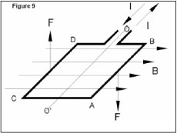
Figure 2. Current carrying wire in a magnetic field.

A better model involves the forces between current-carrying wires and magnetic fields. A current carrying wire experiences a force due to a magnetic field in a direction perpendicular to both the wire and the field, as shown in Figure 2 above. In the most fundamental terms, we express this force as , where f is the force density, J is the current density in the wire (J is I divided by the area of the wire) and B is the magnetic field. Most simply, this expression can be written as , where I is the current, L is the length of the wire (This can be expressed as a vector by multiplying it by the unit vector in the direction of the current flow), and α is the angle between the wire and the magnetic field. There is quite a good discussion of the principles behind the DC motor on the links page under the title “Principles behind the DC motor” from MICROMO Electronics in Clearwater, FL. (The figure above comes from this web site.) It will be useful to read over this material to see how to optimize your motor designs. Where would the magnet be located in the figure showing the forces?

In this experiment, you will build a simple motor coil, attach it to a power source, and make it spin. You will make a simple commutator (that turns the electromagnet on and off) by sanding off only half of one of the motor leads. As the motor spins, the commutator forces the coil to appear alternately like an open circuit and a wire (with resistance and inductance). When the sanded portion of the lead is in contact with the cradle, the coil looks like an inductor, the current flows through the coil, and this creates the electromagnet. At this time, it interacts with the stationary magnet on the battery. When the un-sanded potion of the motor lead is in contact with the cradle, the coil looks like an open circuit, the current is off, and the coil no longer acts as an electromagnet. What forces are still acting on the coil when the current is off? What would happen to the coil if the current was always flowing?

This circuit seems simple: a coil, a switch (the commutator), and a power source. However, there are many factors that influence how the coil spins. The coil itself is an inductor and a resistor. As you know, its properties depend on the type of wire used, the diameter of the coil, and the number of turns. In addition, the connection wires used (if any), the paper clips and the battery itself all have some resistance. Other factors also influence your motor. Energy lost to air drag and coil wobble will look like resistance to the circuit. Also, as the coil spins past the magnet, a small current will be induced in the coil. This current will be in the opposite direction to the applied current. Depending on the relative size of the resistances and inductances, the net effect of all this will either look like an inductance or like a resistance.

Background Information:
- Check the info on the Links by Experiment page, especially “Principles behind the DC motor” from MICROMO. This is a good example of the excellent background information provided by manufacturers.
- Excellent instructions on motor building by Jose Pino.
- Watch the videos on the “Project 1” playlist on the YouTube channel, especially the three videos on “Beakman Motor Design” which build on the DC motor link above.
- Watch at least 2 or 3 of the videos on the “Beakman’s Motor Background” playlist on the YouTube channel.
- The “Beakman’s Motor Video” is fun and a little informative.

Part B - Building your Initial Design

B-1. Building a Motor

The projects in this course typically involve building an initial design that we give you, improving the design, and comparing the initial and final results. For the initial design in this project, you will build a motor using the instructions in a video clip from an old television series, called “Beakman’s World”. Try to build this first motor with characteristics that match the motor in the video as closely as possible. When assembled, it should look much like the motor pictured in Figure 1. Here are some basic instructions:

1. Take about 3 feet of 24 -28 gauge magnet wire from your Experiment 3 transformer.
2. Wind it around a tube. Leave 2” leads.
3. Sand the coating off of one lead completely.
4. Sand the coating off one side of the other lead. (This is your motor commutator.)
5. Bend the paper clips into cradles and attach them to the battery with the rubber band.
6. Place two or three magnets on the battery.
7. Add your motor coil and make it spin.

If it doesn’t work, make sure your sanding job is complete and the motor is well balanced. Note: In the past, essentially all D-Cell batteries were built with magnetic steel cases so that magnets will stick to them without any additional support. However, many inexpensive batteries now have plastic cases. If you are using such a battery, you will have to find a way to attach the magnet. Electrical tape is available on the wire racks in the room. Also, the steel battery case enhances the magnetic field produced by the magnet. Motors will go faster when you use a battery with a steel case.

B-2. Measuring the Frequency

To measure the frequency of the motor, place the Channel 1 Oscilloscope leads on either side of the battery with the motor running. It will be easiest if you have two clip leads from the supplemental kit of parts. Or you may prop the assembly up in a stable position and hold the two leads on the positive and negative sides of the battery. Alternatively, you can try to tape the leads so that they are in contact with the battery. Once you are measuring the battery voltage, you should use the voltage divider and battery techniques we used in Experiment 1. Recall, the battery has an ‘unknown’ internal resistance which we can find using an open circuit load and a small resistance load. During the half cycle when the insulator is in contact with the paper clip, the coil acts like an open circuit and the voltage divider ratio is approximately 1, meaning the load voltage is close to the battery voltage (a maximum). When the copper is in contact with the paper clip, the coil acts like a small resistance and the measured load voltage depends on the voltage divider between the internal battery resistance and the coil resistance.
Note that your motor will be spinning very slowly compared to most electrical signals. You will need to adjust the scope time and voltage scales to correctly display the signal. To do this, you will need to estimate its speed. Think of how many rotations per second your motor seems to spin at and set the time (horizontal) scale accordingly. When the ‘scope is adjusted correctly, you should see a sequence of square pulses, that may look something like Figure 3. The voltage (vertical) scale should be chosen so you can clearly see both the zero reference voltage and the battery voltage.

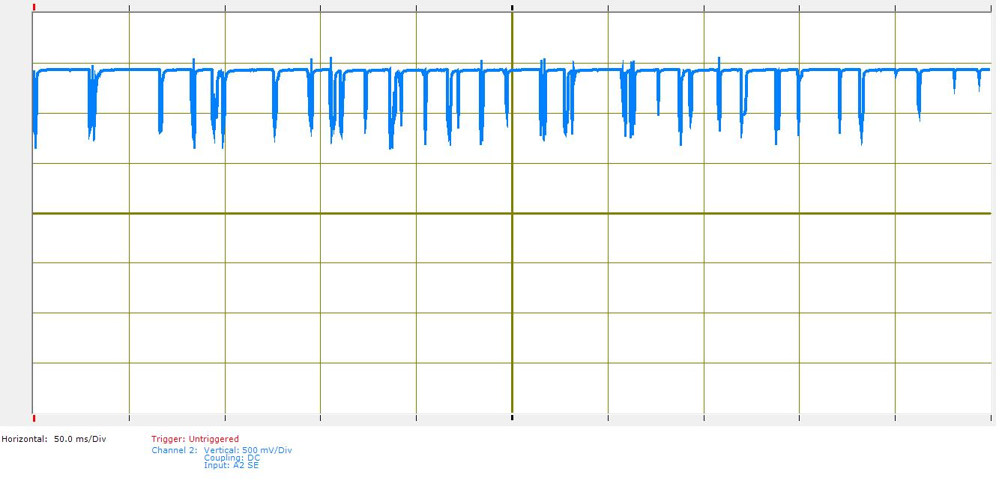
DC level a little less than 1.5V (Used battery)
Zero Volts
Figure 3. Poor data sample (note inconsistent period indicated by the red arrows).

When we extract some information from data we have collected, it is very important that we establish the reliability of the data. For a measurement like the one you are asked to make here, the way we do this is to look carefully at the data and see what story it is telling us, based on the circuit diagram and what we know about how the motor turns.

Note that the maximum voltage in Figure 3 is the open circuit voltage of around 1.5V. This is the voltage of your battery. When the motor spins to the point where the coating has been sanded off, contact is created, the coil is connected to the battery, and the voltage drops. The internal resistance of the battery R_{bat} and the impedance of the coil Z_{coil} form a voltage divider (as shown at the right) so only part of the battery voltage appears across the coil. Recall that the coil has both inductance and resistance but probably only one of the two parameters is necessary to characterize the coil you build for your motor. As the motor turns more, the contact goes away, the coil looks like an open circuit again, and the voltage goes back up to 1.5V. If your voltage ends up between -1.5V and 0, switch the polarity of the leads on the paper clips.
Commutator
V_{bat}
Z_{coil}
R_{bat}

The data above would not be considered to be very good because of the irregularity of the pulses. In order to get better data, you will want to make sure your leads are sanded very well and that your motor is well balanced. These improvements should give you data that looks more like Figure 4, where you can see that the regular groups of pulses more clearly in the second version of the plot in Figure 5.

For your initial design, you may not be able to get data quite so regular. Adding springs (as described later) will improve this. If the spinning is sufficiently regular (usually not the case), the frequency measurement capability of the oscilloscope can be used to get the frequency. You can also calculate the frequency by hand. It is best to average over several pulses to get an accurate speed measurement. Use the entire displayed time (the full width of the oscilloscope signal) for the most reliable results.

To determine the frequency of the data in Figure 4, count the number of cycles shown and divide by the time. In Figure 4, there are a total of 7 cycles over 100mseconds (10ms*10 divisions) for a frequency of 70Hz, which is a very good speed (way above average). Your speed is more likely to be near 10Hz.

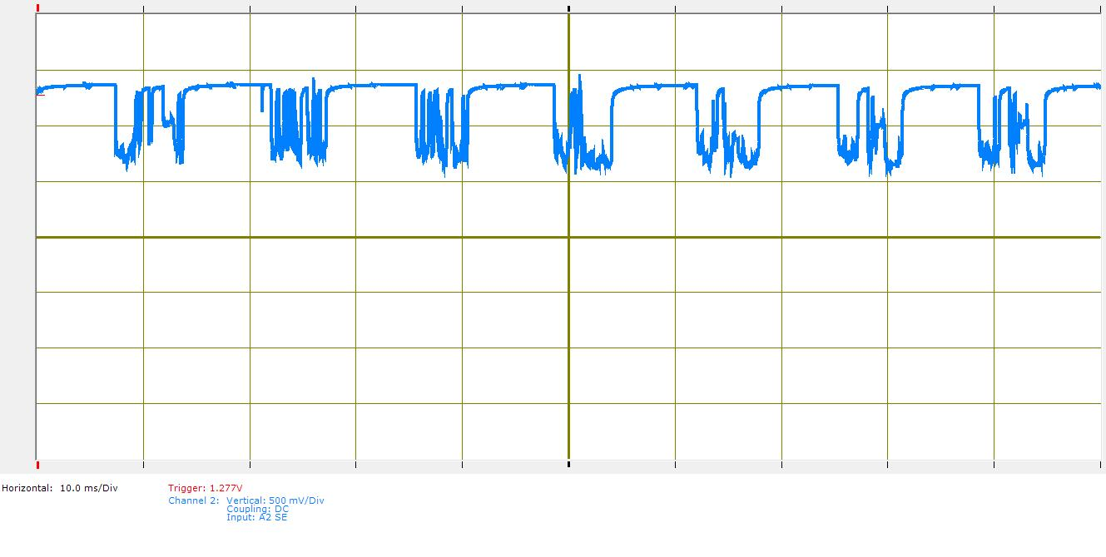
Coil Voltage
Battery Voltage
0.1 sec
Figure 4. Good data sample (note consistent frequency).
The figure is repeated below in Figure 5 with a regular square wave for comparison.

Coil Voltage
Battery Voltage
Figure 5. Good data sample repeated (note consistent frequency).
The regularity of the data is quite clear as is the periodicity. Note that the duty cycle is getting close to the ideal of 50%. The connections are not consistently good, however, since the springs used to get this data were quite weak.

It should be clear from this sample data that one of your most important tasks is to explain as much of the signals you collect as you can. The more you can explain, the more your results can be believed. Recall that this measurement is based on the hypothesis that the commutator will connect the coil to the battery once each revolution of the axle, which causes the voltage to drop. Count the voltage drops in a given time, divide by the time, and you have the frequency of revolution. Unfortunately, the coil can connect to the battery several times per revolution. Axle bounce is usually the most common cause for multiple connections (and multiple voltage drops) per revolution. Another problem is that the sparks that occur when the commutator switches will burn whatever organic matter is on the axle (remnants of your last meal, oil from your skin, etc.) leaving deposits that at least impede maintaining good connections. You will need to make some physical observations and provide a plausible explanation when you demonstrate your motor to a TA or instructor. An essential part of your explanation must be based on how the circuit works, so you will need to have a complete circuit diagram for each of your motor designs.

B-3. Circuit Simulation

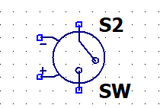
It is possible to simulate the motor using LTpice. You already know how to include batteries, resistors and inductors in a simulation. To do a very simple version of the motor, we also need a switch that opens and closes periodically. One option is to use two components: a voltage-controlled switch, sw component, and a pulsed voltage source which is created using the voltage component. The Voltage Controlled Switch information can be found at: https://www.analog.com/en/technical-articles/ltspiceiv-voltage-controlled-switches.html
- Place the sw component of the schematic grid
- Right click and edit the Value to a name you give the switch. If there is only one switch the name can stay SW. This example changes the name to SW1.
- Click on .op in the tool bar
  - SPICE directive should be checked
  - Type in: .model SW1 SW(Ron=0.1 Roff=1Meg Vt=0.5V Vh=-0.1V) Note; SW1 is the name you gave the switch.
To create a pulsed voltage source to turn the switch on and off to mimic the sanded and un-sanded parts of the wire:
- Place a voltage component
- Right click on the component
  - Advanced
  - PULSE
  - Set Vinitial to 0, Von to 1, Ton to 0.03 and Tperiod to 0.1 The other boxes can be left empty.
- Place the source on the schematic
Add the other parts and set up a simulation that runs for 0.5s with a suggested max step size of 1ms.
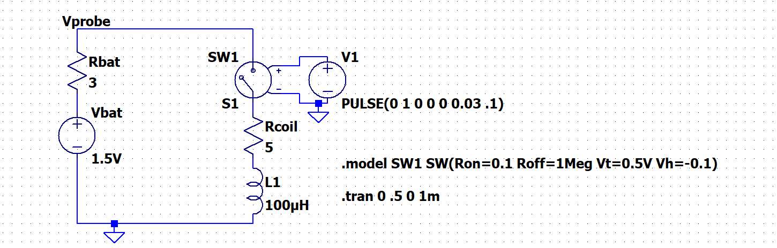
Battery
Coil
Figure 6. LTspice model of Beakman’s Motor. The resistor and inductor values don’t represent your circuit, you must change the values.

When the voltage from V1 is zero the switch is open. The switch changes to closed when V1 crosses 0.5V, so when V1 is 1V the switch is closed. Recall that LTspice does not like floating nodes due to true open circuits so the switch uses a resistor which is Roff=1MegΩ when the switch is open and is Ron=0.1Ω when the switch is closed. You set these values in the .model statement. Thus, the switch is really a voltage-controlled resistor.
Something we will return to later in the course is that the switch is set of change from off to on not at 0.5V but rather at 0.6V. This is Vt-Vh where Vt is a threshold voltage and Vh is a hysteresis voltage. As the voltage from the PULSE source drops from 1V, the switch will open at 0.4V which is Vt+Vh.

As stated Figure 6 is a sample model circuit for the motor. Again, the internal resistance of the battery R1 and the resistance of the coil R2 were chosen only to be sure that the simulation will run and not to represent typical values.

For the simulation, a frequency of 10Hz was chosen along with a 30% duty cycle. Note that the resistance RON of the switch can be used to model the contact resistance of the commutator. You will have to estimate its value from the literature or from your measured data. You should also consider adding resistances for the paperclips, air drag or any other phenomena you think may be playing a significant role. If you think the only resistances that matter are the coil resistance and battery resistance, you need to provide an explanation. There are other phenomena not included in this ideal model. For example, as the coil rotates through the field of the permanent magnet, there will be a voltage induced called the Back EMF. This is a basic voltage generator configuration. Because the motors we build in this course do not go very fast, this term is quite small and can be neglected. However, it is significant in almost all commercial motors. When a transient simulation is run for this circuit, the following voltage signal is observed at point labelled Vprobe (the battery output):

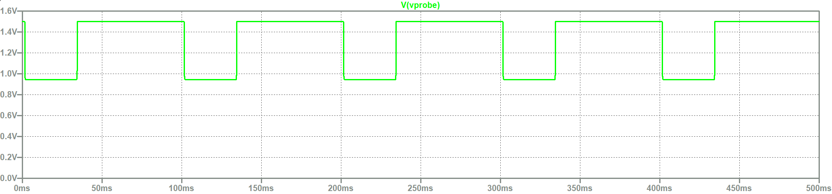
Figure 7. Voltage measured at node labelled Vprobe for circuit of Figure 6.

B-4. Determining the Characteristics of your Battery

Although batteries are designed to produce a particular voltage, the actual voltage will vary slightly from the specifications. Also, batteries have internal impedance. In order to accurately create the circuit diagram for the initial and final motors, you need to find the characteristics of your battery.

As we saw in Experiment 1, you cannot measure the internal impedance of the battery directly because it is inside the battery. You also do not know the exact voltage that the battery is putting out. It is rated at 1.5V, but since it is a real device, it probably is not putting out exactly 1.5V. In order to measure the voltage and resistance of the battery, we can create two circuits, measure the output voltage of each, and solve two equations in two unknowns, as was done in Experiment 1. Note that batteries with lower internal resistance can source more current than those with higher resistance. However, in this project, it is not necessary to repeat the measurements of Experiment 1 because we only need an approximate value for battery resistance.

To characterize your battery, first measure its voltage with the Voltmeter or Oscilloscope on the instrumentation board. This is the open circuit or unloaded battery voltage. It is always necessary to measure the voltage because the age and general state of your battery is unknown. Use the information you collected in Experiment 1 and online sources to determine a typical value for the battery resistance. Be sure to use information for the specific type of battery you have. Note that data for Heavy Duty batteries are very hard to find, probably because resistance for such batteries can vary a lot with operating conditions and age. For a Heavy Duty D-Cell, it seems that resistance is often found to be in the range of 5-10Ω, so you can use a number in this range, but should try to find a good reference. Below, you are asked to try to determine it more accurately when you analyze your motor data. For example, you should calculate the voltage you expect to observe when the commutator connects the coil to the battery based on your estimate of the coil resistance and your estimate of the battery resistance. Then adjust the value of the battery and coil resistances until your calculated voltage and measured voltage agree. You should also do this with the LTspice model. Agreement will not be perfect because the measured voltage will be noisy. However, you should be able to figure out a reasonable average voltage.

B-5. Initial Design Requirements

In order to satisfy the requirements for the basic design, a staff member must observe your motor spinning for at least 15 seconds. During this time, you should take an oscilloscope picture of the motor behavior and save it to your report document. Label the diagram “Basic Design” and fully annotate it with voltage levels, the period and frequency of the pulses. When you are ready to demonstrate the motor, have an Instructor/TA/UGSA sign a checkoff sheet that you create. 2 motors should be demonstrated to the staff, one for each pair of students.

A second requirement for the basic design is measuring the exact voltage and estimating the resistance of your battery. Include this information and any calculations in appendix A-2 of your report. You will also need to create an accurate circuit diagram and include it in appendix A-3 of your report. For your final design, you must show your completed circuit model and explain all of the features of your data to obtain the signature.

Part C - Building your Final Design

C-1. Improving your Motor Design This can be the faster of the motors created by a 2 pairs of students if that motor runs at 18Hz or greater. Or it can be a new motor. You only need to demo one motor per team. In your report you must discuss the differences in the design that might explain the improved speed – size, balance, spacing to magnet, …

At this point, you have succeeded in creating 2 motors that spin. Now you should work to make one that spins faster, at a speed of at least 18Hz. There are many factors that go into this process. One of the key issues is the commutator design. If you have not done so already, watch the three short videos posted on YouTube addressing Beakman’s Motor Design 1, 2, 3 for info on this topic.

a) Coil Design: If you maximize the inductance, you will make the coil spin faster. Consider the equation for the inductance of a ring-shaped coil. You will notice it depends upon the gauge of the wire, the core diameter, and the number of turns. How can you alter these from your original design to increase inductance? The basic Beakman design calls for a coil diameter to be equal to that of a toilet paper tube. Improved performance should be obtained if a smaller coil is built. How much smaller is hard to determine. Try at least two coils that are a different size than the initial ones and record the performance. Is smaller better? You also have control over the number of turns, though, like all engineering, there is a tradeoff when increasing the number of turns.

b) Coil Shape: Note that the coil need not be round. A rectangular or oval shaped coil may be faster. You can find an excellent site that describes the influence of coil shape on the inductance of a coil under “Inductance Calculations” on the links page for this course.

c) Proximity to Magnet: The closer the magnetic field of the coil is to the stationary magnets, the more force there will be between the coil and the magnet. Hence, a smaller diameter coil, located closer to the magnet, may result in faster spinning.

d) Coil Weight: If the leads to your motor do not support its weight, it will not spin well. If the motor is too large and heavy, 1.5V will not provide enough power to make it spin fast. The speed of the motor also depends upon how well its leads are contacting the cradle. If the motor is heavier, then you will have good contact and the motor will spin faster. If the motor is lighter, it may not contact as well. This will slow down the speed, but you can fix this problem by adding springs. (This process is discussed in section C-2.)

e) Coil Balance: A key issue noticed by nearly all motor builders is balance. The better balanced the coil, the faster it turns. If the coil is at all asymmetric from top to bottom, it will be out of balance and will not spin well. To achieve good balance, it has generally been found that a smaller coil will be more stable.

Thus, there is a tradeoff between wire gauge, number of turns, coil diameter, coil shape, coil weight, and balance that determines how fast an individual motor will spin. Getting a motor that spins well is somewhat of a trial and error process. You may find Dr. Connor’s Hints on the links page helpful in deciding how to redesign your motor.

A base for your battery will help you obtain reliable data. Also, the stability of the paperclip cradle influences the speed of your motor. By moving the cradle to a stable surface, you will be able to obtain faster speeds. It is not recommended that you use your protoboard for this purpose because you may damage it.

For further information on what you can and cannot do when you redesign your motor, please see the ground rules in section C-3.

Try several motor designs. Once you have one you like that conforms to the Ground Rules described in section C-3, you will have to provide documented evidence that you have designed a motor (without springs) that turns for 30 seconds and at a faster rate than your initial design. You will include this data in appendix B of your report. (See requirements in section C-4 for details.)

C-2. Improving Contact with the Cradle

Having good contact between the coil leads and the paperclip cradle is essential to having a fast motor. You can test this by gently placing two hand-held (non-conducting) wires against the leads close to the cradle as your motor is spinning. Enameled magnet wire is a good choice. If you press too hard, the motor will stop. However, if you press just hard enough to hold the leads against the cradle, the motor gets better contact and spins faster. In this class, we call the devices that hold the coil in the cradle “springs”. In the above scenario, you have improved your motor using hand-held springs. You will need to provide documented evidence of a motor that spins for at least 30 seconds when you use hand-held springs. Include this data in appendix C of your report. (See requirements in section C-4 for details.)

C-3. Ground Rules

Since this is somewhat of a competition to get the fastest motor, we need to establish some ground rules. The following is a list of what you can and cannot do in the final design:

YOU CAN:
1. Use a single battery (indicate the type of battery you used).
2. Use the magnet wire provided.
3. Make your cradle from paper clips.
4. Change the shape of your coil as long as it still has an open end.
5. Use a separate motor support to hold your motor and/or a battery holder.
6. Use non-conducting material to build your mechanical springs.
7. Make your motors run for at least 15 seconds.

YOU CANNOT:
1. Use a power supply or more than one battery.
2. Use magnet wire not provided by us.
3. Use creative sanding to create a double duty cycle.
4. Use springs made of material that is not somehow insulated from the circuit.
5. Get signed off on a motor that runs for less than 15 seconds.
6. Replace the paper clip with another metal.
7. Bend the paper clip to form a complete circle that contains the coil lead. There must be an opening.

Any design ideas that deviate significantly from the basic Beakman’s motor should be discussed with the instructor.

C-4. Final Design Requirements

In order to satisfy the requirements for the final design you must have a staff member observe two situations: a motor operating with no springs and a motor operating with springs. These observations can all be made using the same motor. If you prefer, you can use a different motor for any of these situations. For each situation, have a staff member observe your motor spinning for at least 15 seconds. During this time, you should take an oscilloscope picture of the motor behavior and save it to your report document. Label the diagram “Design Without Spring” or “Design With Springs” and fully annotate it with voltage levels, the period and frequency of the pulses. Have the staff member, who observed the motor spinning, record your frequency and sign your checkoff sheet. Once, when demonstrating your motor, you must show a complete circuit diagram and explain the main features of your data. If the motor is particularly fast (over 100 Hz), send a copy of your data to the Instructor.

Include the output from the final motor design without springs in appendix B-1 of your report. You also need to create a new circuit diagram with the component values for the new motor. Include this in appendix B-2 of your report. Don’t forget to recalculate any circuit parameters in the circuit that have been added or changed. Appendix C of your report should contain the output from your motor using hand-held springs. If you choose to use a different motor for either of these cases, include an appropriate circuit diagram.
Part D - Comparing the Motors

Once you have built your motors, you need to demonstrate that you have actually improved on the original design. Create a table similar to the following and include it in the conclusion of your report. If you have more motors to compare, you can modify it to include the additional motor descriptions and data.
 | speed (Hz) | % improvement over Beakman’s | % improvement over previous design
Beakman’s Motor for student 1 and 2 |  | XXX | XXX
Beakman’s Motor for student 3 and 4 |  | XXX | XXX
Motor without springs |  | Enter number and state which motor is used as the initial design | XXX
Motor with hand-held springs

To find the percent improvement, use the following equation:
Part E - Your Report

For this project we ask that you follow the outlines in the appendices of this handout when writing up your report. You will find that the organization of the report will be quite rigid. We find that, if all the reports are consistent, it takes less time to get them graded and returned to you. It also ensures that you are graded on what you know and how well you did the work, rather than on whether you remembered to include certain pieces of information (or did an effective job of hiding the fact that you did not). You will be penalized if you deviate from this format.

Appendix I of this handout contains a list of tasks you must complete in order to satisfy the requirements of the project. These are tasks that, for the most part, must be demonstrated during class or open shop. Appendix II of this handout contains a detailed explanation of what the appendices of your report should include. Appendix III of this handout describes the report itself and asks some questions you will be expected to answer.

Part F - Extra Credit Opportunities (absolute max of 10 extra points – very rare.)

By creating additional motor designs, testing them (with signatures verifying the observed motor speed), it is possible to receive some extra credit. Note that total extra credit received by students in the past has only rarely exceeded 5 points.

Creativity (0-5 pt)
Exceptionally creative approaches to implementation or in the final design.

Excessive Speed (0-5 pt)
If your motor is particularly fast, you will be eligible for additional points.

Experimentation and Comparison (0-5 pt)
Engineering problems are often solved by experimenting with different types of configurations, finding the changes that have the most positive effects, and systematically choosing a course of action based on those experiments. There are many variables to explore including number of turns, shape and size of the armature, how leads are sanded, placement of magnets, mass of the armature, battery type, type of spring design, coil balance, etc.
Part G - Appendices

Appendix I: Task List

A. Build 2 basic Beakman’s motor. One per pair of students in team.
- Demonstrate that each works for at least 15 seconds.
- Take data that verifies the frequency of your motor. Record the frequency and get a signature.
- Determine the actual on and off voltages of our coil and estimate the resistance of your battery.
- Using equations from Experiment 3, estimate the resistance and inductance of your coil.

B. Improve one motor design to get faster speeds, at least 18Hz. One for entire team. Could be one of the initial designs.
- Demonstrate that a design works for at least 15 seconds (no springs).
- Take data that verifies the frequency of your motor. Record the frequency and get a signature.
  - Explain all features in your data
- Using equations from Experiment 3, estimate the resistance and inductance of your coil.
  - Show your circuit diagram and explain why it is consistent with your data
- Take data for any other motors you tested successfully without springs. Record the frequency.

C. Improve contact between motor coil and paper clips using hand-held springs. One for entire team.
- Demonstrate that a design works for at least 15 seconds using hand-held springs.
- Take data that verifies the frequency of your motor. Record the frequency and get a signature and have an Instructor/TA record that data.
- Using equations from Experiment 3, estimate the resistance and inductance of your coil.
  - Show your circuit diagram and explain why it is consistent with your data
- Take data for any other motors you tested successfully using hand-held springs. Record the frequency

D. Assemble the appendix (as described in Part H of this handout).

E. Write your report (as described in Part I of this handout).

Part H: The Appendix of Your Report

The following list of items must be included in the appendix of your report, numbered and ordered as listed. This will help make sure that everyone includes everything that is required. In your report you should refer to each appendix specifically as needed to help illustrate your descriptions and conclusions. If you would like, you can include a second copy of what is in the appendix in order to better illustrate what you are trying to say, however, this is not necessary and cannot be used as a replacement for the contents of the appendix.

Appendix A: Basic Beakman’s Motor
1. Plot of motor speed
- plot title
- frequency (cycles/sec) clearly indicated
- reference to TA signature on signature sheet
2. Battery characteristics
3. Circuit diagram, including
- title
- voltage and resistance of your battery from appendix A2
- estimated inductance and resistance of your motor coil
- estimated additional resistances (such as paper clips) clearly identified
- the measuring device (and its impedance)
- switch representing the commutator
4. Additional plots taken of this motor (This section may be blank.)
- a title for each plot
- frequency clearly indicated
- no signature required for these plots

Appendix B: Motor Without Springs
1. Plot of motor speed
- plot title
- frequency (cycles/sec) clearly indicated
- reference to TA signature on signature sheet
2. Circuit diagram, including
- title
- actual voltage provided of the battery
- estimated inductance and resistance of your motor coil
- estimated additional resistances (such as paper clips) clearly identified
- the measuring device (and its impedance)
- switch representing commutator
3. Additional plots of this motor, or others without springs (This section may be blank.)
- a title for each plot
- frequency clearly indicated
- no signature required on these plots

Appendix C: Motor With Hand-held Springs
1. Plot of motor speed
- plot title
- frequency (cycles/sec) clearly indicated.
- reference to TA signature on signature sheet
2. Circuit diagram, including (This section may be blank.)
- title
- actual voltage provided of the battery
- estimated inductance and resistance of your motor coil
- estimated additional resistances (such as paper clips) clearly identified
- the measuring device (and its impedance)
- switch representing commutator
3. Additional plots of this motor, or others hand-held springs (This section may be blank.)
- a title for each plot
- frequency clearly indicated
- no signature required on these plots

Appendix D: References (Must be included.)
- Names of websites referenced.
- Title, author, etc. of any books used.
- Any additional references.

Appendix E: Extra Credit
- Any plots or data you would like to include for extra credit.

Part I: Your Group Report (80 points) This is a report with cover page, table of contents, page numbers, … This isn’t the same as what you submit for the experiments.

Introduction (5 points)
- State the purpose of the project.
- Also include at least 2 topics you studied in this course that helped you understand the project.

Theory (10 points)
- Describe the basic theory. What are the forces that enable the motor to spin? Where do they come from? How and when do they interact?
- Describe what happens to the voltage across the coil as the motor spins. (A sketch of the circuit when the coil is connected and not connected will help to illustrate this.)
- Use your own words and be sure to cite any resources you used in appendix E.
- Demonstrate to the grader that you understand what is happening.

Initial Design (15 points)
1. Describe your initial design.
- How did you build it?
- What did you learn about designing a motor when you were trying to get your initial design to spin?
- What results did you get for the voltage and resistance of the battery?
- Include a reference to where the circuit diagram is located in the appendices.
2. Describe your initial results.
- How well did your motor work?
- What was the frequency in cycles/second? What is this in rpm (rotations per minute)?
- Include a reference to where the signed output is located in the appendices.

Final Design Without Springs (10 points)
1. Describe your final design without springs.
- What criteria did you use to redesign your motor for faster speeds? Or describe what criteria allowed improved performance.
- What did your final motor look like (number of turns, wire gauge, shape, etc.)?
- What did you learn about designing a motor when you were trying to get your final design to spin faster?
- Include a reference to where the circuit diagram is located in the appendices.
2. Describe your final results without springs.
- How much better does this motor work than the initial design?
- What was the frequency in cycles/second? What is this in rpm (rotations per minute)?
- Include a reference to where the signed output is located in the appendices.

Final Design With Springs (5 points)
1. Describe your spring design.
- What did you learn about designing a spring when you used your hand-held springs?
- Include a reference to where the circuit diagram (if different) is located in the appendices.
2. Describe your final results with springs.
- Did the motor work better with springs?
- What was the frequency of your motor in cycles/second? What is this in rpm (rotations per minute)?
- Include a reference to where your signed output (with hand-held and mechanical springs) is located in the appendices.

Conclusions (10 points)
In this part, we want a summary of the basic conclusions you can draw from the project addressing both the motor design and measurement technique. Include the chart from Part D comparing the speeds of the four different motors you have tested. By what percentage were you able to improve the motor speed with any design change? Why were the fast ones faster? Why did the design changes you made make this happen? Which factors seemed to make the most difference? What could you do in the future to improve the design even more? What issues did you encounter and how did you address them both for your motor and speed measurement? Discuss any extra credit activities you did and why.

Personal Efforts – this is different than the Responsibilities statement for experiments (5 points)
- How was the effort divided between team members? This is different than the responsibility statement in the experiments. The efforts can be divided among team members by %.

Appendices (10 points)
- See appendix II of this handout

Extra Credit (0-10 points)
- Include details about anything you tried above and beyond the basics of the project.

Your grade will also include a general assessment of project understanding and quality worth up to 10 points. You do not need to write a general assessment.

Total: 70 points for project report
+10 points for general assessment of report
+20 points for attendance
100 points

Attendance (20 possible points)
3 classes (20 points), 2 classes (10 points), 1 class (0 points)
Minus 5 points for each late day.
No attendance at all = No grade for the project.

