Experiment 8
Submission Template

The following should be included in your experimental checklist. Everything should be labeled and easy to find. Credit will be deducted for poor labeling or unclear presentation. ALL PLOTS SHOULD INDICATE WHICH TRACE CORRESPONDS TO THE SIGNAL AT WHICH POINT AND ALL KEY FEATURES SHOULD BE LABELED.

Hand written schematics are required for physically built circuits, ONLY!!!

Part A – The I-V Characteristic Curve (16 pts)

A.1 I-V Characteristic curve of a diode, the LTspice Plot with 5 points marked. (3 pt)

A.2 Scopy/Waveform plot of diode current vs. voltage. (2pt)

A.3. MATLAB plot of diode current vs. voltage from data taken using M2k/Analog Discovery software. This should include the data points and a line found using the diode characteristic equation. (3 pt)

Answer PART A questions:

- Use the data you took for the i-v characteristic curve of the 1N914 or the 1N4148 diode to determine the mathematical representation of the i-v curve. What values did you find for I_{S} and n (curve on the MATLAB plot)? (4 pt)

Click here to enter text.

- Why do you know that the current through the diode is V(ch 2)/R1? (2 pt)

Click here to enter text.

- What differences, if any, did you notice between the i-v characteristic curve given by LTspice and the one you measured experimentally? (2 pt)

Click here to enter text.

Part B – Diode Circuits: Rectifiers and Limiters (32 points)

B.1.Picture or plot of the M2k/Analog Discovery data for the circuit in Figure B-1, the half-wave rectifier. This figure has a triangle wave input signal. (2 pt)

B.2. LTspice plot of the half-wave rectifier circuit, Figure B-5. (2 pt)

B.3.LTspice plot of the rectifier with smoothing with 5 experimentally obtained points marked.
(4 pt)

B.4 LTspice plot of the rectifier (output only) at 10kHz. (2 pt)

B.5. M2k/Analog Discovery plot of the rectifier (with no smoothing capacitor, sinusoidal waveform). (2 pt)

B.6. M2k/Analog Discovery plot of the rectifier (with a smoothing capacitor). (2 pt)

B.7. LTspice plot of the voltage limiter at 10V (with 5 experimental points marked). (2 pt)

B.8. LTspice plot of the voltage limiter at 4Vp-p (2V amplitude). (2 pt)

B.9. M2k/Analog Discovery plot of the limiter circuit with 10Vp-p input. (2 pt)

B.10. M2k/Analog Discovery plot of the limiter circuit with 4Vp-p input amplitude. (1 pt)

B.11. M2k/Analog Discovery plot of the limiter with only one diode. (1 pt)

Answer the following questions:

1. Explain why Vout changes when you add the capacitor to the rectifier in parallel with R. Explain why this circuit would be better for use as a DC source than the circuit without the capacitor. (3 pt)
Click here to enter text.

2. Did the circuit with the capacitor work better (more like a DC source) at high or low frequencies? (1 pt)
Click here to enter text.
- Comment on the similarities and differences between the LTspice and experimental results for the rectifier. (2 pt)
Click here to enter text.

- At what values (positive and negative) does the limiter cut off the voltage of the 10Vp-p input signal? (2 pt)
Click here to enter text.

- Why is this circuit called a limiter? (2 pt)
Click here to enter text.

Part C – LEDs, Photodiodes and Phototransistors (10 points)

Include the following plots:
C.1. M2k/Analog Discovery plot of the input and output for the optical link. (5 pt)

Answer the following questions:
- What are the minimum and maximum voltages of the output waveform under the best signal conditions? (2 pt)

Click here to enter text.

- Describe what happens to the output waveform at the higher frequencies. (1 pt)

Click here to enter text.

- Comment on any two of the following: a) the effect of misalignment of the LED and transistor, b) the effect of the room lights, c) signal level through paper, skin, or other objects. (2 pts)

Click here to enter text.

Part D – Zener Diodes (14 points)
D.1. LTspice Zener diode characteristic curve. (5 pt)

D.2 Plot of Zener diode i vs. v from the experiment. (5 pt)

Answer the following questions:

- What is the Zener voltage of your diode? What Zener did you use for the LTspice simulation? (2pt)
Click here to enter text.

- Shown below is the I-V characteristic curve of the 1N914 or 1N4148 non-Zener diode we looked at in part A, but obtained over a much wider voltage range. Compare this plot with the one you obtained for the Zener diode. List actual values as you compare them. (2pt)

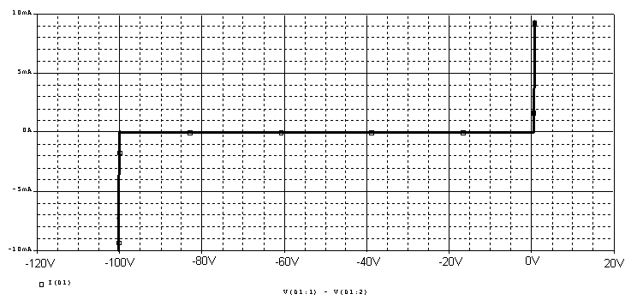

Click here to enter text.

Organization. (8pt)

Member responsibilities (0 to -4pts) Note that this is a list of responsibilities, not a list of what each partner did. It is very important that you divide the responsibility for each aspect of the experiment so that it is clear who will make sure that it is completed. Responsibilities include, but are not limited to, reading the full write up before the first class; collecting all information and writing the report; building circuits and collecting data (i.e. doing the experiment); setting up and running the simulations; comparing the theory, experiment and simulation to develop the practical model of whatever system is being addressed, etc.

Click here to enter text.

Summary/Overview (0 to -10 pts) There are two parts to this section, both of which require revisiting everything done on this experiment and addressing broad issues. Grading for this section works a bit differently in that the overall report grade will be reduced if the responses are not satisfactory.

Click here to enter text.

Experiment 8
Checklist w/ Signatures for Main Concepts
INSERT SIGNED COPY OF CHECKLIST BELOW (OR ADD SCANNED PDF VERSION)

Experiment 8
Hand Drawn Schematics
INSERT HAND DRAWN SCHEMATICS FOR ALL CIRCUITS BUILT

