Experiment 5
Bridges, Potentiometers, and Harmonic Oscillation

Purpose: In the following exercises, you will learn what a bridge is and how it can be used to measure small changes in resistance. You will also learn how to balance a bridge using a potentiometer. Then you will use the bridge to measure small resistances from a strain gauge mounted to an oscillating cantilever beam. You will use the oscillation frequency and your knowledge of cantilever beams to determine material constants for the beam (mass and Young’s modulus) and through tables, the material of which the beam is made. Finally, we will extend the theory of oscillation to an electrical system, an oscillating circuit.

Background: Before doing this experiment, students should be able to
- Analyze simple circuits consisting of combinations of resistors, inductors, capacitors and op-amps.
- Measure resistance using a Multimeter and capacitance using a commercial impedance bridge.
- Do a transient (time dependent) simulation of circuits using LTspice
- Do an AC Analysis (frequency dependent) simulation of circuits using LTspice, determining both the magnitude and the phase of input and output voltages.
- Determine the general complex transfer function for circuits.
- Build simple circuits consisting of combinations of resistors, inductors, capacitors, and op-amps on protoboards and measure input and output voltages vs. time.
- Perform basic mathematical operations on electrical circuits using op-amps.
- Review the background for the previous experiments.

Learning Outcomes: Students will be able to
- Use a combination of strain gauges and resistors configured in a bridge circuit to determine the position of a cantilever beam.
- Use a difference op-amp configuration to amplify the difference signal from the fixed and variable nodes in a strain gauge Wheatstone bridge.
- Apply harmonic oscillator analysis to both a mechanical and an electrical system.

Equipment Required:
- DMM (Keithley 8050A 4-1/2 Digital Multimeter – the two Keithley bench meters are NOT the same)
- M2k/Analog Discovery (with Scopy/Waveforms Software)
- Oscilloscope (M2k/Analog Discovery)
- Function Generator (M2k/Analog Discovery)
- Instrumented Beam, Weights, Clamps, & Scale
- Parts Kit

Helpful links for this experiment can be found on the links page for this course.

Note: For Experiment 5 and Project 2 you will work in teams of 4 as you did for Project 1. A single report from your team will be submitted for Exp 5 and a single report for Project 2. You should be looking ahead to Project 2 and assign member responsibilities. Write down the number of the beam and use the same one throughout the experiment for more consistent results and keep your circuit intact.

Pre-Lab
Required Reading: Before beginning the lab, at least one team member must read over and be generally acquainted with this document and the other required reading materials listed under Experiment 5 on the EILinks page.

Hand-Drawn Circuit Diagrams: Before beginning the lab, hand-drawn circuit diagrams must be prepared for all circuits that are physically built and characterized using your M2k/Analog Discovery board.

Part A – Bridge Circuits

Background
Bridges and Voltage Dividers: In Experiment 1, we looked at one of the simplest useful circuits – the voltage divider. In many simple applications of electronics, we have only a small number of standard voltages in whatever circuits we are building. When we use a 9V battery or V+ on the M2k/Analog Discovery as our source, we have only one voltage level available, unless we use a voltage divider to get smaller voltages. We can also use a divider, to measure resistance, if we have some device with an unknown resistance. For example, if we connect an unknown resistor in series with a known resistor, then the voltage across the unknown resistor can tell us the value of the resistance. An even better measurement can be done by combining two voltage dividers in a configuration like the one shown in figure A-1, which you should recognize as being made from two dividers. Note that if R1 = R2 = R3 = R4, the voltages at the two points marked Vleft and Vright will be equal to half of the source voltage. Thus, their difference should be zero. Whenever the voltage difference dV = Vleft – Vright across a bridge output is zero, we say that the bridge is balanced. If one of the resistors (e.g. R4) is slightly larger or slightly smaller than the other three resistors, the output voltage dV will not be zero and becomes, as we shall see, a very sensitive measure of the difference in resistance.
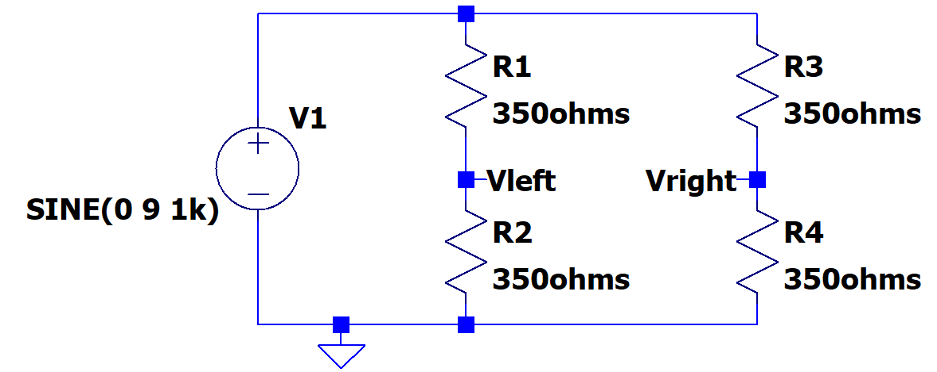
Figure A-1.

The following equations apply to the bridge circuit:

When all four resistors are equal to 350Ω, the bridge is balanced:

Experiment

Modeling a bridge in LTspice: In this part, we will set up a bridge in LTspice and look at the effect of a small change in one of the resistors on the difference across the bridge.
- A.1 Look at the behavior of a balanced bridge circuit.
  - Set up the circuit shown in Figure A-1.
  - Use a 9V amplitude, 1kHz frequency and no DC offset.
  - Label Vleft and Vright as shown.
  - Then run a transient analysis. (You have done enough transients now to be able to find a reasonable “run to time” and “step size.”)
  - Add a Trace of the difference between the two voltages, (Vleft - Vright).
    - In Experiment 2 you did a trace that was the voltage difference between 2 points by hovering over the schematic at a point where you want the positive probe, left click and hold, and then drag the mouse to the point where you want the negative probe.
    - The other option is to add a trace and enter the formula: V(vleft)-V(vright).
  - Is the difference zero?
- A.2 Look at the behavior of an unbalanced bridge circuit.
  - Now, change R4 to be equal to 360Ω, about a 3% change in R.
  - Do the analysis again and add the trace of the difference between the two voltages.
  - What is the amplitude of the difference voltage as a percentage of the source voltage?
  - Label the plot, copy it and include it with your report.

- A.3 Analyze this circuit by hand
  - Use the voltage divider formula to find the voltages at the two points and their difference. Make sure that your answer agrees with the LTspice simulation.
  - Assume that R1 = R2 = R3 are known resistors equal to R, and that R4 is unknown. Derive a formula for R4 in terms of R , the source voltage V1, and the voltage difference between the two divider voltages (dV=Vleft-Vright). [Hint: Substitute voltage divider expressions in for Vleft and Vright and solve for R4.]

- A.4 Parameter sweep
  - In LTspice, it is possible to run simulations for several values of a component. Above you ran two separate simulations, one with R4=350Ω and one with R4=360Ω. Now you will do one run with 11 values for R4. This is called a parameter sweep.
  - Change the resistance value of R4 from 360Ω to a variable name set within the curly brackets {Rvar} as shown in the figure below. You can make the name anything you want, but use something that reminds us what you are doing. The resistance value is now a variable.
    - Select the .op in the tool bar, as was shown in Experiment 3, Figure C-4. Make sure it is set as a SPICE directive (not a comment.) Enter: .param Rvar 350 click OK and place it on the schematic. This tells LTspice that the nominal value of Rvar is 350.
    - Add another SPICE directive and enter: .step param Rvar 340 360 2
    - This says to do 11 runs starting with Rvar=340. The increment to 340+2 and run again, and do this until Rvar is run with a value of 360.
- Run the simulation and plot the difference voltage between Vleft and Vright. You should see 11 traces.
- You can use the cursor to see which trace is which.
    - Left click on the trace name and the cursor lines will show.
    - Move the mouse to the cursor and a 1 should appear.
    - Click and drag that cursor to a point of interest.
    - Right click on the cursor and it lists Rvar value for that trace.
    - Use the up and down arrows to change which Rvar the cursor is following.
    - Copy this page and include it in your report.

- Delete all traces from the plot window. Plot just Vright, for all values of R4.
      - Include this plot in your report
      - Comment on if it is easier to see the effect of a change in R4 using the bridge (Vleft - Vright) compared to just using one side (Vright.)
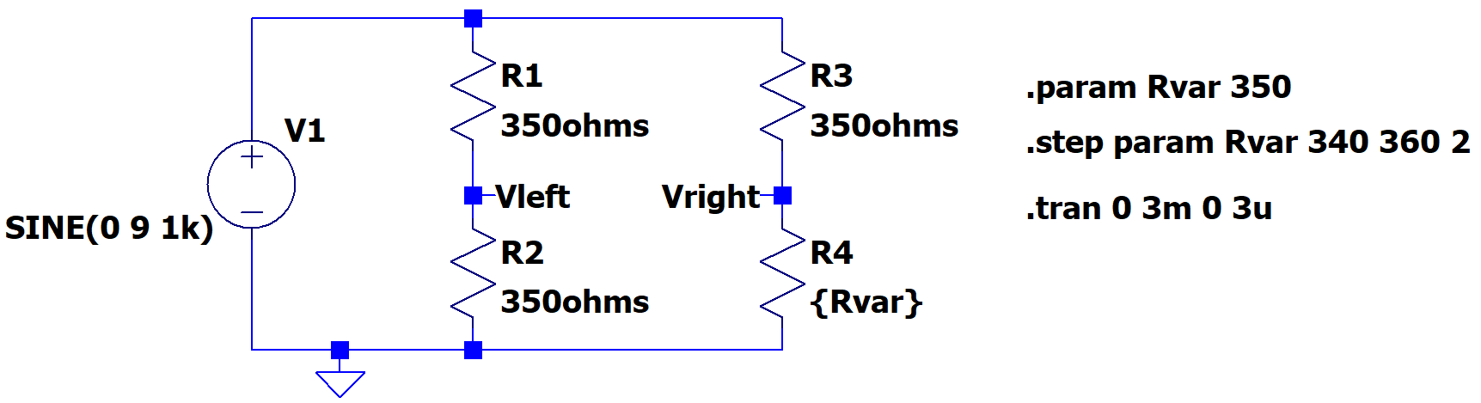
Figure A-2.
- A.5 Sensitivity calculation – can be done by one team member.
  - Use the results from the plot to determine the sensitivity of the bridge circuit to changes in R4.
  - What is the change in (Vleft-Vright) divided by the change in R4?

Summary
A bridge allows you to compare two voltages and to detect relatively small changes in a component value. We will use it in part B to observe small voltage differences caused by very small changes in the resistance of a strain gauge.

Part B – Strain Gauges

Background
Strain Gauges: A strain gauge measures the displacement of a surface when it is subjected to stress. The gauge is mounted securely to a surface (usually with something like super glue). When the surface stretches because of an external force, the strain gauge also stretches. The conductors of the strain gauge are either stretched or compressed strained. This results in a small change in the strain gauge resistance. In our case, the change in resistance of the strain gauge will give a signal proportional to the displacement at the end of the beam. Figure B-1 shows a typical strain gauge.

National Instruments has a very good discussion of stain gauges and our application at: http://zone.ni.com/devzone/cda/tut/p/id/3642
Go to the link and read up to Figure 8, Full-bridge Circuit. We use Half-Bridge, Configuration II – Bending Strain only.

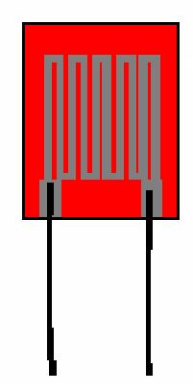
Figure B-1.

The Cantilever Beam: Figure B-2 shows the cantilever beam we use in class.
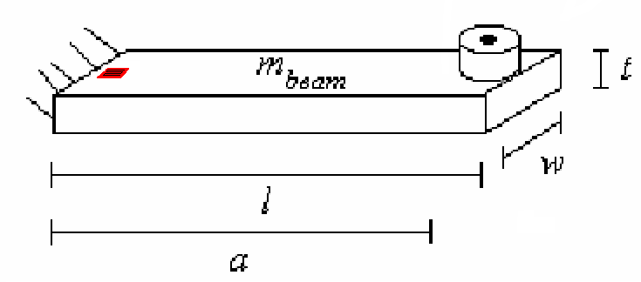
w
a
l
t
Figure B-2.

Please note: The beams have two strain gauges, one on the top of the beam and one on the bottom. This allows for the use of the Half-Bridge Circuit discussed on the NI website. These beams look somewhat different than the figure above but the principles are the same.

The beam has two strain gauges wired together, replacing R3 and R4 in Figure A-1of this document. It also has two matched 350Ω resistors. These are R1 and R2 of Figure A-1. The signals from the stain gauges are small, so a difference amp with a gain of 100 is required.

Experiment:

Strain Gauges:
We will now combine our study of strain gauges, bridge circuits and op-amps in a practical hardware application. We use the two resistors and the two strain gauges mounted to a beam to create a bridge circuit to measure the deflection of the beam. The signals are small so the output of the bridge will be amplified using a difference amplifier op-amp circuit.

- B.1 Before you build the circuit, use the multimeter to determine the resistance of one strain gauge in its rest position.
  - Unfortunately it is not easy to make this measurement when the beam is configured for the circuit. Rather than disconnect the easily broken strain gauge wires, the best you can do is measure the strain gauge while it is in parallel with 3 series resistors (the second strain gauge and two 350Ω resistors). You should verify that this is what will actually be measured when connecting 2 terminals from a strain gauge to the Ohm meter. This series/parallel resistor combination changes by about 1Ω from one extreme to the other. Verify the nominal measured resistance value in terms of the series/parallel combination. Be sure to use the most accurate DMM (Kiethly 8050A) on the center table for this measurement. Do not over extend the beam upwards or downwards.
Figure B-3
  - Measure the resistance of the strain gauge with the DMM when the beam is at rest. This is the resistance measured between terminals A and B or A and D (with the rest of the bridge connected to the circuit).
  - Deflect the beam down until you observe about half way to the support plate and measure the resistance with the DMM. If you do not observe any change, deflect it
downward until the beam is close to but not touching the support plate.
  - Deflect the beam up an equal amount and measure the resistance with the DMM.
  - Note that the resistances you measure are proportional to how much you move the beam.
  - Write down the maximum and minimum resistance of your strain gauge circuit. You should now see why we indicate this resistance with a variable resistor in the figure below.

Note that as the strain gauge undergoes expansion and compression its resistance varies a small amount. The bridge is designed so that the four resistances start at a value R. When the beam is flexed, the resistances of the two strain gauges become R + ΔR and R – ΔR. That is, one gets larger and one gets smaller. The parallel resistor combination measured is given by the following expression. Thus, the measured change in R is only half of the resistance change of the strain gauge. You should also see that the measured resistance is about ¾ of the strain gauge resistance.

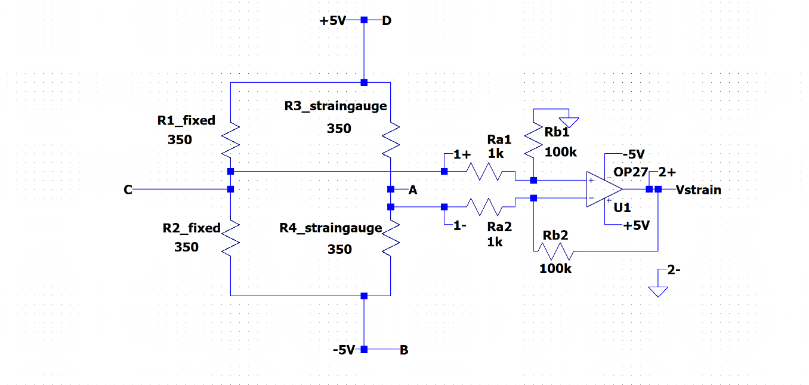
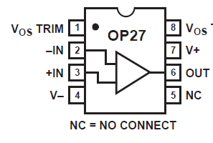

B
C
D
A
Terminal Block on Beam Base

1+, 1-, 2+, and 2- are the inputs for channel 1 and 2.

Figure B-4. Dotted line shows components on the beam. Dash line shows what is on the breadboard.
Wire the circuit neatly because it will be used for the next project. Note, before taking data, identify and label every element in the circuit on your hand-drawn diagram, especially the resistances in the pre-wired circuit on the beam. Almost all problems students have with this circuit occur because they do not understand what they are building.

- B.2 Wire the circuit shown in Figure B-4, using the OP27 op amp.
- The circuit in the dashed box is wired on your protoboard.
This should be wired neatly. It will be used for this experiment and for Project 2.
- The circuit in the dotted box is prewired on the instrumented beam.
- You need to connect 4 wires between the beam and the Protoboard, including V+ (to D) and V- (to B).
- Don’t enable V+ and V- on the M2k/Analog Discovery until you are certain that the circuit is wired correctly. You must enable these supplies when you are ready to collect data.
- Note that you are to measure both the output from the strain gauge bridge (which is also the input to the difference amplifier) and the output from the difference amp. For the bridge output, channel 1 is set up to measure in differential mode (neither wire is grounded).

- B.3 Repeat the deflection measurements of part B.1. Remember that the output of the amplifier (channel 2) should be 100 times larger than the output of the bridge (channel 1), so you should not use the same scales on your oscilloscope.
- Read the two output voltages without any beam deflection.
- Read the two output voltages with the beam deflected about halfway to the plate.
- Read the two output voltages with the beam deflected an equal amount up.
- Record the three voltage measurements. Hint: Use the measurement function to read the output. Keep the signal in the center of the screen. Use different scales for channel 1 and 2.

Damped Sinusoids: When the beam is deflected and then allowed to oscillate, you should measure signals that look like the damped sinusoid in Figure B-5. Damped sinusoids are governed by the equation: v(t) = Ce-αtsin(ωt), where α is called the damping constant that determines the rate of decay. To find the damping constant, choose two points at extreme ends of the sinusoid and use the following equation and solve for α:

v1 = v0e ^{-α (t1– t 0)}

Figure B-5
- B.4 When you have everything hooked up, set the beam into free oscillation.
  - You should observe decaying sinusoidal voltages. The two signals should look the same, but channel 2 should be 100X larger than channel 1. Once you have observed two reasonable decaying sinusoids, turn off channel 1 on your scope display. You only need to observe channel 2 for the following measurements.
  - It will take a little experimenting to get a good trace on the screen.
    - Start with time base of 10ms/div. Why is this a good place to start? What is the approximate frequency of oscillation of your beam?
    - Pull the beam down about half way and note if the voltage has dropped or increased.
    - If the voltage increases when you push the beam down, swap the two wires connected to Ra1 and Ra2 of Figure B-4. That is, swap the two inputs to the difference amplifier.
    - Pull the beam up about the same amount (1cm or ½”). Note how much the voltage changed relative to no deflection. Call this V_{trigger}.
    - Adjust the trigger level so it is above zero by about V_{trigger} or a little less.
    - Now set the trigger mode to “Normal”. Pull the beam down and release. If the M2k/Analog Discovery scope triggered, you are set.
    - Now set the time to 100ms/div. For long time traces, ≥ 0.1sec/div, you may need to use Single Sweep.
    - Pull the beam down and release.
  - Once you have obtained a clear signal of a decaying sinusoid, save the data to a file and plot it with Excel.
  - You can also use the “measurements” or directly click on the trace on the Analog Discovery scope to measure points on the trace.
  - Determine the frequency of oscillation and the decay constant.
  - Include this plot with your report. Indicate on it how you found the beam frequency and the decay constant. Note that a more accurate estimation of the frequency can be found by counting over many cycles.

There is a very good reference on strain gauges from the Vishay Measurements Group, Inc available on the links page.

Summary

The position of a cantilever beam can be measured using strain gauges. The signals from strain gauges are relatively small so they are typically used in a bridge circuit and with amplification. In this experiment, we used the signals to observe the oscillation of a cantilever beam.

Part C – Instrumented Beam as a Harmonic Oscillator

Background

Simple Pendulums: Before we address harmonic circuits, we will review some of the properties of the simple pendulum. The instrumented beam is a very good example of a simple pendulum, even though it looks more like a small diving board. Let us assume that the end of the beam moves in the x-direction. Obviously, this is a simplification, since it really travels along the arc of a circle. When the beam is stationary, we will assume that it is horizontal and at x = 0. Again, this is an approximation because the beam must bend downward slightly due to its own weight. When the beam is bent, it experiences a restoring force like a spring, , where k is the spring constant. From Newton’s Law, we can relate this force to the acceleration, a, velocity v, and displacement, x, of the beam.
Using only the terms related to the displacement, we can derive the harmonic oscillator equation: .
In standard form, the harmonic oscillator equation is where ω is the frequency of oscillation in rad/sec. Thus, the beam will oscillate at . The solution to this equation is: , where x₀ is the initial deflection of the beam and φ₀ is the initial phase. If you do not recall that this is the solution, plug the expression for x into the differential equation and you will see that it works. For simplicity, there is no need to include φ₀. Therefore, we can model the oscillation of a beam (with no friction) using the now familiar sinusoidal equation: . Using this equation, we get an oscillation that will go on forever, rather than decaying slowly away, like the actual beam.

We can use the conservation of energy to verify this result. We know that the pendulum or any harmonic oscillator works by exchanging energy between two different forms. Not all forms of energy can be easily converted to another state and then back again, but we know this is trivial with the kinetic and potential energy of a mass.
The kinetic energy of a mass (the beam) is given by the equation: and the potential energy of a spring system (like the beam) is given by . Upon initial deflection, the energy of the beam is all potential. Since we have assumed no dissipation (no friction or other damping force), the total energy will be conserved. Therefore, the total energy, W, will be constant and given by, at any one point in the beam’s oscillation.

We can start at this expression of energy conservation to determine the equations of motion of the beam or any other simple pendulum. Since the total energy is a constant, we can take the time derivative of the entire expression and set it equal to zero:

Since , we can substitute for dx/dt and write ,

which brings us back to Newton’s second law: . Thus, once we have a conservation law, we can use it even to find out how things change with time.

Young’s Modulus: We can use frequency to determine the properties of an oscillating mechanical system. In this part, we will use it to determine Young’s Modulus for an oscillating beam and use this information to guess what type of material the beam is made of. We can do this using the relationship between ω and the properties of the oscillating system. We already know the relationship between force and the properties of a spring. We can solve for –k: . For the oscillating beam, x corresponds to the displacement at the end of the beam. This relationship is defined by the physical properties of the beam, , where l is the length of the beam, E is Young’s Modulus, and I is the moment of inertia of the beam. If we solve this relationship for F/x, we will have a second expression for our constant, . Now, we can look up the moment of inertia for an object with a rectangular cross-section and substitute it in for I: .

Recalling our relationship for frequency from before and solving for k, we find: . Since this is an oscillating system, we will ignore the negative sign. This gives us our final result:

Therefore, if we can come up with a reasonable estimate for the mass of the beam and its resonant frequency, we should be able to find Young’s Modulus and use that to look up the material from which the beam is made.

The mass of the cantilever beam: Recall that the pendulum or harmonic oscillator equation holds for point masses located at the end of a massless beam. Since the beam has mass, but its center of mass is not located at the end of the beam, this term is multiplied by 0.23 to give the equivalent mass placed at the end of the beam that produces the same response. The beam may also have a sensor attached to the end which adds extra mass. When we talk about “m” in this experiment we are referring to the actual mass of the beam migrated to the end. Thus m is the effective mass of the beam with no load and .

Experiment

Frequency of a loaded beam
In the last experiment, you should have measured the oscillation frequency of the unloaded beam using the strain gauge and the bridge circuit.

- C.1 Use the circuit from part B to find the frequency of the beam with varying mass.
  - Set the beam into oscillation.
  - Produce a plot of the decaying sinusoid you observe and save it using the M2k/Analog Discovery software. Copy it, show it to a TA or instructor and have them sign your checklist.
  - Record the frequency in the table below.

Mass of object | Mass of clamp | m_{n} = Total mass at end of beam | Frequency (Hz)
0 kg | 0 kg | m₀ = | f_{o} =
 |  | m₁ = | f₁ =
 |  | m₂ = | f₂ =
 |  | m₃ = | f₃ =

- C.2 Measure the frequency three more times using additional masses of your choice.
  - Choose three objects from about 20 to about 100 grams. You should try to get a good distribution to get discernable data. The actual mass of the beam becomes less important with the heavier masses. So one mass should be heavy (around 100 grams). Don’t load the beam with a mass so heavy that it permanently bends the beam.
  - Measure the masses of the objects you have chosen with the scale in the studio. Enter them into the table. Be sure to include the mass of the paper clips used to hold the added mass.
  - The total mass at the end of the beam, m_{n}, is the sum of the object plus the clamp.
  - Place each mass as close to the end of the beam as possible using a paper clip.
  - Find the beam frequency for each mass and record it in the table. Try to be as accurate as possible. Your values should have at least one decimal point. You should check the frequency a couple of times, since you should notice that there will be a range of values for the frequency, primarily because of noise and the somewhat non-ideal nature of the sinusoidal voltage.

Analysis of beam data
In this part of the experiment, we will analyze the frequency data to determine the mass of the beam, Young’s Modulus for the beam, and, finally, the material out of which the beam is made.

- C.3 Find 4 equations in 2 unknowns.
  - We know that our system is governed by the relationship between the oscillation frequency and the properties of a spring.
, n=0,1,2,3

- We can write out a k expression for each of the four frequencies you have measured:

- C.4 Use these numbers to determine the values of k, and m.
  - Note that you are making four measurements to determine two constants. This means that you have some redundancy built in and also that you will not obtain perfect agreement for all four equations. None of your measurements will be perfect, so it is best to have more measurements than constants to average out measurement error. You need to find the values of k and m that come the closest to satisfying all four equations.
  - We are going to use Excel to plot the frequency of our system in relation to the mass added to the end. First we must solve for f_{n}. Note that in the equation below, m_{n} is the x variable and f_{n} is the y variable.

  - We need to determine a good guess for k (the spring constant) and m (the effective mass of the beam) in order to plot this equation. Use the data from only two of your masses and solve two equations in two unknowns to determine a guess for k and m. (If you get a negative mass, try using your smallest and largest mass to do the calculation.) Keep in mind that these are just guesses, so you don’t need to get carried away solving all combinations of all the equations. You could use some type of statistical analysis instead to get your guesses for k and m. For example, you could determine the standard deviation of the four expressions for k for a range of realistic values for the effective beam mass.
  - Now you can plot the equation in Excel. Use k_{guess} and m_{guess} you just calculated. Choose values for m_{n} between 0 and 120 grams. You are plotting a general function and matching your data to it. m_{n} is the domain of your function, you just need a set of x (m_{n}) values so you can calculate y (f_{n}). Have Excel calculate values for f_{n} for each m_{n} and plot the results.
  - Place your four data points on the plot. How well do these points fit the curve you generated? If your guesses are exactly perfect, they will lie right on the curve. Since they are only guesses, there is probably room for improvement.
  - Now it is time to adjust k_{guess} and m_{guess} to get the curve to match your data as closely as possible. Adjusting one will move the plot up and down. Adjusting the other will cause the curvature to change. Play with the numbers until the curve matches your 4 data points as closely as possible. When you are doing this, keep in mind that the location where the graph crosses the y axis represents the unloaded frequency of the beam. The function goes up very quickly near zero mass. What is a reasonable estimate for the unloaded beam frequency? Include the final plot with the general curve and the four data points marked in your report.
  - Use the values of k_{guess} and m_{guess} that give you the closest match in your final calculations for the beam mass and Young’s Modulus.

- C.5 Final results.
  - Calculate the mass of the beam using your best guess for m, m = 0.23m_{beam}.
  - CAREFULLY measure the dimensions of your beam. A small inaccuracy in your measurements can lead to a large discrepancy in your results.
  - Extrapolate the frequency for the beam (with no load at all on the end) from your plot. This is the point at which mass at the end of the beam is 0 kg.
  - Calculate Young’s Modulus using your best estimate for k and m.
  - Look up Young’s Modulus in the table of your choice and find some possible materials for your beam. (There may be more than one possibility.)
  - If you find more than one possible value for the material, think about other properties of the beam that may narrow the possibilities.

Summary

In this part of the experiment, you used the oscillation frequency and other physical properties of a cantilever beam to find information about the beam that you could not measure. You also learned how to use curve fitting to find a solution when there are more equations than unknowns.

Part D – Oscillating Circuits

Background

Energy storage in inductors and capacitors: In passive electrical systems, there are three kinds of circuit elements: resistors, capacitors and inductors. Resistors turn electrical energy into heat. When a current I flows through a resistor, there will be a voltage drop V across the resistor. The power dissipated by the resistor is equal to the product of I times V. Since resistors produce heat, it should be no surprise that they play the same role as friction in a mechanical system. The ideal pendulum will oscillate forever … a real pendulum will oscillate until all its stored energy is converted to heat through friction. Thus, if we wish to create a circuit analogous to the ideal harmonic oscillator, it can have no resistors in it. Rather, we will combine only inductors and capacitors.

A typical inductor consists of a coil of wire. If we pass a current through the coil, a magnetic field will be created. Many of us have made simple electromagnets at some time in our lives by wrapping wire around some magnetic material like a nail. When a battery is connected to the wire, it is possible to attract small pieces of iron to the nail. The field created by the coil, the magnetic field, can do work and thus contains energy. The energy stored in an inductor is given by the expression
W_{M} = (1/2) L I²

where we have used the subscript M to indicate that the energy is stored in the magnetic field and L is the inductance in units of Henries. Joseph Henry was honored by using his name for this unit because of his early work in developing practical electromagnets. He began his work here in New York’s capital district when he was teaching at the Albany Academy. There is a statue of this great scientist outside the original location of the Academy across the street from the Albany City Hall. Henry was a contemporary of Amos Eaton, the intellectual force behind the founding of RPI. He eventually left Albany for Princeton and the Smithsonian.

A typical capacitor consists of two metal plates of large area separated by some insulating material such as Teflon or some other plastic. When a voltage source is connected to the plates, charge flows from the source to the plates with positive charge deposited on the plate with the highest voltage and negative charge deposited on the plate with the lowest voltage. Since these charges are opposite in sign and since unlike charges attract one another, there is a force between the two plates. Again, the existence of this force tells us that we have to do work to charge up the plates and that there is energy stored. In this case, the energy is stored in the electric field created by the charges. The energy stored by a capacitor is given by the expression

W_{E} = (1/2) C V²

where we have used the subscript E to indicate that the energy is stored in the electric field and C is the capacitance in units of Farads. Michael Faraday also worked on electromagnets and, being British, gained much more fame for his work, since America was a scientific backwater at the time. Henry showed him how to make better magnets, but Faraday’s work was much more far reaching. Henry also showed Morse how to build a telegraph!

Aside: It is somewhat interesting to note that neither Henries nor Farads turns out to be much of a common practical unit. One Henry is a huge inductor, rarely seen in practice. One Farad is also rare, now occasionally seen in highly filtered power supplies for computers. We will need to use the prefixes milli-, micro-, nano-, pico-, etc. a lot when dealing with these components. We also do not see one Ohm all that much, but require the other kind of prefixes (kilo-, mega-, etc.).

Conservation of Energy in a Harmonic Circuit: There are many important lessons we can learn from the harmonic oscillator, but perhaps one of the most useful is the value of conservation laws. It is fair to say that the most powerful problem solving technique is to first decide which conservation laws hold. Once the conservation laws are identified, they can be used to determine a great deal of information about any system.

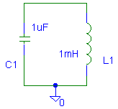
Figure D-1.

Consider the simplest possible configuration of a single capacitor and a single inductor connected as shown in Figure D-1. Note that, since there are only two components, one can describe this connection as either in parallel or in series. Also assume that the capacitor has been charged up to some voltage V at time t = 0, at which time it is connected to the inductor. The charge will begin to flow creating a current through the inductor. After a short time, all the charge that was originally on the capacitor plates will be gone and the current through the inductor will reach its maximum value. Thus, we began with all the energy stored in the capacitor and none in the inductor and end with the opposite condition. The current flowing through the inductor will then charge the capacitor back up and the process will begin again. The energy is traded back and forth between the two storage elements.

The total energy of the system must remain constant because there is no dissipative element (no resistor). The total energy, W, is a constant equal to the energy stored in the capacitor added to the energy stored in the inductor. Thus, . Since this is a constant, we can take the time derivative of this expression and set it equal to zero.

We want to do with this equation what we did with the energy conservation equation of the beam. This time, though, instead of expressing the equation in terms of the displacement, x, we want to express it in terms of the voltage, V.

We can use the general equations for the behavior of the capacitor and inductor to make these substitutions:

For the circuit shown above, V is the voltage at the top of the circuit and I is the current flowing around the circuit. Since this is a series circuit with only two elements: V = V_{C} = V_{L} and I = I_{C} = I_{L}. Making these simplifications, our equations become:
We can further conclude from the capacitor equation that, by solving for dv/dt, and, by taking the time derivative of both sides, . Substituting into the conservation of energy equation, we get
This leads us directly to the harmonic equation for oscillating circuits:
If we compare this to the general expression for harmonic oscillation, ,
we can determine the resonant frequency of the circuit: .

Also recall that this is the equation for the resonant frequency of any simple RLC circuit.

Damped Oscillation: The circuit we modeled above is unrealistic because it has no resistance at all. This is analogous to a mechanical system with no friction. To make a more realistic system, we must add some resistance, as shown in Figure D-2.
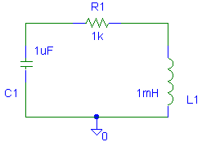
Figure D-2.

The circuit will still oscillate, however, the oscillation energy will gradually dissipate because of the resistance. The output signal will be similar to the oscillation behavior of the beam - a damped sinusoid. Note that this circuit has no voltage source. It needs to have an initial amount of energy placed into it. This is similar to the initial displacement you place on the beam to make it oscillate.

The damped circuit has the following oscillation equation
where α is the damping constant. It can be shown that in an ideal damped oscillation circuit, α is given by the following equation below:
Experiment

Part D: Modeling a damped oscillator. This part is a team project, only one member needs to do Part D. But all are responsible to know the material.
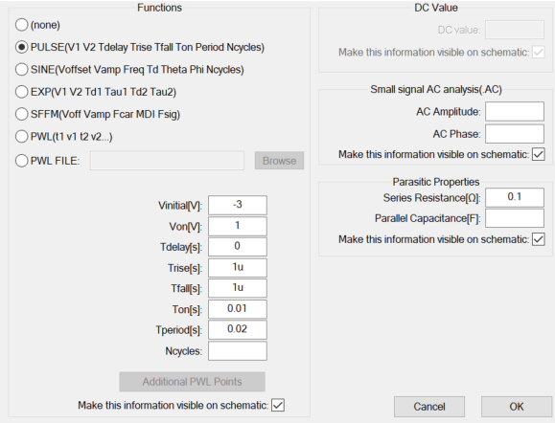
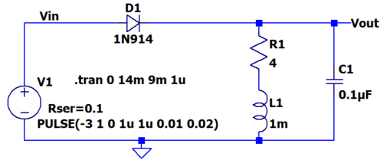
We will now consider an RLC circuit, with all three kinds of passive components and observe the damped oscillations. Note that we are also using a diode, a device that only allows current to flow in one direction (to the right in the figure). When a diode is on (forward biased), about 0.6 – 0.7V drops across it. We will learn more about diodes in Experiment 8, but, for now, you can consider it to be a switch that turns on when a positive voltage exceeding 0.6 or 0.7V is placed across it and is otherwise off. We are using it here so that the combination of an inductor L and a capacitor C are forced to oscillate over and over, kind of like ringing a bell. The resistance in the circuit is the DC resistance of the inductor and not a separate component.
Figure D-3.
We have been ignoring the fact that the M2k Signal Generator has an internal 50Ω series source resistance. The Analog Discovery has a very low series resistance. We will correct that now, so there are different settings to model the circuit for the M2k and Analog Discovery. In both cases right click on the V1 signal source and put in a value for the Series Resistance of the source.

Which board | Series resistance | Vinitial | Von
M2k | 50 | -4V | 2V
Analog Discovery | 0.1 | -3V | 1V

- D1: Create the oscillating circuit in Figure D-3 above in LTspice. The diode should be the D1N914
  - The voltage source used is a square wave with a negative offset so that the positive voltage is smaller than the negative voltage. Since the period is 20ms, what is the frequency of the square ware?
  - Place labels on the circuit at the points Vin and Vout.
  - Use LTspice to simulate the transient response of this circuit for a total time of one complete period. But you should only display a time window that allows you to determine the frequency of the oscillation and the damping constant.
  - Copy your results and include them in your report.
  - What features of the voltages reminds you of the instrumented beam?
  - Use the transient plot to find the oscillation frequency of your circuit. How does it compare it to the calculated value of ?
  - Use the plot to determine the damping constant of the circuit. In a simple RLC circuit, such as this one, the damping constant can also be found mathematically using the expression α=R/(2L). Calculate the damping constant and compare it to the one you found using the plot.
  - Keep your simulation active because you will be returning to it after the next task.

- D2: Build the same circuit on your breadboard and measure the same input and output voltages.
  - Remember that the resistance and inductor in the circuit are actually only the inductor in a physical circuit. If possible, confirm that the DC resistance of the inductor is about 4Ω by measuring it with a multi-meter.
  - Set up the function generator to produce a square wave and set the frequency, amplitude and offset to obtain the same values used in the LTspice simulation.
  - Connect the wires for channels 1 and 2 (1+ and 2+) at the points labeled Vin and Vout, and ground the other wires for each channel (1- and 2-).
  - Set up the time scale on your scope to be able to measure the oscillation frequency and the decay rate.
  - Copy your results and include them in your report.
  - Answer the same questions as you did for your LTspice results.
  - Describe the similarities and differences between your simulated and experimental results.

You should have found reasonable agreement between your simulated and experimental results. Our experience is that the decay constant may differ between the simulation and the experiment but that the initial oscillation amplitude the frequency are similar. The similar experimental and simulated results validate the simulation and permit us to use features of the simulation that are not available in experiments. For example, there is no simple way to obtain the current through the inductor in the experiment. (You may want to think about why this is the case.) In the simulation, it is possible to easily find the current by just hovering the cursor over a component and left click when you see the current meter symbol. In the final task of this experiment, you are to use the simulation to determine the energy stored in both the inductor and capacitor and see how they vary with time.

- D3: Return to LTspice
  - Delete the trace of Vin and add a current trace for the inductor current. Your results plot should change without having to run the simulation again because LTspice calculates all voltages, currents and power each time.
  - If you find that the initial flat current in the inductor is negative you can cut the wires to the inductor, rotate it 180 degrees and rewire. Or you can edit the signal plotted by adding a minus sign.
  - Now you have all information necessary to determine the energy stored in the capacitor and in the inductor. Modify the two traces in your plot so that they display the energy in the inductor and the energy in the capacitor . Also, add a third trace that is the sum of the two energies (e.g. the total energy).
  - Copy your results and include them in your report. There should be some very interesting features in these plots. Be sure that you annotate them fully so that an observer can easily identify all features.
  - Describe the key features of your energy data vs time, including the maximum stored energy in either the inductor or the capacitor.

Summary

In this part of the experiment, you have related your knowledge of oscillating mechanical systems to an oscillating electrical system and created an oscillating circuit.

Note that you will continue your study of harmonic oscillators in Project 2, where you will use the strain gauge set up from this experiment and an accelerometer to determine both the position and acceleration vs time for the beam. The beam will be loaded a little differently because you will install the accelerometer near the end. You will be using the two measurements to determine the velocity of the beam. Once you have both the beam position and velocity, you will be able to produce a plot that will look a good deal like the energy vs time plot for the RLC circuit.

Checklist and Conclusions

The following should be included in your experimental checklist. Everything should be labeled and easy to find. Credit will be deducted for poor labeling or unclear presentation. ALL PLOTS SHOULD INDICATE WHICH TRACE CORRESPONDS TO THE SIGNAL AT WHICH POINT AND ALL KEY FEATURES SHOULD BE LABELED.

Hand-Drawn Circuit Diagrams for all circuits that are to be analyzed using LTspice or physically built and characterized using your M2k/Analog Discovery board.

Part A (16 points)

Include the following:
- A.1 Nothing to plot. (0 pt)
- A.2
  - Plot of Vleft - Vright with R4 modified. (1 pt)
  - Fraction of output signal compared to Vac source. (2 pt)
- A.3
  - Analysis of circuit in part A.2. (2 pt)
  - Derivation of formula for Vout = dV (= Vleft – Vright) as a function of R4, V1, ... (2 pt)
- A.4
  - Plot of all 11 Vout traces. (2 pt)
  - Plot of just Vright for all 11 cases. (1 pt)
  - Comment on the advantage of using a bridge (Vleft - Vright) vs. using just a divider (Vright). (2 pt)
- A.5 What is the sensitivity of this circuit (change in Vout/change in R)? (4 pt)

Part B (16 points)

Include the following:
- B.1 Min and Max resistance measured. (2 pt)
- B.2 Nothing.
- B.3 Voltage measurements for three beam positions. (3 pt)
- B.4 M2k/Analog Discovery plot of beam oscillation with calculations of beam frequency and damping constant on it. (6 pt)

Answer the following questions:
- What is the resonant frequency of the beam? What value did you find for the damping constant? Write an equation for the decaying sinusoid output of the beam in the form v(t)=Ce-αtsin(ωt). (5 pt)

Part C (18 points)

Include the following plots/table:
- Two M2k/Analog Discovery plots of the decaying sinusoid obtained with different masses added. For each write the mass added and the frequency measured. Have a TA or instructor see one plot. (4 pt)
- A table such as the one on page 10 of this document, listing the mass, total mass and frequency. (2pt)
- Excel plot of frequency vs. load mass with four points marked. (3 pt)

Answer the following questions:
- Explain or show your work on how you did your analysis to determine a reasonable first guess for k and m. (2 pt)
- What are the values for k and m that you obtained by making the plot in Excel? (2 pt)
- Calculate the mass of the beam. (1 pt)
- Calculate Young’s Modulus for the beam. Clearly indicate the values you measured for the beam’s dimensions. (2 pt)
- What do you conclude the beam could be made of? Why? (2 pt)

Part D (20 points)
Include the following plots:
- LTspice plot of input and output from the oscillating circuit. Be sure to label your plot with the resonant frequency and damping constant of the circuit you analyzed using the LTspice plot. Write an equation for the output in the form v(t)=Ce-αtsin(ωt). (4 pt)
- M2k/Analog Discovery plot of input and output from the oscillating circuit. Again, be sure to determine the resonant frequency and damping constant and include this information on your plot. (4 pt)
- LTspice plot of the energy in the inductor, the energy in the capacitor and the total energy as functions of time. Be sure to label everything interesting in these plots. Describe the key features of the energy plots. (6 pt)
Answer the following questions:
- Compare and contrast both your LTspice and M2k/Analog Discovery plots with the plots for the cantilever beam. (2 pt)
- In D1: What value did you calculate for f using the equation for the resonant frequency? How close of an estimate is this to the resonance you found in the plot? (2 pt)
- In D1: What value did you calculate for α using the equation? How close of an estimate is this to the damping constant you found in the plot? (2 pt)

Organization, completeness, ordering. Is this easy to grade? (6 pt)

List member responsibilities. (4 pt) For the experiments we continue with responsibilities. For Project 2 you will list Personal efforts. Note that this is a list of responsibilities, not a list of what each partner did. It is very important that you divide the responsibility for each aspect of the experiment so that it is clear who will make sure that it is completed. Responsibilities include, but are not limited to, reading the full write up before the first class; collecting all information and writing the report; building circuits and collecting data (i.e. doing the experiment); setting up and running the simulations; comparing the theory, experiment and simulation to develop the practical model of whatever system is being addressed, etc.

Summary/Overview (0 to -10 pts) There are two parts to this section, both of which require revisiting everything done on this experiment and addressing broad issues. Grading for this section works a bit differently in that the overall report grade will be reduced if the responses are not satisfactory.

- Application: Identify at least one application of the content addressed in this experiment. That is, find an engineered system, device, process that is based, at least in part, on what you have learned. You must identify the fundamental system and then describe at least one practical application.
- Engineering Design Process: Describe the fundamental math and science (ideal) picture of the system, device, and process you address in part 1 and the key information you obtained from experiment and simulation. Compare and contrast the results from each of the task areas (math and science, experiment, simulation) and then generate one or two conclusions for the practical application. That is, how does the practical system model differ from the original ideal? Be specific and quantitative. For example, all systems work as specified in a limited operating range. Be sure
to define this range.

Total: 80 points for experiment packet
0 to -10 points for Summary
20 points for attendance
100 points

Experiment 5
Section: ______
Report Grade: ______
#1 name: | #2 name:
#3 name: | #4 name:
Checklist w/ Signatures for Main Concepts

For all plots that require a signature below, you must explain to the TA or instructor:
- the purpose of the data (using your hand-drawn circuit diagram),
- what information is contained in the plot and
- why you believe that the plot is correct.
Any member of your group can be asked for the explanation.

PART A: Bridge Circuits

A2: Behavior of unbalanced bridge circuit
- Plot of Vleft – Vright with R4 modified ________________________
- Fraction of output signal compared to Vac source
A3: Analyze circuit by hand
- Analysis of circuit in part A.2
- Derivation of formula for Vout=dV(=Vleft – Vright)

A4: Parameter sweep
- Plot of all 11 Vout traces _____________________________________
- Plot of just Vright for all 11 cases
- Comment on the advantage of using a bridge vs. using just a divider

A5: Sensitivity calculation
- What is the sensitivity of this circuit?

PART B: Strain Gauges

B1: Min and Max resistance measured
B3: Voltage measurements for three beam positions
B4: M2k/Analog Discovery plot of beam oscillation with calculations _______________
Question 1

PART C: Instrumented Beam as a Harmonic Oscillator

- Two M2k/Analog Discovery plots of the decaying sinusoid with different masses
- A table listing the mass, total mass and frequency
- Excel plot of frequency vs. load mass with four points _________________
Questions 1-5

PART D: Oscillating Circuits
- LTspice plot of output from the oscillating circuit, with parameters and equation
- M2k/Analog Discovery Plot of oscillating circuit, with parameters _______________
- LTspice Plot of Energy, with explanation
Questions 1-3

Member Responsibilities

Summary/Overview

