Activity 03: Voltage Dividers
(Edit this document as needed, after you are done, convert to PDF and upload to Gradescope)

Student Name: ______________

Design Problem

The model of a cable and load resistor (100 Ω) connected to a voltage source is shown below. Determine the appropriate cable resistance, R, so that the output voltage, Vout, i.e. voltage drop across the 100 ohm resistor, remains between 9 V and 13 V when the source voltage, Vin, varies between 20 V and 28 V. The cable resistance can only assume integer values in the range of 20 < R < 100 Ω.
A few correct answers are possible here, you just need to choose one as your answer.

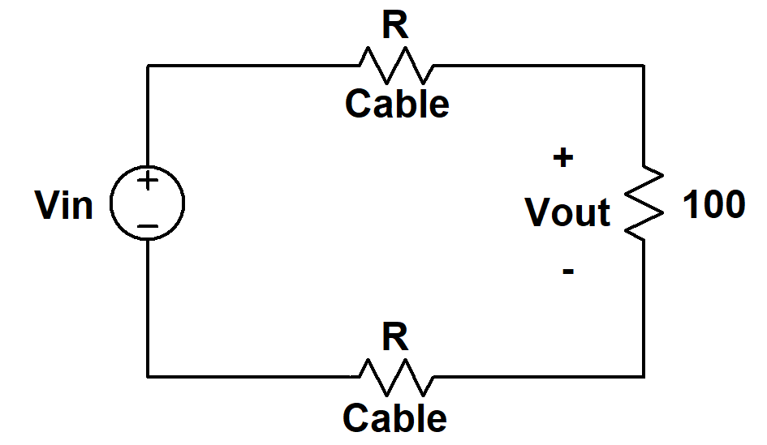

(show work)

Answer: __________________

Effect of input impedance of voltmeter on voltage measurements.

Background

Impedance: Every piece of electrical equipment has an effect on the circuit you connect it to. Just as it is impossible to design a dynamic mechanical system without friction (that resists motion), it is impossible to design an electrical system without impedance (that resists the flow of electrons). Impedance has two effects on an electrical system. It changes its magnitude (the value of the voltage) and its phase (voltage behavior over time). If the impedance affects only magnitude, then we call it resistance. Each electrical measurement device has an internal impedance, and this is also true for the M1K board (or Analog Discovery).

Note that presently we are only concerned about the effect of the equipment on the magnitude (resistance component) of the impedance. Also note that the devices we will use are designed to have minimal effect on any circuit they are connected to. In this part of the activity, we will examine how much of an effect the equipment has.

In the figures below, V1 is modeling an ideal voltage source, R1 and R2 are modeling two equal resistors and R3 is modeling the input impedance of the voltmeter. M1K board has two voltmeters that we will start using from next class.

‘k’ = kilo = 10³ and ‘Meg’ = ‘M’ = 10⁶

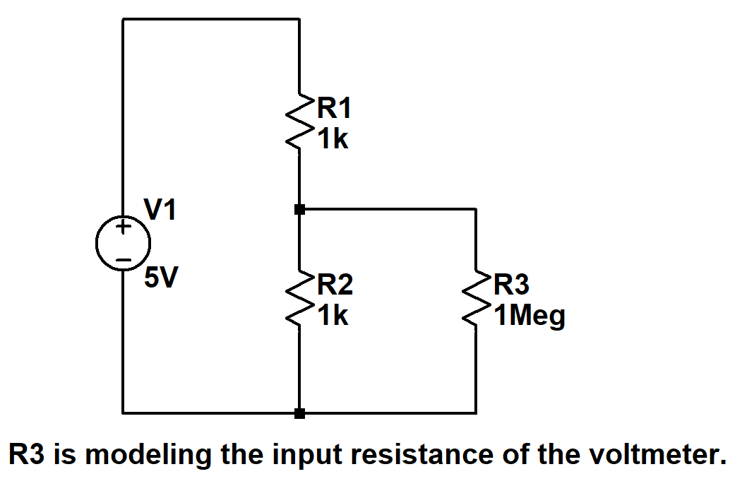

In the circuit shown above, what is the expected voltage drop across R2? i.e. you are determining the voltage drop across R2 without including the effect of voltmeter (R3 removed).

Answer:__________________

In the same circuit above, what is the voltage drop across R2 when you include the include the effect of voltmeter (R3 present as shown) ?

Answer:__________________

How do the above two answers compare? _________________

R1 and R2 are now changed to 1 Meg ohm each.
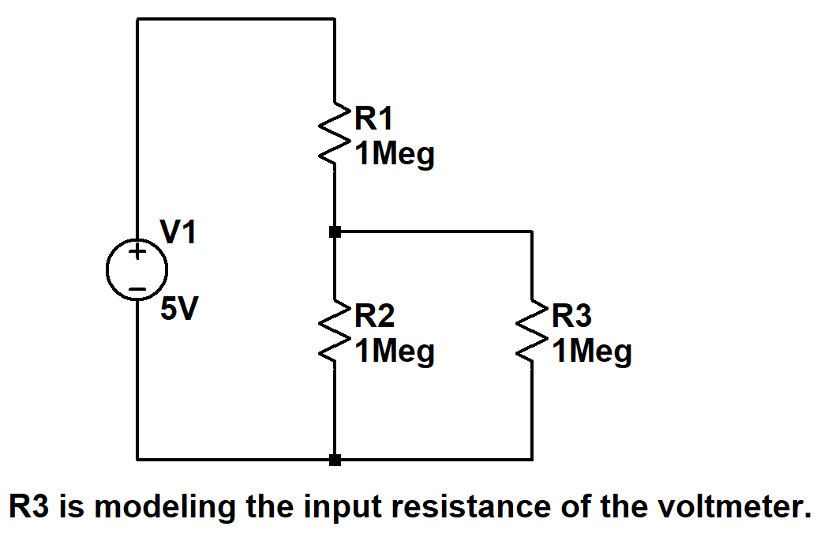

In the circuit shown above, what is the expected voltage drop across R2? i.e. you are determining the voltage drop across R2 without including the effect of voltmeter (R3 removed).

Answer:__________________

In the same circuit above, what is the voltage drop across R2 when you include the effect of voltmeter (R3 present as shown)?

Answer:__________________

How do the above two answers compare? _________________

Due on January 27th, 11:59 pm eastern on Gradescope.

