Activity 02: KCL, KVL, Series and Parallel Resistors
(Edit this document as needed, after you are done, convert to PDF and upload to Gradescope)

Student Name: ______________

Design Problem

Specify the range of resistance R in circuit shown below so that both of the following conditions are satisfied:

- $i>40 mA$ (Remember ‘m’ stands for milli)

- The power absorbed by the resistor is less than 0.5 W

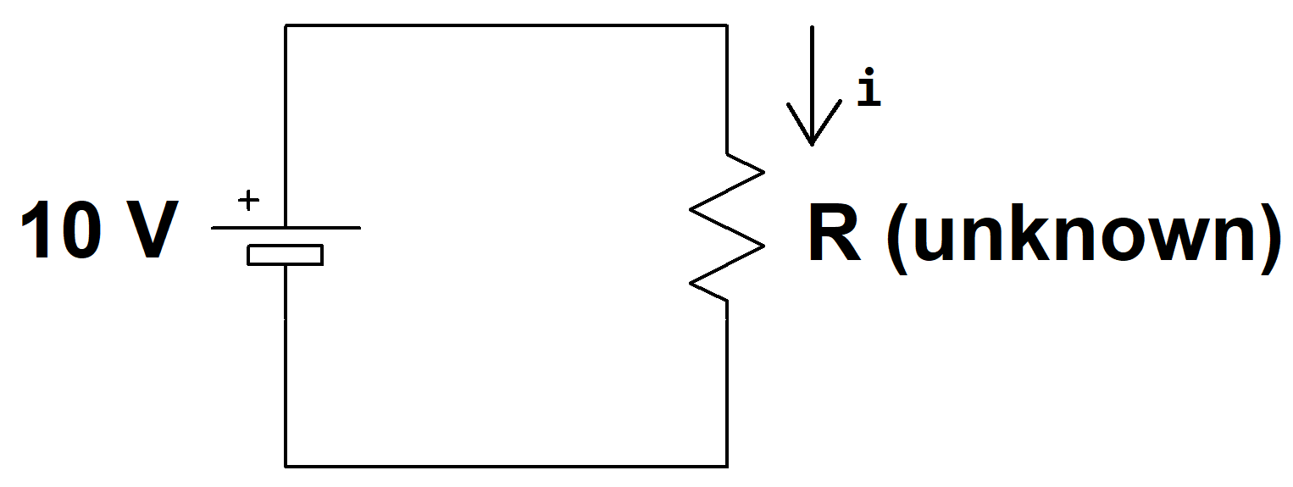

(show work)

Answer:_____________________________

Can you find one resistor in your parts kit that satisfies the above range?

______________

If yes, then specify the value of this one resistor?______________________

If no, then how can you combine multiple resistors from your parts kit to achieve the equivalent resistance R to satisfy the range? This has many correct answers, you just need to provide one answer that works. You need to specify how you would connect them and what values of resistors from your kit would you use?

Answer:

Linear Models

An element has voltage ‘v’ and current ‘i’ as shown in the figure below. Values of the current i and corresponding voltage v have been tabulated below.

v in volts | i in amps
-3 | -3
-4 | -2
0 | 0
12 | 2
32 | 4
60 | 6
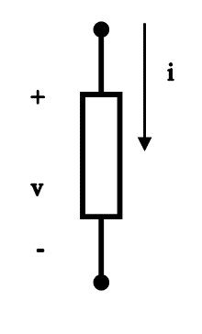

Determine if the element is linear or not? Provide work or explanation for your answer.

Circuit Analysis
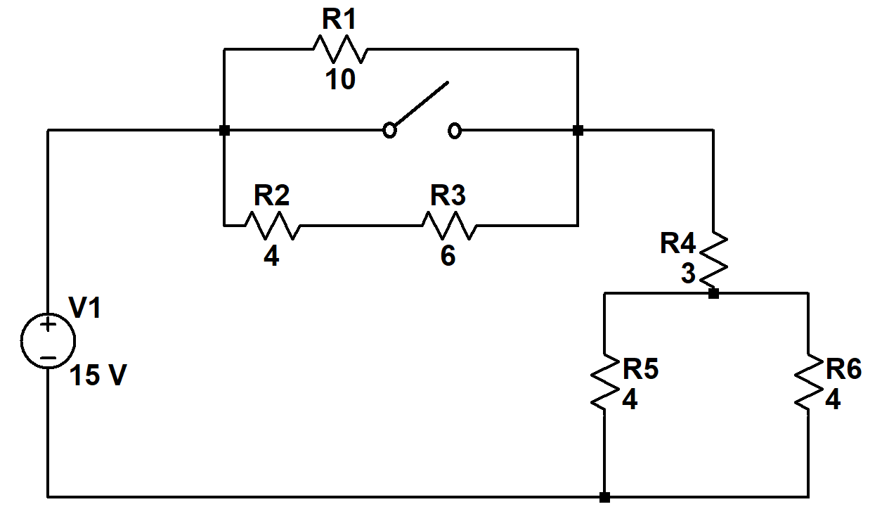

Find the current supplied by the voltage source when the switch is open.

Answer:_______

Find the current supplied by the voltage source when the switch is closed.

Answer:_______

How do the above two current calculations compare? Why do you think there is a difference? Explain in a sentence or two.

Answer:_______

Due on January 24th, 11:59 pm eastern on Gradescope.

