Activity 01: SI Units, Prefixes, Electrical Quantities
(Edit this document as needed, after you are done, convert to PDF and upload to Gradescope)

Student Name: ______________

SI Units

Fill all the empty cells in the table below

Quantity | Unit Name | Symbol
Charge
 |  | A
Voltage
Resistance |  | Ω
 | farad | F
Inductance
Power
 |  | J

SI Prefixes

Which of the three currents, i₁ = 45 μA, i₂ =0.03 mA and i₃ =25x10⁻⁴ A, is the largest?

Answer:

Electrical Quantities

Ten billion electrons per second pass through a particular circuit element. What is the average current in that circuit element? It is convenient to express your answer in nA.

Answer:

Explain, in a few sentences, how you would measure voltage across the flashlight bulb and current through the flashlight bulb in the circuit shown below? Which general instruments would you use? Use hand-drawn sketches (circuit diagrams) to pictorially represent how you would make connections to conduct these measurements.

Hint: Use the DC measurements – Multimeters video linked here and the class website to answer this question.

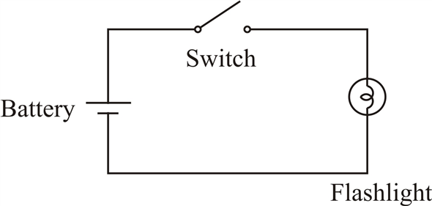

Answer:

What is due on January 20th, 11:59 pm eastern on Gradescope?

- This activity
- Academic integrity and digital tools forms after signature

