Alpha/Omega Lab Project Plan
Contents
Choosing Lab Type 2
Background on YOUR Lab Adventure 3
Lab 01 Choose Your Adventure! Voltage Divider Applications and Design Background 3
Lab 02 Choose Your Adventure! Applications: Transfer Functions, Linear Algebra, and Control 4
Lab 03 Choose Your Adventure! Music to MY ears: Filters and Signal Processing 5
Important Details for your Plan 6
Trainings, Visits, and Access to Labs 6
Goals and Objectives 6
Parts List List an expected number of parts you will need that are not in your circuits kit. List the cost of parts you want to purchase. 7
TA/SA/STUDENT “Is this plan right?” Checklist 7
Project Plan Example Error! Bookmark not defined.
Goals and Objectives Error! Bookmark not defined.
Parts List List an expected number of parts you will need that are not in your circuits kit. List the cost of parts you want to purchase. Error! Bookmark not defined.
TA/SA/STUDENT “Is this plan right?” Checklist Error! Bookmark not defined.

This is a guideline to help you and your supporting instructors, TAs, and SAs determine if your project is well-defined and feasible. You must fill out this today and submit it to Gradescope by the beginning of the next lab. YOU WILL BE ASKED TO ITERATE and resubmit at least two more times this semester. You CAN CHANGE YOUR PLAN. It’s part of the process of learning. It will get better. See the example Project Plan below for more details on what is expected. A general overview of what is expected for your lab submissions can be found on the course website under Alpha Experiments - Omega Lab Explorations.

Choosing Lab Type
 | Do you plan to do an Alpha Experiment?  Write Yes or No below if you intend to do the guided design project at the end of each lab | Do you plan to do an Omega Exploration?  Write idea from the less guided exploration list OR write your own project idea below (note: your idea must relate to concepts in the lab!)
Lab01: Basic Analysis and Engineering Practices
Link to first class day videos background
Lab02 Part A: Linear Systems and Beyond….
Link to first class day videos and background
Lab03: The Signals and the Noise
Link to first class day videos and background

Background on YOUR Lab Adventure

Lab 01 Choose Your Adventure! Voltage Divider Applications and Design Background

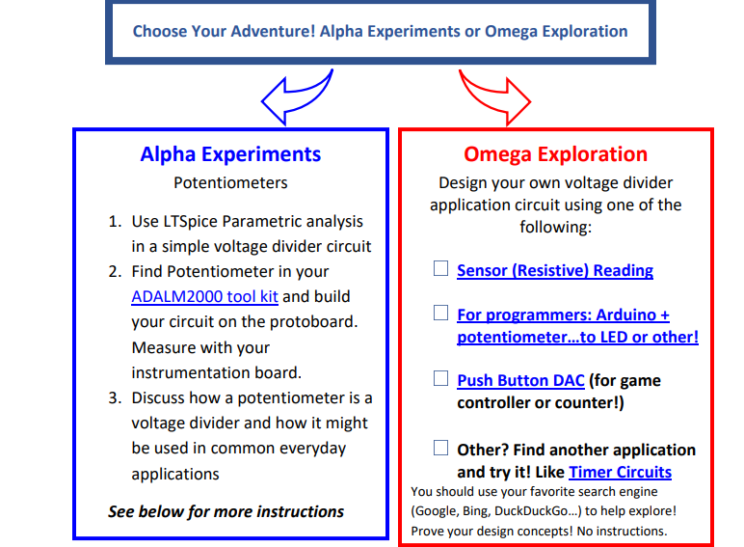

Lab 02 Choose Your Adventure! Applications: Transfer Functions, Linear Algebra, Sensors and Control

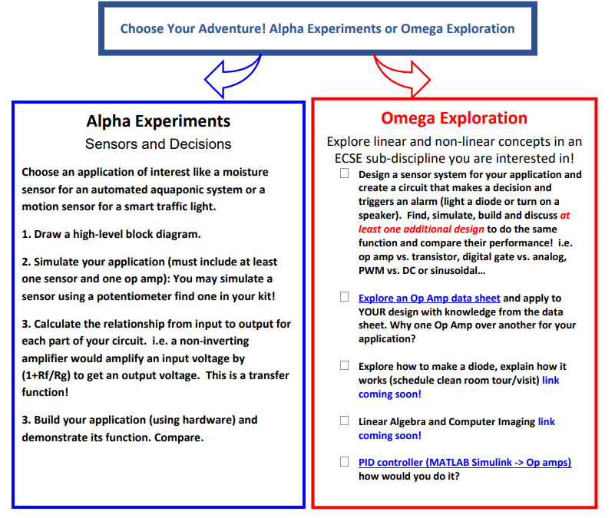

Lab 03 Choose Your Adventure! The Signals and the Noise: Filters and Signal Processing

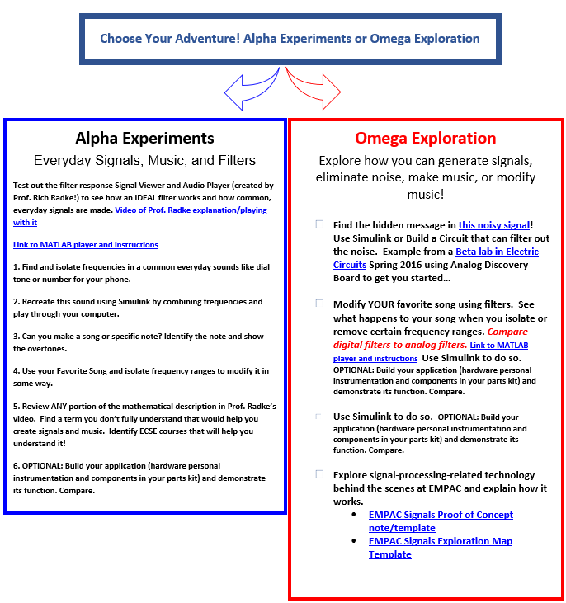

Important Details for your Plan

Trainings, Visits, and Access to Labs
Please check all of the trainings or visits or access you think you need if you are doing Omega Explorations:
 | Training, Visits, and Access | Purpose for your Project
 | I plan to use the Mercer Lab, I need access.
 | I plan to use the Forge for 3D printing.
 | I plan to schedule a visit for the clean room as an Omega Exploration for Lab02.
 | I want to learn how to design a Printed Circuit Board (Altium - Free enrollment).
 | I plan to schedule a tour of EMPAC as an Omega Exploration for Lab03

Goals and Objectives
Outline your goals, team member roles, deadlines for at least Lab01. Try to fill out as much as you can for the other Labs so the TA can give you advice.
Lab 01 (Date: )

Lab 02 (Date: )

Lab 03 (Date: )

Reason for update (if applicable)

Parts List
List an expected number of parts you will need that are not in your circuits kit. List the cost of parts you want to purchase.

What potential issues do you foresee with this design?

What skills and concepts do you need to learn to do this?

What is your plan if this design does not work?

TA/SA/STUDENT “Is this plan right?” Checklist
A TA must check each of these items to pass the plan. Be prepared to answer each of these questions with justification.
☐ Can the project be completed in the given time?
☐ Do the Goals and Objectives provide a reasonable pace for the project?
☐ Does the project align well with the learning objectives of the course?
☐ Is the circuit size and cost reasonable?

Team Signatures (online by Gradescope not physical)
______________________________
______________________________
______________________________
TA Signature
______________________________

