Experiment 8

**Diodes**

**Purpose:** The objective of this experiment is to become familiar with the properties and uses of diodes. We will first consider the i-v characteristic curve of a standard diode that we can use in the classroom. We will also see how the diode can work as a rectifier, which is an essential part of most DC sources that are driven by AC voltages. A serious problem with simple rectifiers is that the DC voltage they produce is dependent on the load. A common way to make the rectifier less sensitive to the load is to add some regulation. This we can do by utilizing the avalanching effect that occurs if we reverse voltage the diode too much. We will also see what kind of voltage limitation can be achieved with a forward biased diode. Such limitation of voltages is usually applied to protect circuit components.

Background: Before doing this experiment, students should be able to

* Analyze simple circuits consisting of combinations of resistors, inductors, capacitors and op-amps.
* Measure resistance using a Multimeter and capacitance using a commercial impedance bridge.
* Do a transient (time dependent) simulation of circuits using *LTspice*
* Do a DC sweep simulation of circuits using *LTspice*.
* Build simple circuits consisting of combinations of resistors, inductors, capacitors, and op-amps on protoboards and measure input and output voltages vs. time.
* Review the background for the previous experiments.

Learning Outcomes: Students will be able to

* Generate I-V curves for resistors and diodes, both experimentally and with *LTspice* simulation
* Make differential voltage measurements using M2k/Analog Discovery and Scopy/Waveforms.
* Generate theoretical diode I-V curves using Matlab and plot them along with experimental diode data.
* Characterize the operation of diode rectifiers (half-wave and full-wave) and limiters both experimentally and using *LTspice* simulation.
* Build basic LED and photodiode/phototransistor circuits, modulate the light from the LED and detect it with a photodiode/phototransistor, displaying both the input and output signals on a scope.
* Characterize the operation of a Zener diode both experimentally and using *LTspice* simulation.

Equipment Required:

1. **M2k/Analog Discovery** (with Scopy/Waveforms Software)
2. **Oscilloscope** (M2k/Analog Discovery)
3. **Signal/function generator** (M2k/Analog Discovery)
4. **Protoboard**
5. Resistors, Capacitors, Diodes, Zener Diodes
6. OrCAD *LTspice* and *LTspice*

Helpful links for this experiment can be found on the links page for this course: [Exp 8](https://www.ecse.rpi.edu/courses/F21/ENGR-2300/EILinks.html#Exp8) Also look at a document on the parts used: [Supplemental information for experiment 8](https://www.ecse.rpi.edu/courses/F21/ENGR-2300/EIexp-proj-lect/Supplemental%20information%20for%20experiment%208.pdf)

**Pre-Lab**

*Required Reading:* Before beginning the lab, at least one team member must read over and be generally acquainted with this document and the other **required reading** materials listed under [Experiment 8](http://www.ecse.rpi.edu/courses/S21/ENGR-2300/EILinks.html#Exp8) on the EILinks page.

*Hand-Drawn Circuit Diagrams:* Before beginning the lab, hand-drawn circuit diagrams must be prepared for all circuits physically built and characterized using your M2k/Analog Discovery board.

**Part A – The I-V Characteristic Curve**

**Background**

*Diodes:* An ideal diode is a device that allows current to flow in only one direction. The symbol of a diode, shown in Figure A-1, looks like an arrow that points in the direction of current flow. The current flows through the diode from the anode to the cathode. The cathode is marked on a real diode by a band.

 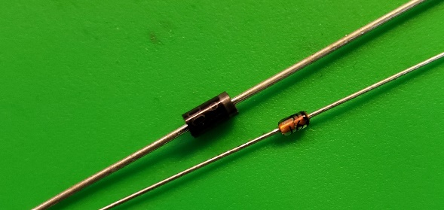

**Figure A-1.**

A small positive voltage is required to turn a diode on. This is a voltage drop across a diode that is in what we call the “on” state, so the voltages at the two ends of the diode will differ. The voltage required to turn on a diode is typically around 0.6 - 0.8V for a standard silicon diode.

*I-V characteristic curve:* In order to understand how a diode functions, it is useful to look at a plot of the voltage across the diode vs. the current through the diode. We call this type of curve and i-v characteristic curve. If we were to create an i-v curve of a resistor, where the current is directly proportional to the voltage (V=IR), we would see a straight line with a constant slope or R-1. When we plot the characteristic curve of an ideal diode (that switches on when the voltage across it goes above zero), we see zero current when vD is negative and infinite current as soon as vD tries to go positive. This is shown in Figure A-2. Note that, when and ideal diode turns on, it is a short circuit and, therefore, the voltage across the ideal diode when it is on is always zero.

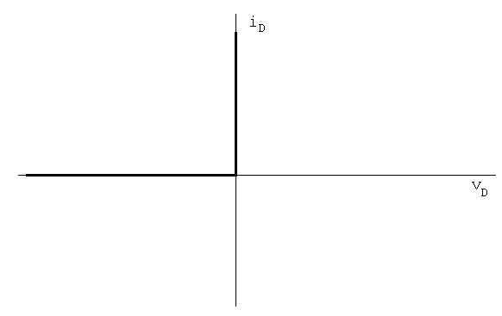

**Figure A-2.**

*I-V curve of a diode:* Figure A-3 shows typical characteristics of a real diode.

Ideally, a diode is a device that allows current to flow in one direction only. In practice, diodes allow large amounts of forward current to flow when the positive voltage across them reaches a small threshold. They also have a small “saturation” current and a “breakdown” region in which a large amount of current will flow in the opposite direction when a large negative voltage is applied. In small signal diodes, the forward current will typically be up to a few tens of mA at a forward voltage of about 1V. The reverse-breakdown voltage might be about 100V, and the saturation current Is may be of the order of 1nA. Power diodes may allow forward currents up to many amps at forward voltage drops of 0.6 to 1.5V or so, depending on the type of diode. The reverse-breakdown voltage of power diodes may range from as low as 50V up to 1000V or even much more.

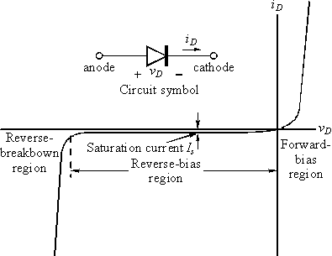

**Figure A-3.**

*The diode equation:* The equation below gives a reasonably good representation of the *i-v* characteristics of a diode.



Is is the saturation current usually measured in nanoamps or picoamps. VT is the Thermal Voltage [K in your book] where VT = kT/q = 0.0259V at 300K and n is a somewhat arbitrary parameter which depends on construction and usually lies between 1 and 2. Note that this equation characterizes the basic features of the diode *i-v* curve, but leaves out some details like reverse breakdown, junction capacitance, etc.

**Experiment**

*I-V Characteristic Curve of a Resistor*

Now we will plot the voltage across a resistor vs. the current through the resistor. The resistor of interest is labeled Ra2 in the figure below. *LTspice* allows you to plot currents, but M2k/Analog Discovery does not. So we will add a 1kΩ “current sensing resistor,” Ra1. The current through Ra1 is equal to the voltage across Ra1/1000. M2k/Analog Discovery can be used to measure the voltage across the “current sensing resistor.”

* Wire the circuit shown in Figure A-4 in *LTspice*.

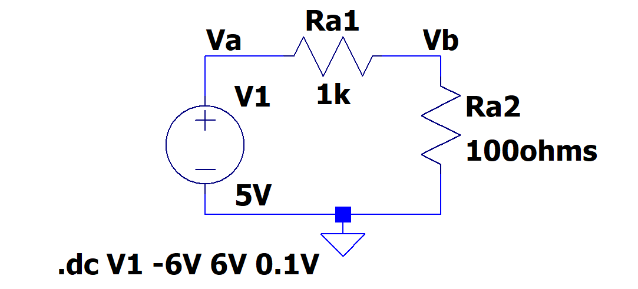

**Figure A-4.**

* Run a simulation and create the i-v characteristic curve
  + Set up a DC sweep: source: V1, Type of sweep: Linear, Start Value: -6, Stop value: +6, Increment: 0.1V. This assumes that the name of your source is V1.
  + Run the simulation.
  + Hover the cursor over Ra2 and the current probe appear. Note the direction of the current arrow. It should be down, if it is pointing up you will need to add a minus sign as is discussed below.
  + Left click while the current probe is visible and plot the current.
  + If your plot slopes down, the current arrow was up, edit the trace displayed by inserting a minus sign. Right click on the trace name in the plot window and insert a minus sign. (Or edit the schematic by rotating Ra2 by 180 degrees.)

Current probe

* + Change the x-axis of your plot as follows:
* Hover over the x axis, the ruler type image appears.
* Right click
* Change the Quantity plotted to be the voltage on Ra2. It is V(Vb) if you have labelled your schematic as was done for Figure A-4
* Click OK
  + The plot produced will show the i-v characteristic curve for resistor R1a2. Your plot should look something like Figure A-5:

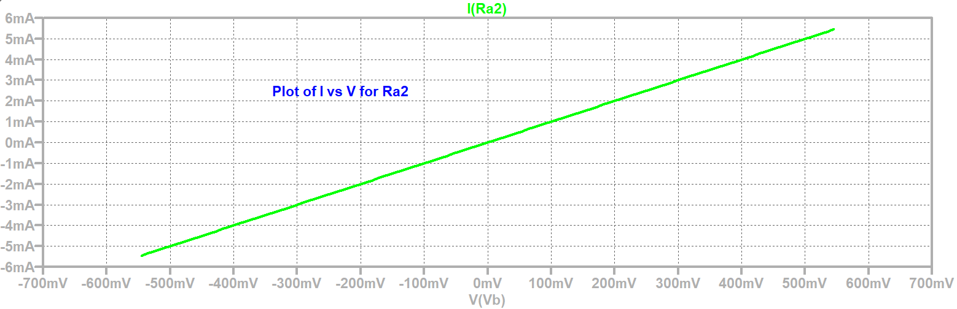

**Figure A-5.**

* + Now add a trace in the plot window (V(va)-V(vb))/1000
    - * You should note that the new trace falls on top of the old trace. Left click on each trace name in the plot and you should see that the traces are indeed on top of each other. You can change the vertical scale for the current to be -5.8mA to +6.2mA to separate the traces. Keep the total range the same but shift the zero away from the center of the plot.
      * Note that there are now 2 vertical scales, one for the voltage across Ra1/1000 and one for the current in Ra2. Plotted this way every mV of Ra1/1000 represents 1mA in Ra2.

***Ra1 can be used as a current sensing resistor. The M2k/Analog Discovery can’t measure current but it can measure the voltage across the resistor Ra1 and use that value to determine the current. Even though LTspice can measure current, we will use a current sensing resistor.***

***A.1*** *I-V Characteristic Curve of a Diode*

Now we will plot the current through a diode vs. the voltage across the diode.

* Modify your *LTspice* schematic by replacing Ra2 with D1, a diode, as shown in Figure A-6. The diode is in the toolbar or add a component and type: diode. Right click on the diode, Pick New Diode, choose the 1N914.
* 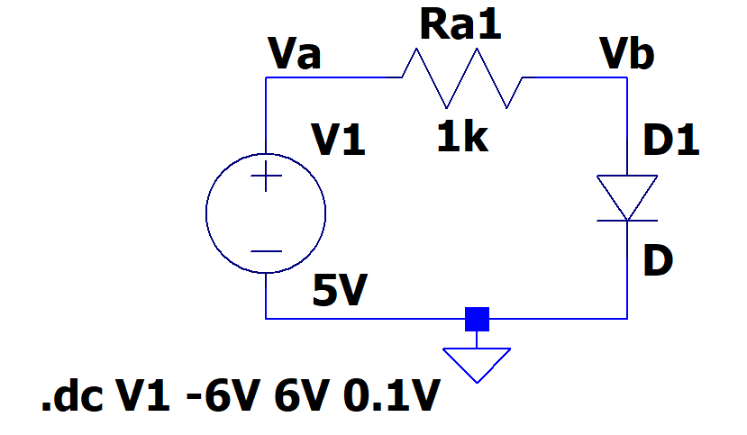The goal is to create the i-v characteristic curve of a diode.

Figure A-6

Insert a diode, right click, Pick New Diode, use 1N914

* + Rerun the DC sweep simulation, again from -6 to +6V.
  + Add a trace in the plot window (V(va)-V(vb))/1000 this represents the current in Ra1 and therefore also the current in the diode with 1mV represents 1mA.
  + The horizontal axis might still be the voltage across the diode, if not change it.
* Right click on the horizontal axis.
* Change the Quantity Plotted to be V(vb) if your schematic matches Figure A-6.
* Click on the “Axis Variable…” button at the bottom.
  + The plot produced will show the i-v characteristic curve for diode D1. It should look like the i-v curve for a real diode. If it looks upside down or backwards, change the sign of one or both of the parameters.
* Mark your plot
  + Expand the part of the plot with interesting results.
    - Right click on X Axis.

Set the range to interesting values, such as 0V to 1V.

Set the tick to a useful value, such as 0.1V

* + - Right Click on Y Axis.

Set the range to interesting values, such as 0 to 5mV and a tick such as 0.5mV

Note that by using R1 as a current sensor, the plot reads as mV but you know it represents mA.

* + ***Using the cursors and mark at least 5 points on this plot. You will be using these 5 points in Matlab to help you plot the characteristic curve of the diode. Choose points that accurately represent the features of your curve.***
    - ***Place the cursor at a point of interest.***
    - ***Right click on plot > Draw > Cursor Position***
    - ***Or – Plot Setting > Notes and Annotations > Label Curs. Pos.***
  + ***Copy your plot and include it in your report.***

***A.2*** *I-V Curve of a Real Diode*

In this part, we will build the simple diode circuit on your protoboard and use M2k/Analog Discovery to take a data sample from the circuit itself. Then, you can use Excel or MATLAB to generate the i-v curve of the diode using the data from the diode itself.

* Wire the circuit shown in Figure A-7 on your protoboard. The output of the M2k/Analog Discovery signal/function generators is limited to ±5V, which is not quite enough to identify the features of all of the diodes we will be using. Therefore, you will connect one end of the diode to the V- power supply. This will allow an effective DC shift of the signal from the Waveform Generator 1. *Note: This is the only circuit you will build without an explicit ground connection. There certainly is a ground but it is internal to the M2k/Analog Discovery.*
* **Look at document on course website: *Supplemental information for experiment 8*. This will help you determine which diode to use. There is a link on page 1 of this document.**



D1  
1N914 or any small signal diode

R1 is current sensing resistor

D1 is diode to be measured

**Figure A-7.**

* + Diodes look like very small resistors with only one stripe. The stripe corresponds to the straight line of the diode symbol at the cathode. The 1N3064 and the 1N914 diodes are very similar and can be used interchangeably. The kit has 4 of the 1N914 and one of the 1N3064. Other diodes in the kit are different.
  + When you wire the circuit, make sure your diode is placed so that the cathode faces toward ground as shown in the figure above.
  + ***Use 2+ and 2- to sense the current. Use 1+ and 1- to sense the voltage. Both are differential measurements, neither side of R1 or D1 is connected to ground.***

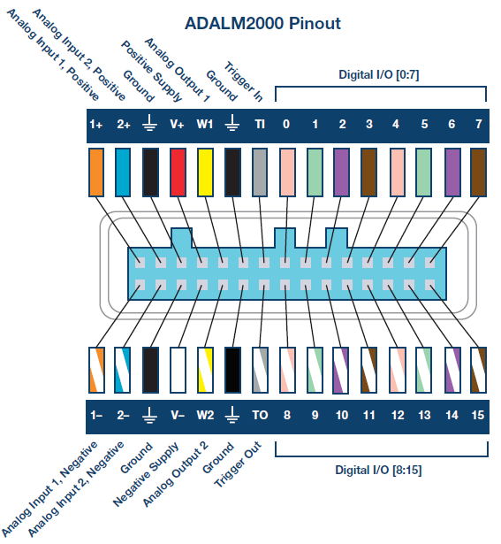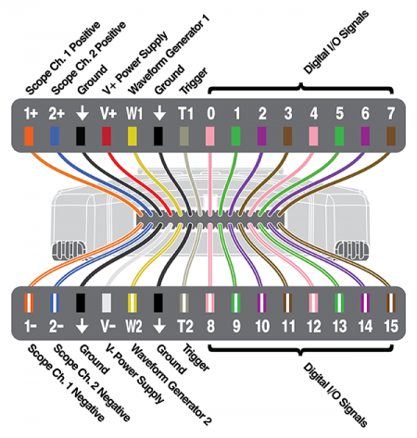

**Figure A-8. Analog Discovery and M2k pinout.**

* Set Function/Signal Generator 1(W1) to a 1kHz, triangle wave, 5V amplitude, (10Vp-p).
* Enable the power supplies. Set V- supply to -4V.
* Observe the diode voltage on channel 1 of the Oscilloscope, (1+, 1-).
* Observe the diode current on channel 2 of the Oscilloscope, (2+, 2-).
  1. Remember that channel 2 is the current with a scale factor of 1mA/V because R2=1kΩ..
* Set the oscilloscope up to display a couple of cycles of the signal, for example set the time base to 250us/div.
* Save the data to a file once you have a clean plot on the screen. You will use the data with MATLAB later.

**Both Waveforms and Scopy are able to plot one trace vs. another trace, much as you did with *LTspice* for the resistor and diode characteristics.**

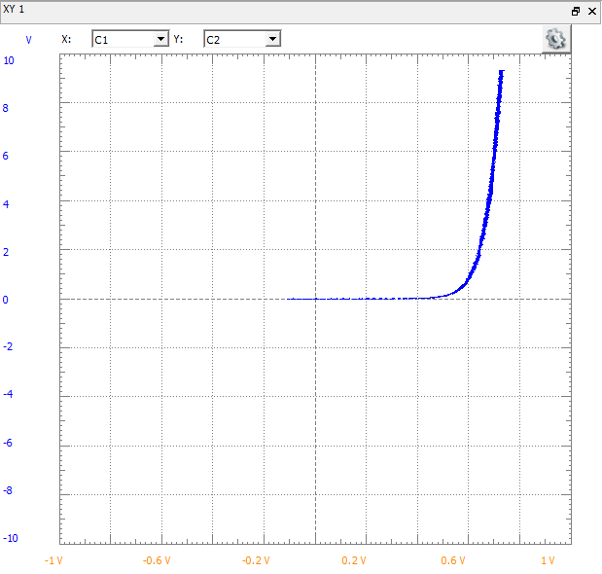**For the Analog Discovery:** In the Oscilloscope, with the traces shown that were saved in the lines above:

* View > Add XY A new plot should appear.
* You might need to change which channel is X: and which is Y:
* **Save this plot and include it in your report. Mark or hand write on the report that the vertical scale is a measure of the current, I=VR1/R1=VR1/1000. The scale is the current in mA.**
* Below you will plot the same data in MATLAB and compare the results to the diode equation.
* ***Note: if the diode current isn’t close to zero when the diode voltage is zero, you need to calibrate your Analog Discovery.***

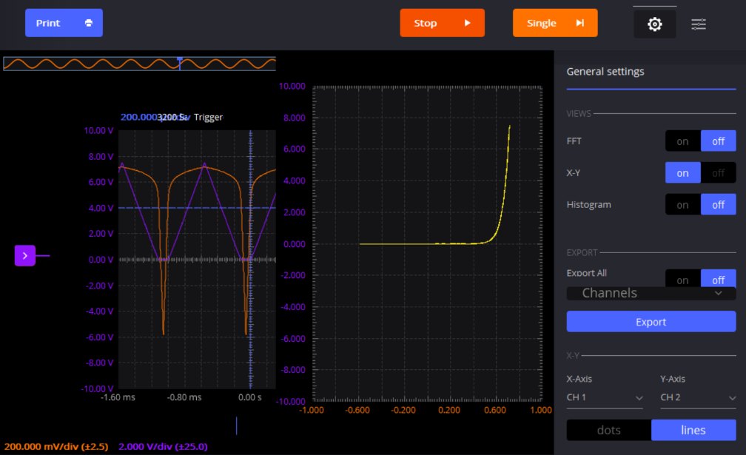**For the M2k,**

Settings

In the oscilloscope:

Click on the settings.

Turn on the X-Y.

* **Save this plot and include it in your report. Mark or hand write on the report that the vertical scale is a measure of the current, I=VR1/R1=VR1/1000. The scale is the current in mA.**

X-Y plot

* Below you will plot the same data in MATLAB and compare the results to the diode equation.

**A.3** MATLAB plots:

* Start MATLAB and Import the data file. The Import Data command is found under the File menu. You should see a window that looks something like this, with three columns showing for time and the two voltages.

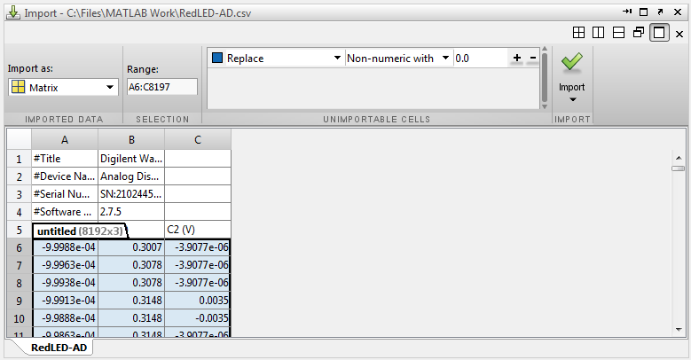

**Figure A-9.**

* 1. In MATLAB, plot the diode current vs. the diode voltage. You only want to display the useful data, so for example there isn’t a need to plot negative voltages because the current is zero.
     1. The m-file below shows how you might do this. This is a guide.

% LED or Other Diode I-V Plots for Data Taken with the M2k/Analog Discovery

% K. A. Connor, 4 April 2014

% Import Data From Spreadsheet

% Click on Import Data from the File Menu in Matlab

% Select the CSV File You Stored in the Directory Where This Program is

% Located. Once you have imported the file, type 'whos' to see what the

% default name is for the array with the data in it. It might be 'data' and

% it might be 'untitled.'

% Identify the Time Data

time=untitled(:,1);% The first column is the time vector

% Voltage Data

v_diode=untitled(:,2);% The voltage across the diode

% Current Data

i_diode=untitled(:,3)/1000;

% The current is measured by finding the voltage across a 1000 Ohm Resistor.

% If a different resistor is used, this expression must be changed.

% There may be some instrumental offsets in the measurements. If they are

% large enough to cause problems, they can be removed. Usually, this step

% is not necessary, so the expressions below have been commented out.

% Eliminate current offset;

% i_diode=i_diode+8.3333e-004;

% Eliminate voltage offset

% v_diode=v_diode-0.55;

% Plot the results

plot(v_diode,i_diode,'.');

hold on;

grid;

% axis([-2 4 -1e-3 21e-3]);

% The axes can be adjusted to produce a better plot.

% Ideal Diode Equation

is=.8e-14;n=2;

vd=[0:.01:5];

id=is.*(exp(vd./(n.*.0259))-1.0);

plot(vd,id,'linewidth',3,'color','r');

axis([0 5 0 .01]);% For most diodes, positive voltages are all that we

% need to plot. However, you may want to extend the range to negative

% voltages in some cases.

* Add a plot of the diode current equation to the figure. (This is done in the bottom part of the m-file.)



* 1. Start with *n*=2, guess a value for *Is*, plug in several values for *vD*, and plot the points.
  2. Use 25.9mV for *VT*.
  3. Vary the value of *Is* until you get a reasonable fit.
* The figure below is the result of the MATLAB example on the output from the code on the previous page. You should be able to get a better fit. Consider using the “grid” command in MATLAB.
* If time permits, vary the value of n also. For real diodes, n is in the range of 1 to 2.



**Figure A-10. Diode current vs. diode voltage. Thin lines are plots of experimental data, thick lines are two attempts to fit the diode equation. One curve is for *n* = 2 & *Is* = 10-10, the other curve is for n = 2 & *Is* = 10-9A.**

* + - **Add the data points collect in Part A.1 for the simulation of the diode.**
    - **Include a copy of this plot in your write-up. List the final n and *Is*.**

**Summary**

A diode is a device that allows current to flow in only one direction. An ideal diode looks like a short when the current is flowing and an open circuit when the current is not flowing. A real diode has a small voltage across it when it is on, a small negative current through it when it is off, a region in which it switches from on to off, and a breakdown region where it stops blocking the current entirely. As long as the voltages we use do not reach the voltage of the breakdown region, the diode will work close to the theory.

**Part B – Diode Circuits: Rectifiers and Limiters**

**Background**

*Rectifiers:* A rectifier is a circuit that converts an AC current to a DC current. At the very simplest level, a rectifier circuit is also a circuit that takes an AC voltage and modifies it so that the output voltage has only one sign. It will eliminate either all positive voltage or all negative voltage. A true DC current requires a constant DC voltage. The rectifiers we can build with only regular diodes give a first approximation to this. We will continue to refine the rectifiers presented here in other parts of this experiment.

*Half-wave rectifier:* You will build a half-wave rectifier circuit. Build the circuit in Figure B-1. Be sure to ***use a 10kΩ resistor for this circuit.*** Channel 1+ senses the input signal to the half-wave rectifier circuit. 2+ is connected to the output of the rectifier circuit.

Half-wave rectifier circuit



1N914

W1

**Figure B-1.**

The half-wave rectifier uses the fact that the diode only allows current in one direction to eliminate the negative voltage of the input. Note that the current and voltage aren’t exactly DC, but the average of the signal is now positive.

**B.1** Experiment with triangle input:

* Set the signal/function generator on M2k/Analog Discovery to a triangle wave at 1kHz with a 5V amplitude.
* **Produce a plot of the oscilloscope channels 1 and 2. Include this in the report. The plot can be a picture from the M2k/Analog Discovery software, an Excel plot or a MATLAB plot - your choice. Label the traces.**

*Full-wave rectifier:* We can use four diodes in a bridge configuration to create a rectifier that also uses the negative cycle of the signal. The output is shown in Figure B-2.

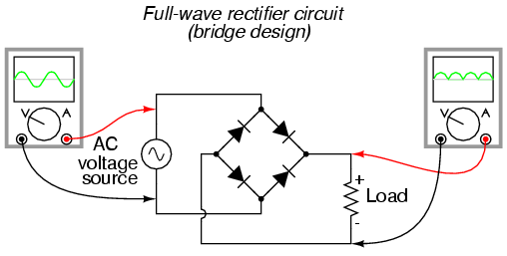

Image from [www.allaboutcircuits.com](http://www.allaboutcircuits.com)

**Figure B-2.**

In a full-wave rectifier one pair of diodes allows current in one direction to flow through the load resistor when the AC source has a positive voltage. The other pair of diodes is arranged such that when the AC source is negative, the current flows through the load *in the same direction.* This keeps the positive half of the input signal and inverts the negative half, resulting in the output shown. Note that the average voltage from this circuit is also positive, and (assuming the same input) its average voltage is greater than that of the half-wave rectifier.

*Smoothing capacitors:* You already know that an RC circuit has a characteristic charge and discharge rate. You should also be aware that larger capacitors charge and discharge more slowly than smaller ones. We can take advantage of the charge and discharge rates of capacitors in order to make the signal from our rectifier more like a DC voltage. As the signal in our rectifier increases, it charges the capacitor. As it decreases, the capacitor discharges. If the capacitor has a sufficiently long discharge rate, it will hold most of its charge until the next positive cycle of the input recharges it. This results in an output signal much closer to a true DC signal. Figure B-3 shows an input that has been rectified and then, smoothed with a capacitor.

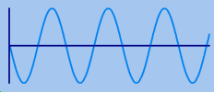 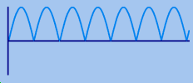 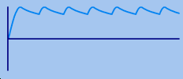

Input Rectified Rectified and Smoothed

**Figure B-3.**

*Limiters:* The purpose of a voltage limiter is to prevent the voltage in a circuit from exceeding a certain level. These circuits are also called “*clippers*” because they clip the voltage signal off at a given level as shown in Figure B-4. When you performed the triangular wave sweep of the 1N914 diode, you should have observed that the voltage across the diode remained near 0.7V when it was on. We can take advantage of this effect to build a circuit that permits small voltages to pass without distortion, but clips any voltage outside the range of about -0.7 to 0.7V.

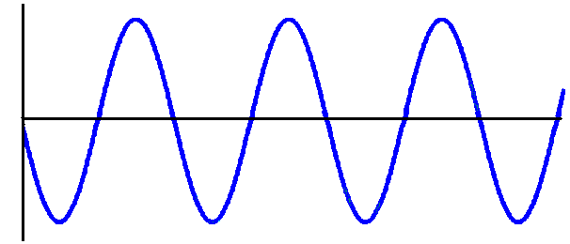 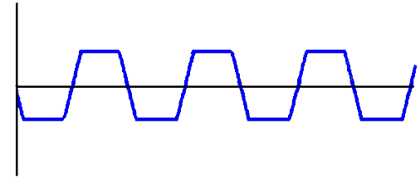

Signal before voltage limitation Signal after voltage limitation

**Figure B-4.**

**Experiment**

*LTspice Simulation of a Half-wave Rectifier with Smoothing*

In this section, we will use a half-wave rectifier to create a signal which maintains a fairly constant DC value by adding a smoothing capacitor.

* **B.2** Create the circuit shown in Figure B-5 in *LTspice*:

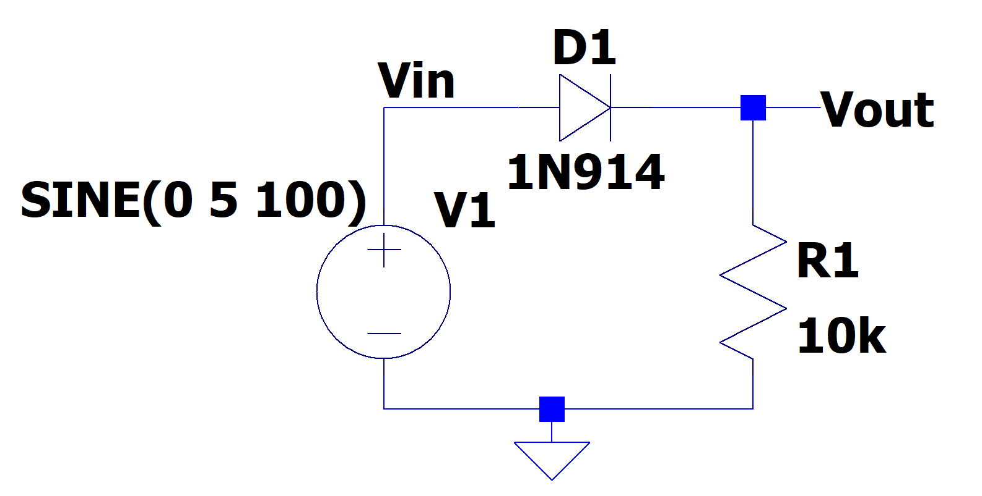

**Figure B-5.**

* Use the Voltage component and set to SINE with 5V amplitude and 100Hz frequency.
* Run the simulation
  + Perform a transient analysis for 50ms with a maximum timestep of 10us.
  + Obtain a graph of the input and output voltages, Vin and Vout if you label you schematic as is shown in Figure B-5.
  + Include this plot in your report.
* **B.3** Add a capacitor across the resistor as shown in Figure B-6 below:



**Figure B-6.**

* + Modify your *LTspice* circuit by adding capacitor C1 in parallel with R1.
  + Perform a transient analysis as you did in the previous part.
  + Obtain a graph of the input and output voltages vs. time.
  + Include this plot in your report**.** (You will also be adding 5 experimental points to this plot based on the circuit you build in the next section.)
* **B.4** Modify the frequency of the input source and observe the output.
  + Modify the frequency of the source to 1kHz and run the simulation for 2ms.
  + Generate a plot of the Vin and Vout.
  + Note the time at which the output voltage reaches around 4V.
* Modify the frequency of the source to 10kHz and rerun the simulation. Run the simulation for 500us with a maximum step size of 1us.
* Note the time at which the output reaches around 4V.
* What is happening as the frequency increases?
* Produce a plot of the output from the second case only and include it in your report.

*Hardware Implementation of a Rectifier*

Now wire the rectifier on your protoboard and observe the output with and without the capacitor.

1. **B.5** Return to the circuit in Figure B-1, redrawn below

W1



1N914

**Figure B-7.**

Use the waveform generator to supply an input sinusoidal signal of 100Hz, 5V amplitude, (10Vp-p) signal applied to the rectifier circuit.

1. Observe both the input and the output voltages with the scope.
   * Take a picture with M2k/Analog Discovery or plot the data using either Excel or MATLAB (your choice).
   * Include this plot with your report. This is very similar to one of the previous plots except now the signal is a 100Hz sine wave.
2. **B.6** Repeat the procedure above with a 4.7uF capacitor in parallel with the resistor R, as shown in Figure B-8. If your kit doesn’t include a 4.7uF capacitor, ask the instructor or TA.

1N914

W1

**Figure B-8.**

* + Note that the sine voltage from the generator may become distorted when you add the large capacitor.
  + Record the input and output signals (Channels 1 and 2) with M2k/Analog Discovery and include it in your report. Again you may choose to use a picture or plot the data using Excel or MATLAB.
  + Measure the output voltage at approximately 5 points during one cycle.
* The data points can be selected from the Excel or MATLAB data files or the cursors can be used in M2k/Analog Discovery
  + - Get a good trace of Vout, (2+) on the scope.
    - Stop the scope.
    - Click the Zoom Button in Waveforms or select an area in Scopy.
    - Move and resize the zoom window to focus on an area of interest.
    - Open the zoom window in Waveforms by right clicking on it.
    - Use the cursors to read 5 voltages and times**,** including the minimum and maximum voltages, and 3 other points.
      * Close the zoom window in Waveforms, hit escape in Scopy
  + Add the experimentally measured points to the plot generated with *LTspice*. This can be done by hand.
  + Vary the frequency of the signal/function generator and observe both the input and output voltage of the rectifier with the capacitor. Try connecting and disconnecting the capacitor as you vary the frequency. Try a larger capacitor, such as a 100uF capacitor.

*LTspice Simulation of Voltage Limitation*

Now we can use *LTspice* to build a limiter using a pair of diodes.

* 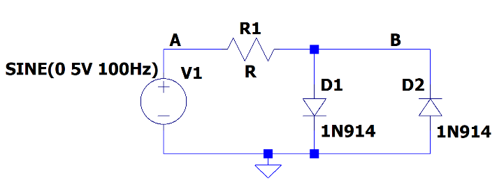 **B.7** Create the circuit shown in Figure B-9 in LTspice:

**Figure B-9.**

* + Use SINE for the source (VAMPL = 5, FREQ = 100Hz, everything else = 0).
  + Perform a transient analysis in increments of 50us for 30ms.
  + Plot the input (point A) and output (point B) voltages. The input is the voltage source while the output is taken across the diode pair, as shown.
  + Copy your plot and include it in your report. (You will also be adding 5 experimental points to this plot based on the circuit you build in the next section.)
  + **B.8** Change the amplitude of the sinusoidal input, Vin, to 2V. Repeat the transient analysis.
  + Copy this plot also and include it in your report.

*Hardware Implementation of a Limiter*

Now build the limiter on your protoboard.



W1

1N914

1N914

**Figure B-10.**

* **B.9** Wire the limiter circuit shown above
  + - Use the signal/function generator to supply a 100Hz, 5V amplitude, sinusoidal input. Observe Vout (2+) and Vin (1+) with the oscilloscope.
    - Take an M2k/Analog Discovery picture of this circuit or save and plot the data in Excel or MATLAB. Include it in your report.
    - Record at least 5 experimental voltages taken within 1 cycle of the input sinewave and add them to your *LTspice* output (**B.7**). The data point may be hand written on the *LTspice* plot.
* **B.10** What is the effect of altering the amplitude of your circuit?
* Repeat the measurements with a 100Hz, 2V amplitude (4Vp-p) sinusoidal input.
* Take an M2k/Analog Discovery picture of this circuit with 2V amplitude and include it in your report.
* **B.11** Alter the circuit to limit voltage in only one direction.
  + Return the amplitude of the signal/function generator to 5V.
  + Remove one of the diodes from your limiter and observe the output.
  + What part of the signal is being limited?
  + Take a picture of this output or plot it and include it in your report.
  + Now reverse the polarity of the remaining diode in the circuit. (Turn it around).
  + What part of the signal is being limited now?

**Summary**

Diodes can be used as rectifiers, which convert an AC signal into a signal with an average non-zero DC voltage. The desired result of a rectifier is to create a DC signal from an AC signal. The signal from a simple rectifier circuit built with a diode can be improved by the addition of a smoothing capacitor. Diodes can also be used to limit voltage. This device is called a limiter. These can be used to limit voltage in one direction, or in both directions.

**Part C – LEDs, Photodiodes and Phototransistors**

**Background**

*LEDs:* An LED is a device that emits light when it is subjected to a voltage. Just like a regular diode, an LED will not turn on (and emit light) until a certain threshold voltage is reached. This threshold depends upon the color of the LED and the diode manufacturing process. Red LEDs turn on when the voltage across them exceeds about 2.2V. With green LEDs, the voltage can vary over a large range from about that required for Red up to 4V. Blue is about 3.5-4V. Note that, although diodes often have a plastic coating that matches the color of the light emitted, the light that comes from a diode is not white. It is light of the wavelength of the desired color, i.e. a red diode (even with a clear plastic covering) will put out light in the red region of the electromagnetic spectrum. The following equation can be used to decide what resistance to use with an LED, given its threshold voltage and the desired current through the diode. 20mA is a reasonable value to use for the current through the diode, although that also depends on the manufacturing process and the size of the diode. A handy calculator for determining the series resistance for a particular LED can be found at <https://www.digikey.com/en/resources/conversion-calculators/conversion-calculator-led-series-resistor>



The amount of light emitted by an LED is roughly proportional to diode current. There is a well-written activity (meant for a science fair project) that addresses illumination. <http://www.sciencebuddies.org/science-fair-projects/project_ideas/Elec_p037.shtml>

*Photodiodes:* A photodiode is a device that generates a current in the presence of light. As photons of light excite the PN junction inside the diode, a current is generated through the junction. The more light that shines on the photo-reactive surface, the more current flows through the device. In the equation for *iD*, the saturation current *Is*, increases with the amount of light hitting the diode. Photodiodes are reverse-biased and operate in the lower left quadrant of the i-v characteristic (both voltage and current are negative), as do Zener diodes. We do not use solar cells in this course, but they also have an *Is* proportional to light and operate in the lower right quadrant.

*Phototransistors:* A phototransistor is similar to a photodiode except that it takes advantage of the ability of the transistor to amplify current in the active region. The current it generates is still proportional to the amount of incident light, but it is amplified by the properties of the transistor. The graph in Figure C-1 shows the linear relationship between incident light and current through a phototransistor similar to the one we will be using. In effect, the light plays the same role as the base current *Ib* in a standard transistor. Recall that the collector current *Ic* is the order of 100 times the base current (the amplification).

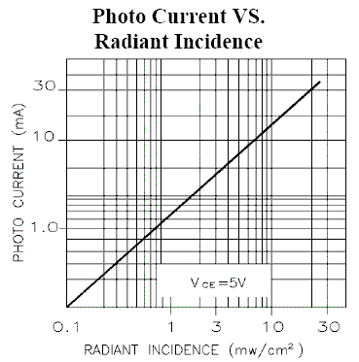

**Figure C-1.**

**Experiment**

*Transmit a Signal using Light*

Here we will build two circuits. The first circuit will cause an LED to blink. A current will be created in the second circuit when the phototransistor detects the light from the blinking LED.

* 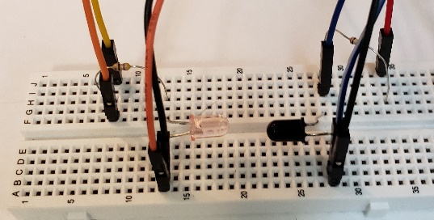**C.1** Wire the circuit in Figure C-2 on your protoboard. Again refer to information on course site on the IR LED and IR photo transistor, link is on page 1 of this document.

**Figure C-2.**

* + The phototransistor looks like a black LED. It is a transistor but the base doesn’t have an external lead. Light supplies the base current.
  + There is a flat side on the phototransistor. The lead next to the flat (emitter) goes to ground.
  + Note that resistor R is 470Ω and resistor R3 is 1kΩ.
  + ***When you wire your circuits, point the LED and the photodiode towards one another so that the rounded tips (lenses) face each other as is shown in figure C-2****.*  Recall that the light from a visible LED is brightest if viewed from the top, it is the same for the infrared LED. The phototransistor takes in light primarily at the top as well. *Having them face each other provides the maximum light transmission and also minimizes the secondary effects caused by other lights in the room.*
  + Adjust the signal/function generator to produce a triangle wave with a frequency of 100Hz. Set the amplitude of the signal/function generator to 5Vp-p with a 2.5V offset. This will result in a triangle wave that goes from 0V to +5V.
  + IR light isn’t visible to our eyes. Cell phone camera chips can detect IR light but some phones, typically IPhones, have IR filters on the lens to block the IR frequencies. The camera in a ThinkPad X1 can detect the IR light also.
* Observe the output of your circuit.
  + Connect the source voltage to one channel of your scope. Connect the output (the voltage across the phototransistor) to the other channel of your scope.
  + If the output signal doesn’t show a significant square wave then:
* Make sure the phototransistor is correctly installed. Simply reverse the phototransistor and see if the signal increases.
* Make sure that the tips of the LED and the phototransistor point toward each other.
* Take your data.
  + Save a picture of the output when the circuit is working well.
  + Include this plot in your report.
  + After obtaining a clear signal with this optical link, block the light by placing a piece of thick paper, your finger, or something similar between the transmitter and receiver. Do you observe anything on the oscilloscope?
  + Change the frequency of the triangle wave to 2kHz and then 20kHz. Does the output look the same at 20kHz? Might this circuit be frequency limited?

**Summary**

Photodetection is a very important use of transistors and diodes. LEDs and phototransistors can be used to emit and detect light in the visible spectrum and also in the infrared. These devices are used in remote control devices to transmit modulated signals of certain frequencies, such as TV remotes. They are also used to sense and/or display information in countless other applications. A photodiode works in much the same way but the transistor has gain. This experiment uses the phototransistor because it is provided in the kit of parts.

**Part D – Zener Diodes**

**Background**

*The reverse breakdown region*: In a semiconductor diode, charge carriers (holes and electrons) are continually being thermally generated, which results in the small, voltage independent reverse saturation current when a diode is reverse biased. If the reverse voltage becomes too large, two phenomena occur to dramatically increase current. As the reverse bias voltage increases, so does the size of the depletion region (the insulating region between the holes and electrons). In this region, the charge carriers experience an electric field force which increases their energy. If this energy is large enough, the collision of a carrier with an ion will generate a new hole-electron pair. The electric field itself can also pull electrons from the ions once it becomes large enough. Both processes increase the number of charge carriers and thus increase the ability of the diode to carry current in the reverse direction.

*Zener diodes:* By appropriate doping, it is possible to design a Zener diode that breaks down at anywhere from a few volts to a few hundred volts. If you recall the figure above showing the i-v characteristic curve of a diode, you will see that, if a diode is sufficiently reverse biased, it will conduct in the reverse direction. Furthermore, the diode voltage will remain approximately constant over a wide range of currents. This property is known as breakdown; the negative of the breakdown voltage is called the Zener voltage (VZ). Diodes that are designed to work in the breakdown state are usually known as Zener diodes. Figure D-1 shows the symbol for a Zener diode.



**Figure D-1.**

*Characteristic curve of a Zener diode:* The characteristic curve of a Zener diode is similar to that of a regular diode. The difference is that, whereas regular diodes will reach the breakdown region at voltages way beyond the operating range of your circuit, Zener diodes are designed to “break down” at (minus) the Zener voltage. You use this feature of the Zener diode as part of the design of your circuit. The characteristic curve for an ideal Zener diode is shown in Figure D-2. In a real Zener diode, the forward bias region occurs at the same voltage as a regular diode, 0.7V. The reverse bias voltage of a Zener diode is known as the Zener voltage. Although the breakdown region occurs at a negative voltage, the Zener voltage is always a positive number (the absolute value (or negation) of the actual breakdown voltage.) Zener diodes are rated by this Zener voltage. For example, a 10V Zener diode will reach breakdown at around -10V and a 5V Zener diode will reach breakdown at about -5V.



**Figure D-2.**

**Experiment**

*I-V Characteristic Curve of a Zener Diode*

Now we will plot the voltage across a Zener diode vs. the current through the Zener diode.

* Determine what Zener diode came with you kit of parts. See the document on the course website with Experiment 8 called: *Supplemental information for experiment 8*. **Determine the voltage of your Zener.**   
  If your diode has a **Zener Voltage of ~6.2V use the D1N4735 diode for *LTspice***, if it has **~3.6V use the D1N4729 diode in *LTspice*. Both require the special instructions listed below**. If it is another voltage let the professor know but wire *LTspice* with the D1N4735  
  Wire the circuit in Figure D-3 in *LTspice*. For either the 1N4735 (6.2V) or the D1N4729 (3.6)
  + Add a component, select *zener*.
  + Right click on the present name, D, and change it to Zener you are using, either D1N4735 or D1N4729.
  + You need to add the .model statement but only for your diode. Listing both .model statements is fine.
    - Click on .op in the toolbar
    - Copy the .model statement from the *supplemental information for experiment 8* file, see link on page 1 of this document. You only need to copy the model for the diode you are using.

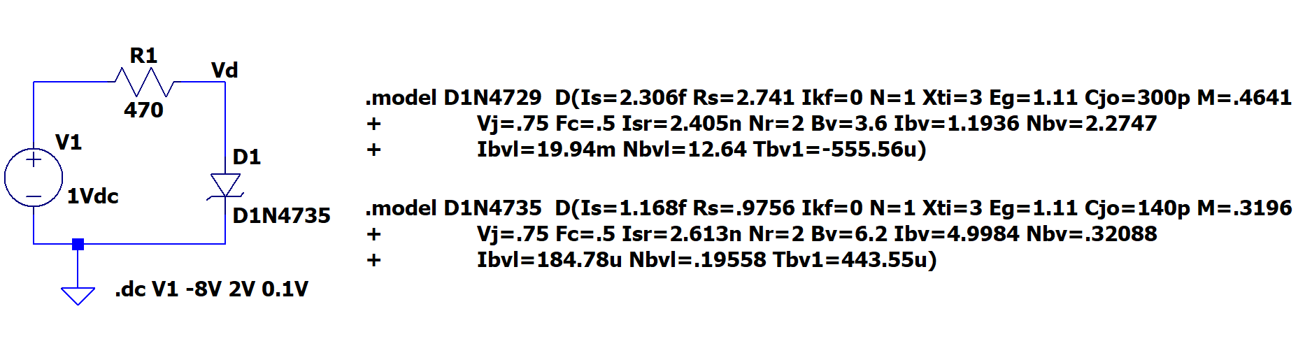**Figure D-3. The Zener name must match your Zener, either D1N4729 for 3.6V or D1N4735 for 6.2V**

* **D.1** Run a simulation and create the i-v characteristic curve.
  + Set up a DC sweep analysis of voltage source V1 from -8 to +2V in increments of 0.1V.
  + Run the simulation
  + Plot the current in D1, hover the cursor over D1 until the current symbol appears and left click.
  + Change the x-axis of your plot:
* Right click on the horizontal axis of the plot
* Change the Quantity Plotted to the diode voltage. V(Vd) if your schematic is labelled as is figure D-3.
  + The plot produced will show the i-v characteristic curve for diode D1.
  + Copy this plot and include it in your experiment.

*Hardware Implementation*

In the final part of this experiment, you will build a Zener diode voltage regulator on your protoboard. In this experiment, you will be measuring current. Current is always measured in series with a circuit.

* **D.2** Assemble the circuit shown in Figure D-4 on your protoboard. The Zener diode looks like the regular diode, make sure that you have the Zener.

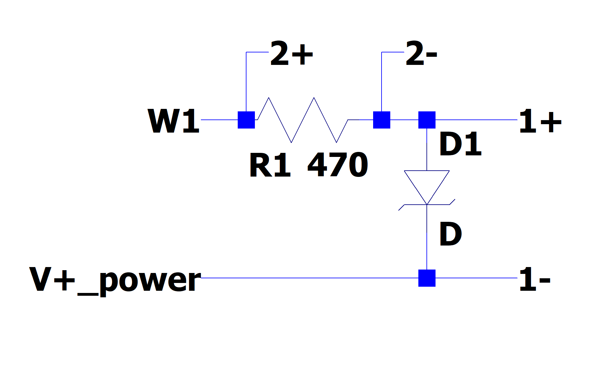

1N4735 or 1N4729

**Figure D-4.**

* Measure the current vs. voltage characteristics of the 1N4735 or 1N4729 Zener diode.
  + ***Note: the V+ supply is used in this case to allow larger reverse voltages to be applied.***
  + Set Signal/function generator 1 to a 1kHz, triangle wave, 5V amplitude.
  + For the M2k or the Analog Discovery 2 set V+ power supply to 3V. This will allow you to see both the forward and reverse diode current. With the original Analog Discovery the voltage is set to +5V on you will only measure the reverse, Zener, current.
  + Observe the diode voltage on channel 1 of the Oscilloscope.
  + Observe the diode current on channel 2 of the Oscilloscope.
    - *R1 is now 470Ω so i=V(channel 2)/470 or 2.1mA/V*
  + Set the oscilloscope up to display a couple of cycles of the signal, for example set the time base to 250us/div.
  + Save the data to a file once you have a clean plot on the screen.
  + Start MATLAB and Import the data file.
  + See Figure A-9 for help in plotting the data in MATLAB.
  + Include the experimental plot of i vs. v in your report. You must scale the channel 2 data to get i as is stated above. If can plot V(channel 2)/0.470 to have current in mA.

**Summary**

Zener diodes exploit the breakdown region of diodes to create a device that allows current to flow freely in one direction at a level above the Zener voltage. You can use a Zener diode to hold a voltage to the Zener voltage. An AC to DC converter of a desired voltage can be created by combining a Zener diode (rated at that voltage) with a rectifier and a smoothing capacitor.

**Checklist and Conclusions**

# The following should be included in your experimental checklist. Everything should be labeled and easy to find. Credit will be deducted for poor labeling or unclear presentation. ALL PLOTS SHOULD INDICATE WHICH TRACE CORRESPONDS TO THE SIGNAL AT WHICH POINT AND ALL KEY FEATURES SHOULD BE LABELED.

# Hand-Drawn Circuit Diagrams for all circuits that are physically built and characterized using your M2k/Analog Discovery board.

**Part A – The I-V Characteristic Curve (16 points)**

Include the following plots:

A.1 I-V Characteristic curve of a diode, the *LTspice* Plot with 5 points marked. (3 pt)

A.2 Waveforms/Scopy plot of diode current vs. voltage. (2pt)

A.3 MATLAB plot of diode current vs. voltage from data taken using M2k/Analog Discovery software. This should include the data points and a line found using the diode characteristic equation. (3 pt)

Answer the following questions:

1. Use the data you took for the i-v characteristic curve of the 1N914 or the 1N4148 diode to determine the mathematical representation of the i-v curve. What values did you find for IS and n (curve on the MATLAB plot)?   
   (4 pt)
2. Why do you know that the current through the diode is V(channel 2)/R1? (2 pt)
3. What differences, if any, did you notice between the i-v characteristic curve given by *LTspice* and the one you measured experimentally? (2 pt)

**Part B - Diode Circuits: Rectifiers and Limiters (32 points)**

Include the following plots:

B.1 Picture or plot of the M2k/Analog Discovery data for the circuit in Figure B-1, the half-wave rectifier. This figure has a triangle wave input signal. (2 pt)

B.2 *LTspice* plot of the half-wave rectifier circuit, Figure B-5. (2 pt)

B.3 *LTspice* plot of the rectifier with smoothing with 5 experimentally obtained points marked. (4 pt)

B.4 *LTspice* plot of the rectifier (output only) at 10kHz. (2 pt)

B.5 M2k/Analog Discovery plot of the rectifier (with no smoothing capacitor, sinusoidal waveform). (2 pt)

B.6 M2k/Analog Discovery plot of the rectifier (with a smoothing capacitor). (2 pt)

B.7 *LTspice* plot of the voltage limiter at 10V (with 5 experimental points marked). (2 pt)

B.8 *LTspice* plot of the voltage limiter at 4Vp-p (2V amplitude). (2 pt)

B.9 M2k/Analog Discovery plot of the limiter circuit with 10Vp-p input. (2 pt)

B.10 M2k/Analog Discovery plot of the limiter circuit with 4Vp-p input amplitude. (1 pt)

B.11 M2k/Analog Discovery plot of the limiter with only one diode. (1 pt)

Answer the following questions:

* 1. Explain why Vout changes when you add the capacitor to the rectifier in parallel with R. Explain why this circuit would be better for use as a DC source than the circuit without the capacitor. (3 pt)
  2. Did the circuit with the capacitor work better (more like a DC source) at high or low frequencies? (1 pt)
  3. Comment on the similarities and differences between the *LTspice* and experimental results for the rectifier. (2 pt)
  4. At what values (positive and negative) does the limiter cut off the voltage of the 10Vp-p input signal?   
     (2 pt)
  5. Why is this circuit called a limiter? (2 pt)

**Part C – LEDs, Photodiodes and Phototransistors (10 points)**

Include the following plot:

**C.1** M2k/Analog Discovery plot of the input and output for the optical link. (5 pt)

Answer following questions/comments:

1. What are the minimum and maximum voltages of the output waveform under the best signal conditions?   
   (2 pt)
2. Describe what happens to the output waveform at the higher frequencies. (1 pt)
3. Comment on any two of the following: a) the effect of misalignment of the LED and transistor, b) the effect of the room lights, c) signal level through paper, skin, or other objects. (2 pt)

**Part D – Zener Diodes (14 points)**

Include the following plots:

**D.1** *LTspice* Zener diode characteristic curve. (5 pt)

**D.2** Matlab Plot of Zener diode i vs. v from the experiment. (5 pt)

Answer the following questions:

1. What is the Zener voltage of your diode? What Zener did you use for the *LTspice* simulation. (2 pt)
2. Shown below is the i-v characteristic curve of both the 1N914 and the 1N4148 non-Zener diodes. We looked at the 1N914 in part A, but now the plot covers a much wider voltage range. Compare this plot with the one you obtained for the Zener diode. (2 pt)

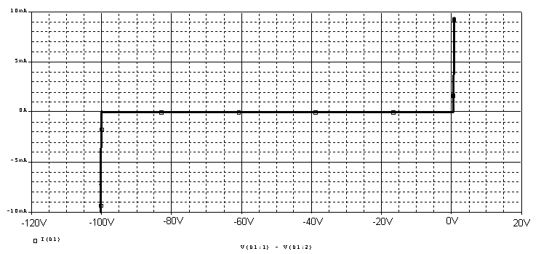

## Organization (8 points)

1. Are all plots and figures included, labeled and are they placed in a logical order. Can they be fully understood without reading the associated text? (8 pt)

**List group member *responsibilities*. (0 to -4pts)** Note that this is a list of *responsibilities*, not a list of what each partner did. It is very important that you divide the responsibility for each aspect of the experiment so that it is clear who will make sure that it is completed. Responsibilities include, but are not limited to, reading the full write up before the first class; collecting all information and writing the report; building circuits and collecting data (i.e. doing the experiment); setting up and running the simulations; comparing the theory, experiment and simulation to develop the practical model of whatever system is being addressed, etc.

**Summary/Overview** (0 to -10 pts) There are two parts to this section, both of which require revisiting everything done on this experiment and addressing broad issues. Grading for this section works a bit differently in that the overall report grade will be reduced if the responses are not satisfactory.

1. 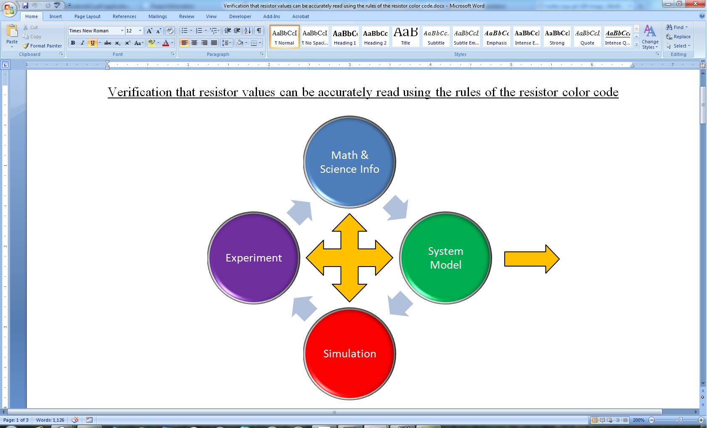Application: Identify at least one application of the content addressed in this experiment. That is, find an engineered system, device, process that is based, at least in part, on what you have learned. You must identify the fundamental system and then describe at least one practical application.
2. Engineering Design Process: Describe the fundamental math and science (ideal) picture of the system, device, and process you address in part 1 and the key information you obtained from experiment and simulation. Compare and contrast the results from each of the task areas (math and science, experiment, simulation) and then generate one or two conclusions for the practical application. That is, how does the practical system model differ from the original ideal? Be specific and quantitative. For example, all systems work as specified in a limited operating range. Be sure  
    to define this range.

**Total: 80 points for experiment packet**

**0 to -10 points for Summary/Overview**

**20 points for attendance**

**100 points**

**Attendance (20 possible points)**

**2 classes (20 points), 1 class (10 points), 0 class (0 points)**

**Minus 5 points for each late.**

**No attendance at all = No grade for this experiment.**

***Experiment 8***

***Section: ______***

***Report Grade: ______***

***____________________________________ Name***

***____________________________________ Name***

***Checklist w/ Signatures for Main Concepts***

*For all plots that require a signature below, you must explain to the TA or instructor:*

* *the purpose of the data (using your hand-drawn circuit diagram),*
* *what information is contained in the plot and*
* *why you believe that the plot is correct.*

**PART A: The I-V Characteristic Curve**

1. ***LTspice* I-V Characteristic curve of a diode (5 points marked)**
2. **Waveforms plot of diode current vs. voltage**
3. **Matlab plot of diode current vs. voltage from   
   M2k/Analog Discovery data ___________________**

**Questions 1-3**

**PART B: Diode Circuits: Rectifiers and Limiters**

1. **Picture or plot of the M2k/Analog Discovery data for the circuit in Figure B-1, the half-wave rectifier. This figure has a triangle wave input signal ________________**
2. ***LTspice* plot half-wave rectifier circuit, Figure B-5**
3. ***LTspice* plot rectifier with smoothing with 5 experimentally   
   obtained points marked _________________**
4. ***LTspice* plot rectifier (output only) at 10kHz**
5. **M2k/Analog Discovery plot rectifier (with no smoothing capacitor, sinusoidal waveform)**
6. **M2k/Analog Discovery plot rectifier (with a smoothing capacitor**
7. ***LTspice* plot voltage limiter at 10V (with 5 points marked)**
8. ***LTspice* plot voltage limiter at 4Vp-p (2V amplitude)**
9. **M2k/Analog Discovery plot limiter circuit with 10Vp-p input**
10. **M2k/Analog Discovery plot limiter circuit with 4Vp-p input amplitude**
11. **M2k/Analog Discovery plot limiter with only one diode**

**Questions 1-5**

**PART C: LEDs, Photodiodes and Phototransistors**

1. **M2k/Analog Discovery plot input and output for the optical link _____________**

**Questions 1-3**

**PART D: Zener Diodes**

1. ***LTspice* Zener diode characteristic curve**
2. **Plot of Zener diode i vs. v from the experiment ________________**

**Question 1-2**

**Member responsibilities**

**Summary/Overview**